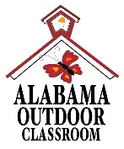 **Outdoor Classroom Project Plan:**

**Materials List & Budget for**

**Pollinator Garden**

A Pollinator Garden should include flowering perennials that provide nectar and pollen throughout the growing season as well as water, shelter, and a place to raise young for a variety of pollinators.

The most critical component of a Pollinator Garden is **native plants** (plants that occur naturally in a specific region, ecosystem, or habitat without human introduction). They are easier to grow and are better adapted for our specific climate and soil than non-native plant species. Native pollinators have co-evolved with these native plants to most efficiently collect pollen and nectar, making their success more likely than if they were to pollinate non-native species. These plants are an important base in the food chain, as they draw in native pollinator species which are in turn food for native birds, mammals, reptiles, and amphibians. For these reasons, native plants increase the biodiversity of an outdoor classroom and should be used as much as possible in your Pollinator Garden.

* **Habitat Requirements:**
* Native flowering wildflowers, bushes and trees that produce nectar
* Puddling stations for pollinators that prefer to get their nutrition from excrement covered in sand
* Bushes and trees for cover from inclement weather and predators
* Dark colored stones where pollinators can warm their bodies
* Full sun for 6-8 hours per day for optimal plant growth
* Near the entrance of the outdoor classroom if possible
* **Example Pollinator Garden Pictures & Educational Sign:**

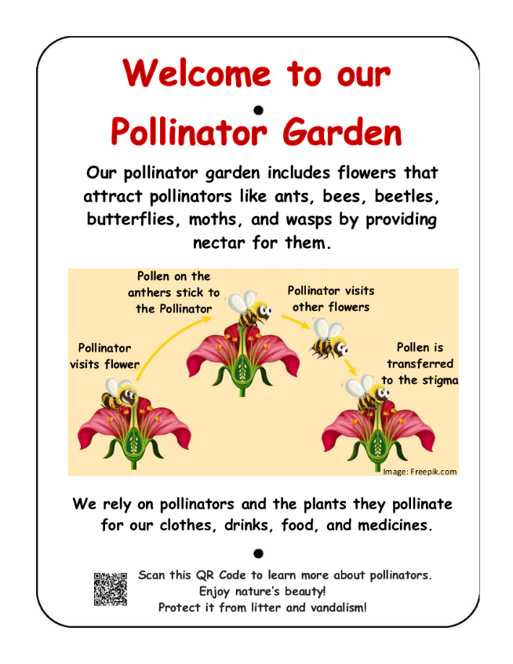

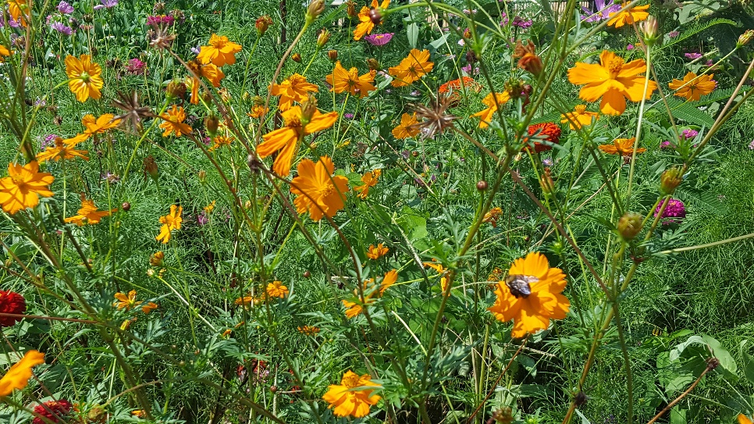

**OC Project Plan: Example Pollinator Garden Materials List & Budget**

* **Estimated Cost:**
* Example 3-sided garden against the school building (3’8” x 13’ 8”): **$535**
* Example 4-sided garden away from the school building (4’8” x 13’8”): **$655**
* **Materials & Supplies Lists with Estimated Budgets:**

|  |  |  |  |  |
| --- | --- | --- | --- | --- |
| **Example 3-sided Pollinator Garden**  (Actual Size: 3 ft 8 in (W) x 13 ft 8 in (L) x 6 in (D) 3-sided raised bed garden against school building 🡪 ~19 CF) | | | | |
| **Station** | **Materials & Supplies** | **Estimated Cost** | **Source of Materials** | **Final Cost** |
| 3-Pollntr | (1) Can of Rust-Oleum Professional White Water-based Marking paint (for laying out garden) @~$9.98 ea | $10 | [Lowe’s](https://www.lowes.com/pd/Rust-Oleum-Professional-White-Water-based-Marking-Paint-Actual-Net-Contents-15-fl-oz/3959183) Item #429750 |  |
| 3-Pollntr | (40) Old Manor 12-in L x 4-in H x 8-in D Concrete Retaining Wall Blocks (to create three sides of raised bed against school building) @~$2.88 ea | $115 total | [Lowe’s](https://www.lowes.com/pd/Rust-Oleum-Professional-White-Water-based-Marking-Paint-Actual-Net-Contents-15-fl-oz/3959183) Item #477088 |  |
| 3-Pollntr | (1) 6’x50’ Sta-Green Professional Landscape Fabric (weed barrier) (*16’* *used for this garden*) @~$33.98 ea | $35 | [Lowe’s](https://www.lowes.com/pd/Rust-Oleum-Professional-White-Water-based-Marking-Paint-Actual-Net-Contents-15-fl-oz/3959183) Item #510606 |  |
| 3-Pollntr | (4) 32-Quart (1CF) Bags of Evergreen Organic Potting Soil Mix @~$6.38 ea | $25 total | [Lowe’s](https://www.lowes.com/pd/Rust-Oleum-Professional-White-Water-based-Marking-Paint-Actual-Net-Contents-15-fl-oz/3959183) Item #380608 |  |
| 3-Pollntr | (7) 1 CF/32 Qt Bags of Evergreen Organic Top Soil @~$2.18 each | $15 total | [Lowe’s](https://www.lowes.com/pd/Rust-Oleum-Professional-White-Water-based-Marking-Paint-Actual-Net-Contents-15-fl-oz/3959183) Item #648834 |  |
| 3-Pollntr | (2) 1 CF Bags of Evergreen Organic Compost and Manure @~$3.68 ea | $10 total | [Lowe’s](https://www.lowes.com/pd/Rust-Oleum-Professional-White-Water-based-Marking-Paint-Actual-Net-Contents-15-fl-oz/3959183) Item #380606 |  |
| 3-Pollntr | (3) 2 CF Bags of Evergreen Organic Drainage and Aeration Soil Conditioner @~$4.58 ea | $15 total | [Lowe’s](https://www.lowes.com/pd/Rust-Oleum-Professional-White-Water-based-Marking-Paint-Actual-Net-Contents-15-fl-oz/3959183) Item #648829 |  |
| 3-Pollntr | (16) Native Plants (4 different species, 4 individuals of each species – see list below) @~$7 ea | $110 total | Nursery via OC Consultant |  |
| 3-Pollntr | (1) Package of 40 6” Black Plastic Landscape Edging Pieces (18 to create (3) 3 ft dividers between the four plant species to make plant ID & weeding easier) @~$21.98 ea | $20 | [Lowe’s](https://www.lowes.com/pd/Rust-Oleum-Professional-White-Water-based-Marking-Paint-Actual-Net-Contents-15-fl-oz/3959183) Item #379805 |  |
| 3-Pollntr | (3) 2 CF Bags of Natural Dark Brown Pine Bark Mulch @~3.48 ea **do NOTget black mulch as it gets hot and kills plants** | $10 total | [Lowe’s](https://www.lowes.com/pd/Rust-Oleum-Professional-White-Water-based-Marking-Paint-Actual-Net-Contents-15-fl-oz/3959183) Item #92118 |  |
| 3-Pollntr | (1) POLLIBEE Mason Bee House  @~$31.99 ea | $30 | <https://www.amazon.com/POLLIBEE-Mason-Bee-House-Productivity/dp/B08CVSCQHD/ref=psdc_4619353011_t1_B095VY6JB7> |  |
| 3-Pollntr | (1) 4” x 4” x 6’ Ground Contact Wood Pressure Treated Lumber (for educational Wooden Insect Hotel) @~$9.78 ea | $10 | Lowe’s Item #312530 |  |
| 3-Pollntr | (4) Plant ID Signs (one for each plant species) @~$6 ea | $25 total | <https://www.alabamawildlife.org/oc-dig-into-plants/> for details |  |

**OC Project Plan: Example Pollinator Garden Materials List & Budget**

* **Materials & Supplies with Estimated Budget (cont.)**

|  |  |  |  |  |
| --- | --- | --- | --- | --- |
| 3-Pollntr | (4) Biomarkers to hold Plant ID signs (13” stakewith a 2” x 4” plate) @ ~$3 ea (*includes S&H*) | $15 total | AWF OC Consultant or <https://mcgbiomarkers.com/shop/> |  |
| 3-Pollntr | Educational Sign (for the pollination cycle) | $75 | Ask OC Consultant about <https://www.alabamawildlife.org/oc-signs/> |  |
| 3-Pollntr | (1) 6 ft. U-Post for Fence (for educational sign) @~$10.69 ea | $10 | Lowe’s Item #493054 |  |
| 3-Pollntr | (1) Hillman 1/4-in x 1-1/2 in Zinc-Plated Coarse Thread Hex Bolt (2-count) @~$0.88 ea | $5 total | Lowe’s Item #137634 |  |
| 3-Pollntr | (2) Hillman 1/4-in x 20 Zinc-Plated Steel Hex Nut @~$0.10 ea | Lowe’s Item #63301 |  |
| 3-Pollntr | (2) Hillman 1/4-in Zinc-Plated Standard Flat Washer @~$0.15 ea | Lowe’s Item #63306 |  |
| **Total Estimated Cost: $535** | | | | |

|  |  |  |  |  |
| --- | --- | --- | --- | --- |
| **Example 4-sided Pollinator Garden**  (Actual Size: 4 ft 8 in (W) x 13 ft 8 in (L) x 6” (D) 4-sided raised bed garden 🡪 ~20 CF) | | | | |
| **Station** | **Materials & Supplies** | **Estimated Cost** | **Source of Materials** | **Final Cost** |
| 4-Pollntr | (1) Can of Rust-Oleum Professional White Water-based Marking paint (for laying out garden) @~$9.98 ea | $10 | [Lowe’s](https://www.lowes.com/pd/Rust-Oleum-Professional-White-Water-based-Marking-Paint-Actual-Net-Contents-15-fl-oz/3959183) Item #429750 |  |
| 4-Pollntr | (70) Old Manor 12-in L x 4-in H x 8-in D Concrete Retaining Wall Blocks (to create four sides of raised bed garden) @~$2.88 ea | $200 total | [Lowe’s](https://www.lowes.com/pd/Rust-Oleum-Professional-White-Water-based-Marking-Paint-Actual-Net-Contents-15-fl-oz/3959183) Item #477088 |  |
| 4-Pollntr | (1) 6’x50’ Sta-Green Professional Landscape Fabric (weed barrier) (*16’* *used for this garden*) @~$33.98 ea | $35 | [Lowe’s](https://www.lowes.com/pd/Rust-Oleum-Professional-White-Water-based-Marking-Paint-Actual-Net-Contents-15-fl-oz/3959183) Item #510606 |  |
| 4-Pollntr | (4) 32-Quart (1CF) Bags of Evergreen Organic Potting Soil Mix @~$6.38 ea | $25 total | Lowe’s Item #380608 |  |
| 4-Pollntr | (8) 1 CF/32 Qt Bags of Evergreen Organic Top Soil @~$2.18 each | $20 total | [Lowe’s](https://www.lowes.com/pd/Rust-Oleum-Professional-White-Water-based-Marking-Paint-Actual-Net-Contents-15-fl-oz/3959183) Item #648834 |  |
| 4-Pollntr | (2) 1 CF Bags of Evergreen Organic Compost and Manure @~$3.68 ea | $10 total | [Lowe’s](https://www.lowes.com/pd/Rust-Oleum-Professional-White-Water-based-Marking-Paint-Actual-Net-Contents-15-fl-oz/3959183) Item #380606 |  |
| 4-Pollntr | (3) 2 CF Bags of Evergreen Organic Drainage and Aeration Soil Conditioner @~$4.58 ea | $15 total | [Lowe’s](https://www.lowes.com/pd/Rust-Oleum-Professional-White-Water-based-Marking-Paint-Actual-Net-Contents-15-fl-oz/3959183) Item #648829 |  |
| 4-Pollntr | (20) Native Plants (4 different species, 4 individuals of each species – see list below) @~$7 ea | $140 total | Nursery via OC Consultant |  |

**OC Project Plan: Example Pollinator Garden Materials List & Budget**

* **Materials & Supplies with Estimated Budget (cont.)**

|  |  |  |  |  |
| --- | --- | --- | --- | --- |
| 4-Pollntr | (1) Package of 40 6” Black Plastic Landscape Edging Pieces (18 to create (3) 3 ft dividers between the four plant species to make plant ID & weeding easier) @~$21.98 ea | $20 | [Lowe’s](https://www.lowes.com/pd/Rust-Oleum-Professional-White-Water-based-Marking-Paint-Actual-Net-Contents-15-fl-oz/3959183) Item #379805 |  |
| 4-Pollntr | (3) 2 CF Bags of Natural Dark Brown Pine Bark Mulch @~3.48 ea **do NOT get black mulch as it gets hot and kills plants** | $10 total | [Lowe’s](https://www.lowes.com/pd/Rust-Oleum-Professional-White-Water-based-Marking-Paint-Actual-Net-Contents-15-fl-oz/3959183) Item #92118 |  |
| 4-Pollntr | (1) POLLIBEE Mason Bee House  @~$31.99 ea | $30 | <https://www.amazon.com/POLLIBEE-Mason-Bee-House-Productivity/dp/B08CVSCQHD/ref=psdc_4619353011_t1_B095VY6JB7> |  |
| 4-Pollntr | (1) 4” x 4” x 6’ Ground Contact Wood Pressure Treated Lumber (for educational Wooden Insect Hotel) @~$9.78 ea | $10 | Lowe’s Item #312530 |  |
| 4-Pollntr | (4) Plant ID Signs (one for each plant species) @~$6 ea | $25 total | <https://www.alabamawildlife.org/oc-dig-into-plants/> for details |  |
| 4-Pollntr | (4) Biomarkers to hold Plant ID signs (13” stakewith a 2” x 4” plate) @ ~$3 ea (*includes S&H*) | $15 total | AWF OC Consultant or <https://mcgbiomarkers.com/shop/> |  |
| 4-Pollntr | Educational Sign (for the pollination cycle) | $75 | Ask OC Consultant about <https://www.alabamawildlife.org/oc-signs/> |  |
| 4-Pollntr | (1) 6 ft. U-Post for Fence (for educational sign) @~$10.69 ea | $10 | Lowe’s Item #493054 |  |
| 4-Pollntr | (1) Hillman 1/4-in x 1-1/2 in Zinc-Plated Coarse Thread Hex Bolt (2-count) @~$0.88 ea | $5 total | Lowe’s Item #137634 |  |
| 4-Pollntr | (2) Hillman 1/4-in x 20 Zinc-Plated Steel Hex Nut @~$0.10 ea | Lowe’s Item #63301 |  |
| 4-Pollntr | (2) Hillman 1/4-in Zinc-Plated Standard Flat Washer @~$0.15 ea | Lowe’s Item #63306 |  |
| **Total Estimated Cost: $655** | | | | |

**OC Project Plan: Example Pollinator Garden Materials List & Budget**

* **Pollinator Habitat Plant Suggestions:**
* Customized plant identification signs with unique scannable QR Codes linked to webpages on AWF's website are available for the **bolded species below**. The webpages provide specific information about that plant species including a description of the plant, photos of the plant, maintenance tips, and the ecological benefits that species provides. Plant species marked with an asterisk* are recommended for a pollinator garden.

|  |  |  |
| --- | --- | --- |
| **Blue False Indigo** | Dianthus | **\*Narrowleaf Sunflower** |
| **\*Bee Balm** | Goldenrod | **Purple Coneflower** |
| **Bronze Fennel** | **\*Indian Blanket** | **Red Salvia** |
| **Cardinal Flower** | Iron Weed | **Black-eyed Susan** |
| Creeping Phlox | **\*Lanceleaf Tickseed** | **Stokes Aster** |
| **\*Dense Blazing Star** | Mountain Mint | **Verbena** |