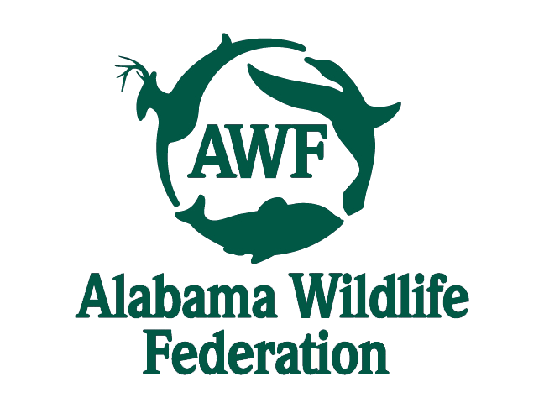
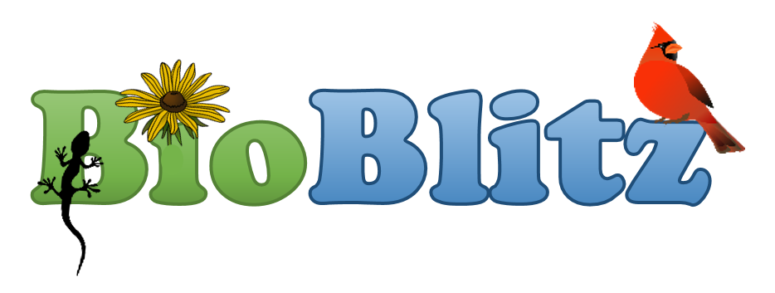
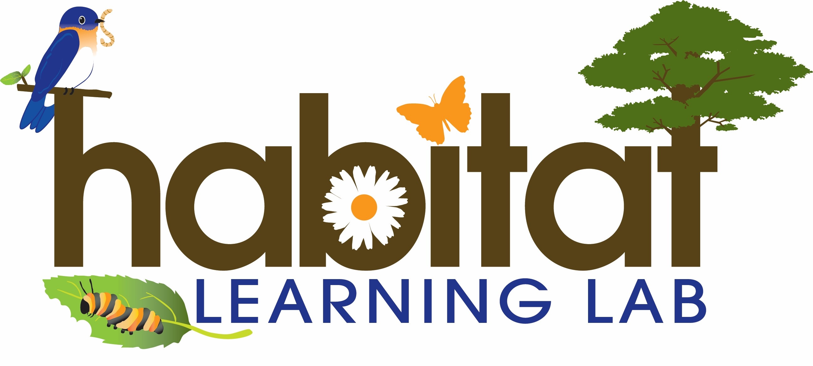

Citizen-Science Excellence Award

National Geographic Society, Alabama Wildlife Federation, Alabama Cooperative Extension System and <Name of School>
present this award honoring your participation in the
Alabama Outdoor Classroom BioBlitz Challenge

(Participant Name)

On this <date>.

Teacher Signature: ________________________________________
