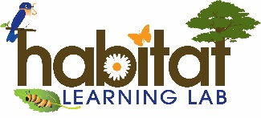
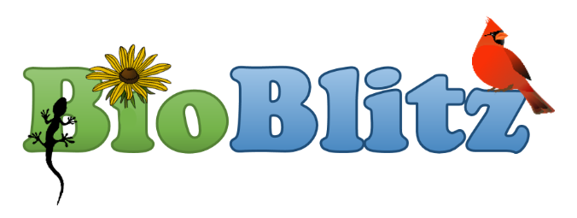
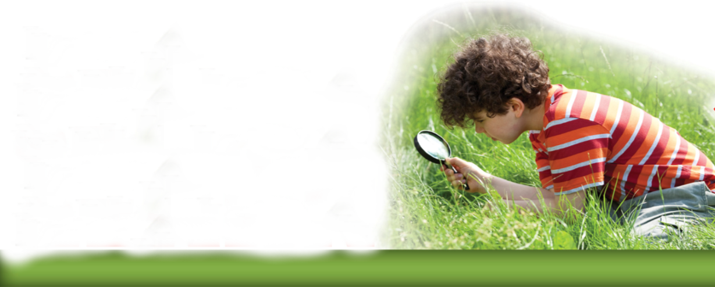

Who?
Your class, your student club or your whole school can participate.

What?
A BioBlitz is a
Biodiversity Treasure Hunt!

Where?
Explore your Habitat Lab and school grounds to find local flora and fauna that use your campus as their habitat.

When?
Hold your BioBlitz during the spring or fall when wildlife is still active and plants still have leaves.

Why?
A BioBlitz is a fun, interdisciplinary, engaging, hands-on activity that gets students outdoors!

Hold a BioBlitz at your School!
What is the Habitat Lab BioBlitz?
An opportunity for schools with habitat labs used as outdoor classrooms to participate in a BioBlitz in which students, teachers, parents and community volunteers work together to find, identify and report the flora and fauna species on your school grounds.
How can your school participate?
Contact your local Habitat Lab Consultant…
- to receive free assistance on the day of the event
- to receive free organizational support to help you plan your event (for active Habitat Lab Members only).
Habitat Lab BioBlitz Participation Benefits
- Students will learn about the classification and taxonomy of plant and wildlife species native to Alabama.
- Students will become Citizen Scientists as they use technology and non-fiction field guides to record, identify, and report their data.
- You will have a biological inventory of the flora and fauna found on your campus that you can update anytime in the future to monitor the biodiversity of your campus.

For more Information
Questions?
April Waltz
aprilwaltz@alabamawildlife.org
Tyler Burgener
tburgener@alabamawildlife.org
Allison Mathis
amathisr@alabamawildlife.org
Avy Elmore
aelmore@alabamawildlife.org

For more information and free resources to help your school hold a BioBlitz on your campus, visit the AWF’s website at https://www.alabamawildlife.org/habitat-lab-bioblitz/.

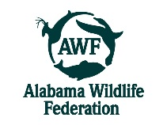
The Habitat Learning Lab Program is provided by the Alabama Wildlife Federation

