
Suggested
Supplies

Suggested BioBlitz Supplies
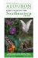 | National Audubon Society Regional Field Guide to the Southeastern States  ISBN-10: 0679446834  ISBN-13: 978-0679446835 | 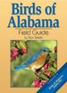 | Birds of Alabama  ISBN-10: 1591931517  ISBN-13: 978-1591931515
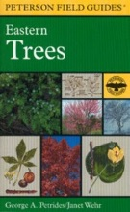 | Peterson’s A Field Guide to Eastern Trees  ISBN-10: 0395904552  ISBN-13: 978-0395904558 | 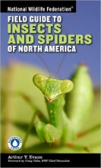 | National Wildlife Federation  Field Guide to Insects and Spiders & Related Species of North America  ISBN-13:9781402741531
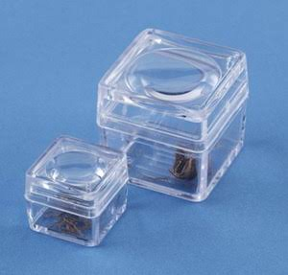 | Magnifying Specimen Boxes |  | Specimen Collection Tubes
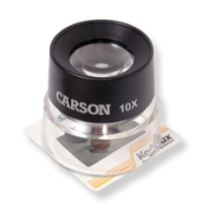 | Magnifying Loupes |  | Magnifying Glasses
 | Digital cameras or  tablets with cameras | 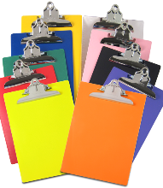 | Clipboards
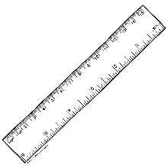 | Measuring sticks |  | Ziploc Bags  (for collecting leaves  or other specimens)

