Name: | _______________________________________________________________  -----------------------------------------------------------------  _______________________________________________________________

Seasonal Weather Observations

Go outside and observe the weather. Record your observations below.
Optional: Record your weather observations at the same time of day on five different days. Then compare your data using the “Weather Observations Chart” on page 2.
Date: | ________________________________________________________________________________________  ------------------------------------------------------------------------------------------  ________________________________________________________________________________________
August September October November December January February March April May
1 2 3 4 5 6 7 8 9 10 11 12 13 14 15 16 17 18 19 20 21 22 23 24 25 26 27 28 29 30 31
Day of the Week:  (Circle the answer) | Monday Tuesday Wednesday Thursday Friday

Time of Day: | _______________________  -----------------------  _______________________ |  | - Morning |  |   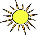 |  | - Afternoon |  | 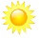  
Which season is it? |  |   spring |  |   summer |  | 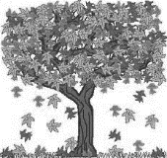  fall |  | 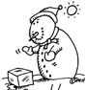  winter

What is the weather like? |  | - Sunny  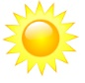  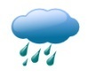  - Raining |  | 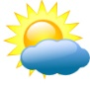  - Partly Cloudy  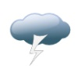  - Thunder & Lightning |  |  |   - Cloudy  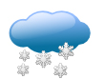  - Snow
What is the temperature? | ______________________  ----------------------  ______________________ |  | 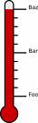  - Hot |  | - Warm | - Cool |  | - Cold

Write sentences to describe the weather using adjectives and correct punctuation.
___________________________________________________________________
___________________________________________________________________
___________________________________________________________________


Alabama Wildlife Federation Outdoor Classroom Activity Sheet: What Living Things Need to Survive (Kindergarten), page 1 of 1

Weather Observations Chart
Name: | _______________________________________________________________  -----------------------------------------------------------------  _______________________________________________________________

Log your weather data into the graph below to create a bar graph.
Temperature

90*F _______________________________________________________________

80*F _______________________________________________________________

70*F _______________________________________________________________

60*F _______________________________________________________________

50*F _______________________________________________________________

40*F _______________________________________________________________

30*F _______________________________________________________________

20*F

10*F

Observation: DAY #1 DAY #2 DAY #3 DAY #4 DAY #5
Date: _________ _________ _________ _________ _________
Which day had the highest temperature?_____________________
Which day had the lowest temperature?______________________

