
Identifying Spheres of Earth
Name:_______________________ Date:_____________
Look for examples of the geosphere, biosphere, atmosphere and hydrosphere as you observe your environment in the habitat lab.
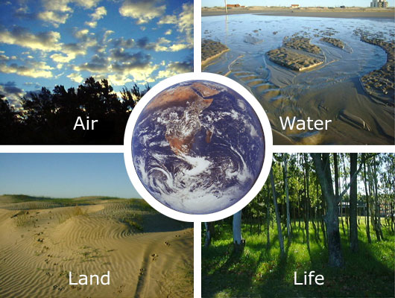
Helpful Hints:
Atmosphere – the envelope of gases (or air) surrounding the earth.
Hydrosphere – all of the water surrounding the earth including on land and in the air.
Biosphere – all of the living organisms on earth and their environments.
Geosphere (also called Lithosphere) – the solid part of the earth consisting of rock, dust, soil, and related material.
Now draw a picture of your habitat lab below including at least one example of each “sphere”.
What represents the geosphere?
_________________________
_________________________
What represents the atmosphere?
_________________________
_________________________
What represents the hydrosphere?
_________________________
_________________________
What represents the biosphere? _________________________________
________________________________________________________

