
Evidence of the Carbon Cycle
Name:______________________ Date:____________
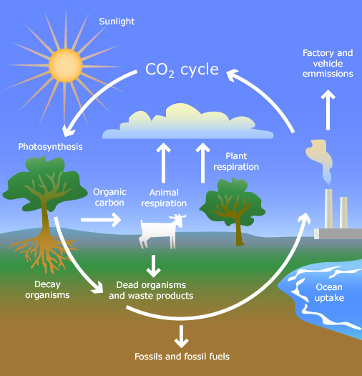
Carbon is an element found in the oceans, air, rocks, soil and all living organisms (including humans).

Almost 99% of the mass of the human body is made up of six elements: oxygen, carbon, hydrogen, nitrogen, calcium, and phosphorus. 18% of our body mass is carbon.

Carbon is the fundamental building block of life and an important component of many chemical processes.

Helpful Vocabulary:
Respiration – the act of inhaling and exhaling air.
Decomposition – the process in which a substance rots or is broken down into basic components.
Biosphere – all of the living organisms on earth and their environments.
Atmosphere – the envelope of gases (or air) surrounding the earth.
Hydrosphere – all of the water surrounding the earth including on land and in the air.
Geosphere – all of the rock and soil that make up the solid earth.
***************************************************************************************
Visit your habitat lab. Look for evidence of the Carbon Cycle.
1. List an example of the carbon cycle that you can find in the biosphere in the habitat lab area:
__________________________________________________________
__________________________________________________________
2. List an example of the carbon cycle that you can find in the atmosphere in the habitat lab area:
__________________________________________________________
__________________________________________________________
3. List an example of the carbon cycle that you can find in the hydrosphere in the habitat lab area:
__________________________________________________________
__________________________________________________________
4. List an example of the carbon cycle that you can find in the geosphere in the habitat lab area:
__________________________________________________________
__________________________________________________________
5. Draw a picture of the Carbon Cycle that exists in your habitat lab and label it in the box below using this word bank:
Assimilation Atmosphere Biosphere Carbon Dioxide
Decomposition Geosphere Hydrosphere Respiration

