
Using your Senses
Explore your habitat lab and document your findings.
Name: | __________________________________________________________________  -------------------------------------------------------------------  __________________________________________________________________


What do you notice first when you walked into the habitat lab area?

Draw a picture of it


Sit quietly.
What do you see?

Draw a picture what you see

Sit quietly.
Close your eyes.
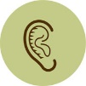
What do you hear?

Draw a picture of what you hear


What do you feel (on the ground, in the air, etc.)?

Draw a picture of what you feel

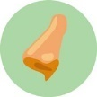
What do you smell?

Draw a picture of what you smell

