
Create a Food Web

Name:______________________________ Date: _________________
When you look at how several food chains overlap, you are describing a “Food Web”. The organisms in a food chain are going to be producers, herbivores, carnivores, omnivores or decomposers. Circle all producers with a green pencil, herbivores with a blue pencil, carnivores with a brown pencil, omnivores with a purple pencil and decomposers with a black pencil. Using the organisms in the diagram below, draw arrows to create several food chains (use a different color of colored pencil for each food chain) and then try to use each organism in more than one food chain to create a food web.
Sun

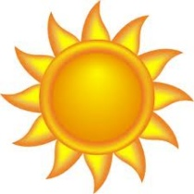

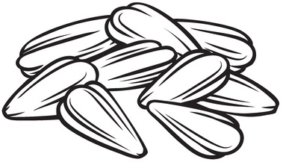
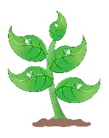

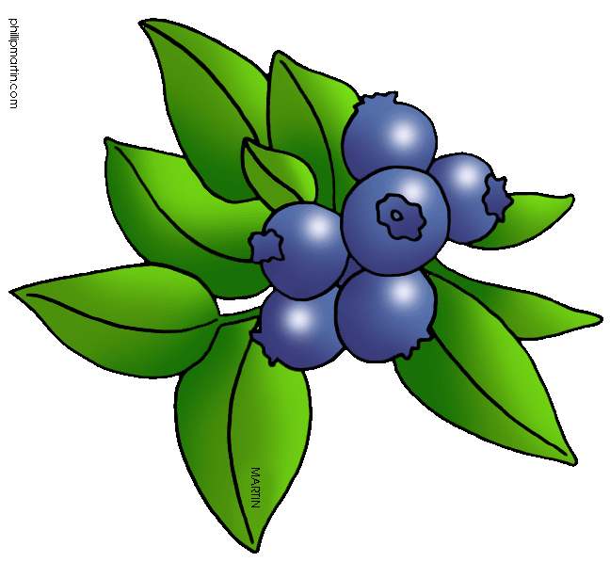
Seeds

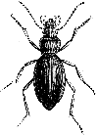
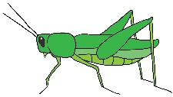
Leaves

Berries

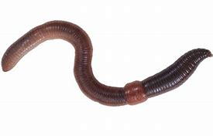
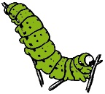
Grasshopper

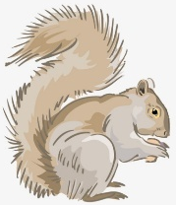
Ground Beetle
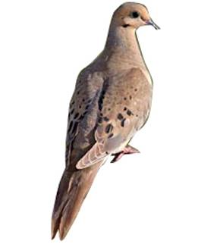
Earthworm
Caterpillar

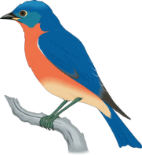

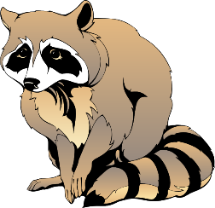
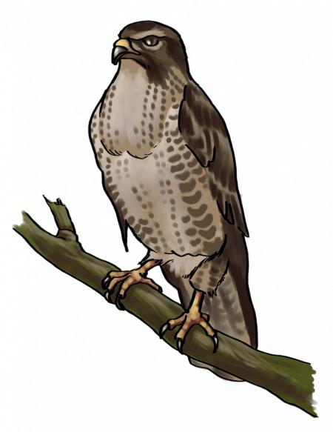
Gray Squirrel
Eastern Bluebird
Mourning Dove

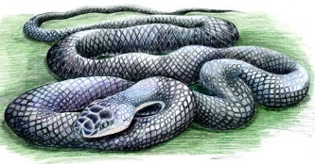
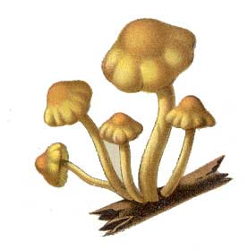
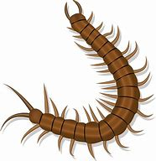
Rat Snake
Raccoon
Cooper’s Hawk
Fungi
Centipede

Use the diagram of the Food Web (on page 1) to answer the following questions.
1. What is the original source of all energy that moves through the food chains and food web?_________________
2. How do the producers produce energy?________________________________________________________
_______________________________________________________________________________________
3. List the producers in the food web: __________________________________________________________
_______________________________________________________________________________________
4. List the herbivores in the food web: __________________________________________________________
_______________________________________________________________________________________
5. List the carnivores in the food web:__________________________________________________________
_______________________________________________________________________________________
6. List the omnivores in the food web:___________________________________________________________
_______________________________________________________________________________________
7. List the apex predator(s) in the food web:______________________________________________________
_______________________________________________________________________________________
8. List the decomposers in the food web:_________________________________________________________
_______________________________________________________________________________________
9. What is the role of the decomposers in a food chain or food web?____________________________________
_______________________________________________________________________________________

