
Create a Food Web
Name:______________________________ Date: _________________
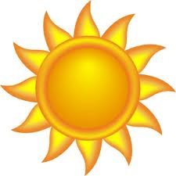
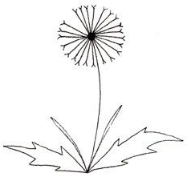
Explore your habitat lab, and then create a Food Web that includes plant(s) and animal(s) that you found (or could find) in your habitat lab. Use the Example Food Web Components chart (on page 3) and the diet information on the Alabama Wildlife Federation’s Dig into Plants and Wonders of Wildlife webpages to help you complete your Food Web.
1. Draw a picture of each plant and animal in your Food Web in each circle.
2. Identify the plant or animal species inside each circle by name.
- Draw arrows from the plant or animal that is eaten to the animal(s) that might eat it to show the flow of energy from the sun through the producer(s), consumer(s), and apex predator(s) to the decomposer(s).
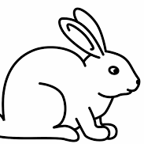
dandelion

rabbit

________________
________________
________________

________________
________________
________________

Use the diagram of your Food Web (on page 1) to answer the following questions.
4. List the producer(s) in your food web:_________________________________________________________
5. List the consumer(s) in your food web:_________________________________________________________
_______________________________________________________________________________________
6. List the apex predator(s) in your food web:_____________________________________________________
7. List the decomposer(s) in your food web:_______________________________________________________
8. What would happen if all of the plants in the habitat lab disappeared? ___________________________
_______________________________________________________________________________________
9. What would happen if all of the apex predators in the habitat lab disappeared?_____________________
_______________________________________________________________________________________
10. What role do decomposers play in an ecosystem’s food web? _______________________________________
_______________________________________________________________________________________
11. Where does ALL of the energy that moves through the food webs in ALL ecosystems originate?_____________
12. What does your food web diagram for your habitat lab (on page 1) represent?_____________________
_______________________________________________________________________________________
_______________________________________________________________________________________

EXAMPLE FOOD WEB COMPONENTS
(A component is one part or element of the larger whole.)
Plants  (Producers) | Herbivores  (Primary Consumers) | Omnivores  (Secondary/Tertiary Consumers) | Carnivores  (Secondary/Tertiary Consumers) | Detritivores & Fungus  (Decomposers)
Grasses | Armyworms | Ants | Spiders | Mushrooms
Wildflowers | Caterpillars | Wasps | Fleas | Worms
Herbs | Butterflies | Lady Bugs | Ticks | Spiders
Shrubs | Bees | Crickets | Bats | Ants
Trees | Moths | Mosquitos | Snakes | Flies
Nuts | Grasshoppers | Songbirds | *Alligators | Beetles
Berries | Treehoppers | Squirrels & Chipmunks | *Some Fish | Millipedes
Acorns | Leafhoppers | Opossums | *Owls | Pill Bugs/Roly Polies
Pinecones | Katydids | Racoons | *Bobcats | Cockroaches
Seeds | Deer | Skunks | *Hawks | Snails
Fruits | Beavers | Frogs & Toads |  | Slugs
Aquatic plants | Rabbits | Salamanders
Algae | Some Fish | Turtles
 |  | Lizards
 |  | *Foxes (Red and Gray)
 |  | *Coyotes
 |  | *Black Bears |  | *Apex Predators

