
Parts of a Plant
Inside, Outside, Over & Below
Name:__________________________
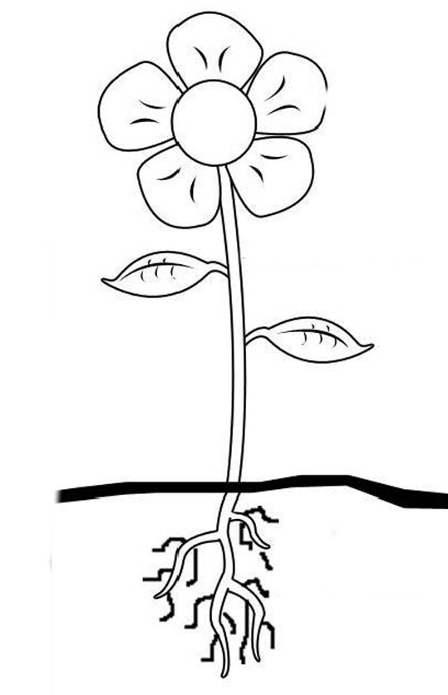

inside

- The _______________ make food for the plant by using sunlight. They take in carbon dioxide and release oxygen into the air.
- The _______________ supports the plant. It contains thin tubes for carrying nutrients (food) and water.
- The _______________ soak up water and nutrients from the soil. They also store food for the plant.
- _______________ helps transport water and nutrients from the roots up to the other parts of the plant.
- The _______________ helps transport sugars and other nutrients from the leaves downward into the rest of the plant.
- The _______________ makes the seeds for new plants to grow.
Word Bank: flower leaves phloem roots stem xylem

