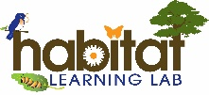
Wildlife Habitat CHECKLIST
Caution – Be careful not to harm any wildlife or their habitats.
Your Name: | __________________________________________________________________  -------------------------------------------------------------------  __________________________________________________________________

Look for an animal in the habitat lab. List the animal’s name. |  | __________________________________________  -------------------------------------------  __________________________________________
Habitat is the natural home of a wild animal. What habitat does this wildlife need to survive including food, water, shelter and a place to raise its young? Explore your habitat lab…
Use the National Audubon Society Guide to the Southeast or the internet to help you identify the animal’s habitat needs.
Draw a picture of its  food source.  (like nuts, berries, leaves, insects, etc)  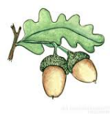  What is its food source?  __________________________________________  -------------------------------------------  __________________________________________  Does the habitat lab have it? | Draw a picture of its  water source.  (like a bird bath, dew on grass, etc)  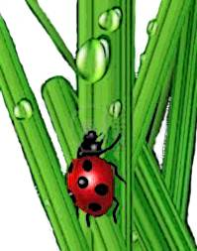  What is its water source?  __________________________________________  -------------------------------------------  __________________________________________  Does the habitat lab have it?
  - yes | - no
  - yes | - no
Draw a picture of its shelter.  (like a bird house, a bush or pond plants)  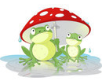  What is its shelter?  __________________________________________  -------------------------------------------  __________________________________________  Does the habitat lab have it? | Draw a picture of where it could raise its young.  (like a bird’s nest, ant hill, or pond)  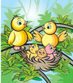  Where does it raise its young?  __________________________________________  -------------------------------------------  __________________________________________  Does the habitat lab have it?
  - yes | - no
  - yes | - no

Draw a picture of the animal you found in its habitat (or home).

