
Birds & Their Adaptations

Name:______________________ Date:____________

Use the Alabama Wildlife Federation’s Wonders of Wildlife Webpages to research and answer questions about one of the bird species listed below. Circle the name of the bird you select.
Eastern Bluebird Northern Cardinal
Northern Mockingbird Red-bellied Woodpecker

1. Draw a picture of the bird.
2. Describe the colors of its feathers:
Head:_________________________
Neck:_________________________
Chest:________________________
Belly:_________________________
Back:_________________________
Wings:________________________
Tail:__________________________
3. How do the colors of their feathers help them survive and reproduce?
________________________________________________________________
4. Describe how birds’ bones help them survive:
________________________________________________________________

5. Which of these describes its beak?
__short & thin | __thick & pointed | __cone-shaped | __long & thin | __wide & flat | __large & hooked
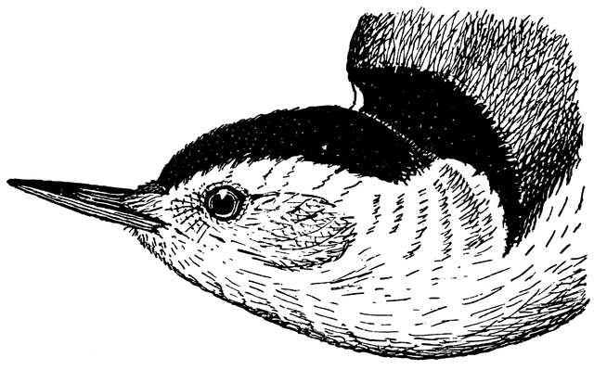 | 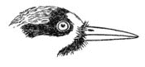 | 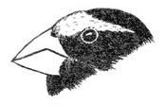 | 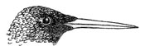 | 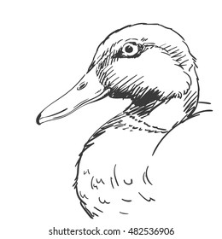 | 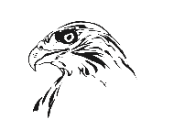
6. How does its beak help it survive?
_____________________________________________________________________
_____________________________________________________________________
7. What is a gizzard? Describe how birds’ gizzards help them survive:
_____________________________________________________________________
_____________________________________________________________________
8. Which of the following describes its feet?
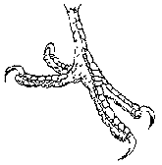  - two toes forward & two toes back (woodpecker) | 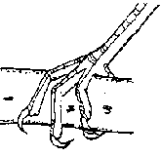  - three toes forward & one toe back (songbird) | 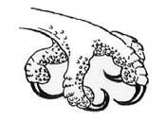  - large toes with claws (raptor) | 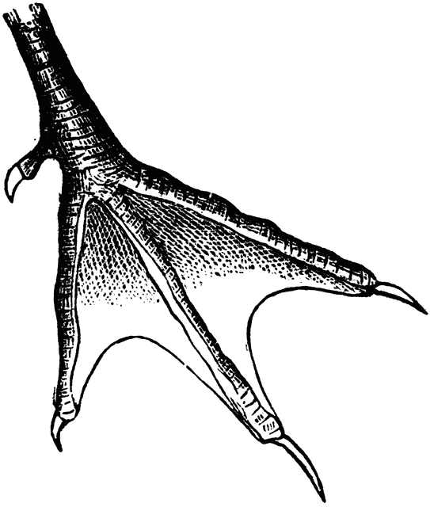  - webbed feet (duck)

9. How do its feet help it survive?
_____________________________________________________________________
_____________________________________________________________________
10. List this species’ other adaptations (other than its feather colors, bones, beaks, gizzards, feet) and provide evidence how these adaptations help it survive and reproduce in its habitat:
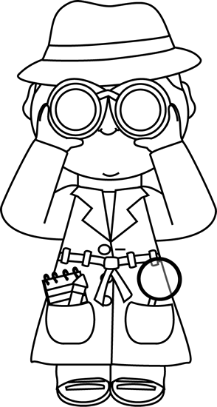
_____________________________________________________________________
_____________________________________________________________________
________________________________________________________________
Explore the habitat lab and look for the bird you selected.
Did you find the bird species you selected? Yes ___ No ___
If yes, where did you find it? _____________________________________________
Describe any other birds that you see. _____________________________________
_____________________________________________________________________
_____________________________________________________________________

Birds and Their Adaptations
Adaptations are those features that help an organism survive in a specific ecosystem. Using the chart below, study birds’ adaptations and then identify these same features in the bird species found in your school’s habitat lab and schoolyard wildlife habitat.
Example Adaptations of Common Backyard Birds
Adaptation | Type of Bird | Advantage
Feathers
Bright plumage  Dull plumage  Change of plumage with seasons | Some male birds  Some female birds  Goldfinch | Attracts females during courtship and mating  Aids in camouflage while nesting  Dull plumage provides camouflage in winter and bright yellow plumage attracts mate in spring & summer
Beaks
Thick & Pointed  Large & Hooked  Short & Cone-shaped  Long & Slender  Short & Pointed  Flat & Wide | Woodpecker  Hawk / Owl  Finch  Hummingbird  Nuthatch  Flycatcher | Breaks and probes the bark of trees looking for insects  Tears flesh of prey that it eats  Cracks seeds and nuts for food  Probes flowers for nectar it eats  Works like tweezers to grab insects hidding in bark  Helps catch insects in air during flight
Wings
Fringed at tips  Large & Broad  Tapered  Short, blunt | Owl  Hawk  Flycatcher/Swallow  Chick-a-dee | Silent flight  Aids in soaring while hunting & flying with caught prey  Fast flight to catch insects and to escape predators  Eratic flight, quick maneuver to escape by zig-zagging
Feet
Webbed  Claws  Three toes forward & one behind  Two toes forward & two behind | Duck  Hawk / Owl  Cardinal  Woodpecker | Aids in swimming  Grasping when hunting prey  Perching on branches  Holding on to side of trees and climbing side of trees

