
Search for Living & Non-living Things
Name: | __________________________________________________________________________  ---------------------------------------------------------  __________________________________________________________________________

Draw and identify three living things in your habitat lab.
Example Living Thing  tree | 1  _________________________________  ---------------------------  _________________________________
2  _________________________________  ---------------------------  _________________________________ | 3  _________________________________  ---------------------------  _________________________________
Draw and identify three non-living things in the habitat lab.

Example Non-Living Thing  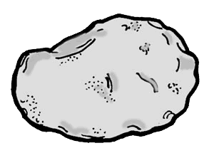  rock | 1  _________________________________  ---------------------------  _________________________________
2  _________________________________  ---------------------------  _________________________________ | 3  _________________________________  ---------------------------  _________________________________

