
Outdoor Learning Station Project Plan:
Materials Budget and Construction Instructions for
Butterfly-shaped Garden
A Butterfly Habitat should provide food, water, and shelter for a wide variety of butterflies and their larvae (or caterpillars). Butterflies will most often search flowering wildflowers, bushes, and trees for their main food source (nectar) using their tube-like “tongues” called a proboscis. However, some species will acquire the minerals and nutrients that they need by probing the ground around decomposing plants or animals or around animal excrement with their proboscises. Nectar, shallow puddles, and drops of rain or dew provide the water that butterflies need to survive. Different species of butterflies only lay their eggs on specific species of plants (referred to as “host plants”) and the caterpillars will only eat these plants before creating a chrysalis to go through metamorphosis into an adult butterfly. Butterflies typically take refuge from inclement weather or predators in bushes or trees.
- Habitat Requirements:
- Native “host plants” that caterpillars eat
- Puddling stations for butterflies that prefer to get their nutrition from excrement covered in sand
- Bushes and trees for cover from inclement weather and predators
- Dark colored stones where butterflies can warm their bodies
- Full sun for 6-8 hours per day for optimal plant growth
- Optional: Native nectar plants for adult butterflies. If you have a pollinator garden, it will provide the native flowering wildflowers that produce nectar.

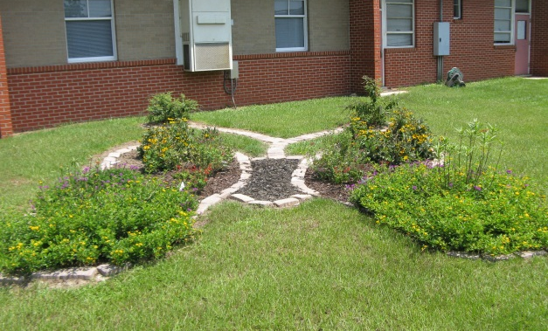
- Example Butterfly-shaped Garden Pictures & Educational Sign:
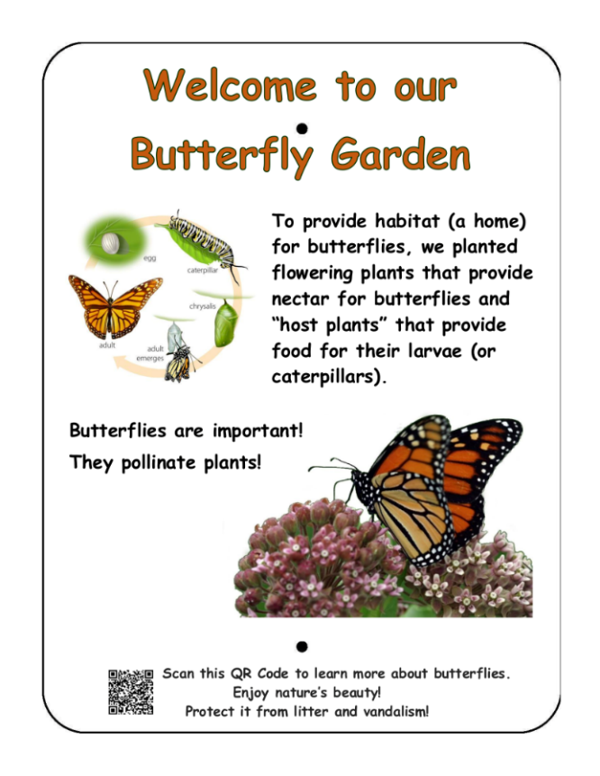

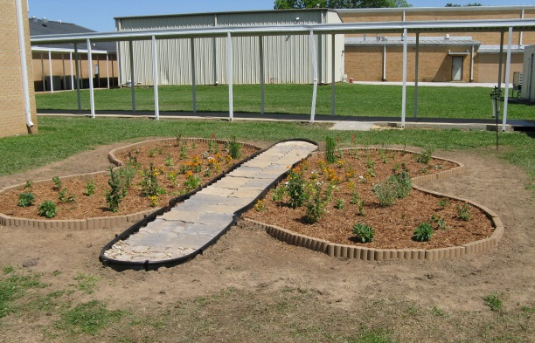

Project Plan for Butterfly-shaped Garden

- Materials List with Estimated Budget:
*Listed prices are as of December 2024. They are subject to change.
Example Butterfly-shaped Garden
4 individual “wing gardens” (~35 CF planting space total) with mulch “body bed” in between them. Notes made in budget for how to modify if you will use a sidewalk as your “body”.
Station | Materials & Supplies | Estimated Cost | Example Source | Final Cost
Required Butterfly Garden Materials, Signage & Plants
Bttrfly-shaped Garden | (1) Can of Rust-Oleum Professional White Water-based Marking Paint @ ~$10.98 ea | $10 | Lowe’s Item# 429750
Bttrfly-shaped Garden | (160) 11-in L x 4-in H x 6-in D Flagstone Concrete Retaining Wall Blocks (trapezoid-shaped to create rounded parts of wings) @ ~$2.98 ea | $475 total | Lowe’s Item# 477095
Bttrfly-shaped Garden | (10) Belgard Overlay Paver 7.75-in L x 3.88-in W x 1.18-in H River Street Concrete Paver (for antennae) @~$0.58 ea | $5 total | Lowe’s Item# 3276557
Bttrfly-shaped Garden | (1) 6’x50’ Sta-Green Professional Landscape Fabric (weed barrier) @ ~$33.98 ea | $35 | Lowe’s Item# 510606
Bttrfly-shape Garden | (8) 32-Quart (1CF) Bags of Evergreen Organic Potting Soil Mix @~$6.38 ea | $50 total | Lowe’s Item# 380608
Bttrfly-shaped Garden | (14) 1 CF/32 Qt Bags of Evergreen Organic Top Soil (for garden) @ ~$2.18 ea | $30 total | Lowe’s Item# 648834
Bttrfly-shaped Garden | (3) 1 CF Bags of Evergreen Organic Compost and Manure (for garden) @~$3.68 ea | $10 total | Lowe’s Item# 757958
Bttrfly-shaped Garden | (5) 2 CF Bag of Evergreen Organic Drainage and Aeration Soil Conditioner (for garden) @ ~$4.58 ea | $25 total | Lowe’s Item# 648829
Bttrfly-shaped Garden | (2) 2 CF Bags of Evergreen Natural Dark Brown Pine Bark Mulch (for garden) @~$3.48 ea **do NOT get black mulch as it gets hot and kills plants** | $5 total | Lowe’s Item# 92118
Bttrfly-shaped Garden | (1) Package of 40 6” Black Plastic Landscape Edging Pieces (create (2-4) 4 ft dividers) @ ~$21.98 ea | $20 | Lowe’s Item# 379805
Bttrfly-shaped Garden | (1) EasyFlex No-Dig 20-ft Black Plastic Landscape Edging Roll (for rounded ends of butterfly body) *Exclude this if you are using a sidewalk as the body. ~$18.98 ea | $20 | Lowe’s Item# 1501486
Bttrfly-shaped Garden | (2) Premium 2CF Black Hardwood Mulch (for body) *Exclude this if you are using sidewalk as the body. @ ~$3.98 ea | $10 total | Lowe’s Item# 148349

Project Plan for Butterfly-shaped Garden

- Materials List with Estimated Budget (continued):
Bttrfly-shaped Garden | (40) Native Perennial Host Plants (2-4 species)  - 1 species per bed (2 species total)  - 1 species in upper bed and 2 species in lower bed, vice versa (3 species total)  - 2 species per bed (4 species total) | $280 total | Nursery via HLL Specialist
Bttrfly-shaped Garden | (2-4) Plant ID Signs (one for each plant species)  @~$6 ea | $10-25 total | Ask HLL Specialist
Bttrfly-shaped Garden | (2-4) Biomarkers to hold Plant ID signs (13” stake with a 2” x 4” plate) @ ~$3 ea (includes S&H) | $5-15 total | Ask HLL Specialist or https://mcgbiomarkers.com/shop/
Bttrfly-shaped Garden | (1) Gorilla Clear 3.75-fl oz Liquid Extreme Condition Waterproof, Quick Dry, Multipurpose Adhesive @~$9.28 ea (to attach Plant ID signs to stakes) | $10 | Lowe’s Item# 955829
Bttrfly-shaped Garden | (1) 6 ft. U-Post for Fence (for educational sign) @~$10.69 ea | $10 | Lowe’s Item# 493054
Bttrfly-shaped Garden | Educational Sign (for the life cycle of butterflies) | $75 | Ask HLL Specialist
Bttrfly-shaped Garden | (1) Hillman 1/4-in x 1-1/2-in Zinc-Plated Coarse Thread Hex Bolt (2-Count) @~$0.88 ea | $5 total | Lowe’s Item# 137634
Bttrfly-shaped Garden | (2) Hillman 1/4-in x 20 Zinc-Plated Steel Hex Nut @~$0.10 ea | $5 total | Lowe’s Item# 63301
Bttrfly-shaped Garden | (2) Hillman 1/4-in Zinc-plated Standard Flat Washer @~$0.15 ea | $5 total | Lowe’s Item# 63306
Estimated Total Cost for Garden Materials (with signage & plants): $1,075-1,100

Additional *Optional* Butterfly Habitat Materials, Signage & Plants
Bttrfly-shaped Garden | Native Host Trees such as Oaks, Dogwoods, or Tulip Poplars | Depends on quantity | Nursery via HLL Specialist
Bttrfly-shaped Garden | Native Host Bushes such as Spicebushes or Wax Myrtles | Depends on quantity | Nursery via HLL Specialist
Bttrfly-shaped Garden | Native Perennial Nectar Wildflowers for Adult Butterflies (If you have a pollinator garden, it will provide the native flowering wildflowers that produce nectar.) | Depends on quantity | Nursery via HLL Specialist
Bttrfly-shaped Garden | Vining Host Plant – Passionflower (to plant nearby) | Depends on quantity | Nursery via HLL Specialist

Project Plan for Butterfly-shaped Garden

- Materials List with Estimated Budget (continued):
Bttrfly-shaped Garden | (1) Black Steel Garden Trellis (ONLY IF you get passionflower vines to plant nearby) | $15 | Lowe’s Item #397037
Bttrfly-shaped Garden | 1 CF/32 Qt Bags of Evergreen Organic Top Soil (to mix with current soil and other amendments) @~$2.18 each | 1 bag/ bush  2 bags/ tree | Lowe’s Item #648834
Bttrfly-shaped Garden | 1 CF Bags of Evergreen Organic Compost & Manure (to mix with current soil and other amendments) @~$3.68 ea | ¼ bag/ bush  ½ bag/ tree | Lowe’s Item #380606
Bttrfly-shaped Garden | (3) 2 CF Bags of Evergreen Organic Drainage and Aeration Soil Conditioner (for garden) (to mix with current soil and other amendments) @~$4.58 ea | ¼ bag/ bush  ½ bag/ tree | Lowe’s Item #648829
Bttrfly-shaped Garden | 2 CF Bags of Natural Dark Brown Pine Bark Mulch (to place around base after planting) *do NOT get black mulch as it gets hot and kills plants* | 1 bag/ bush  2 bag/ tree | Lowe’s Item# 92118
Bttrfly-shaped Garden | Plant ID Signs (one for each plant species) | Depends on # of add’l plant species selected | Ask AWF Consultant
Bttrfly-shaped Garden | Biomarkers to hold Plant ID signs | Depends on # of add’l plant species selected | Ask AWF Consultant or https://mcgbiomarkers.com/shop/
Bttrfly-shaped Garden | (2) 12.2-in Terracotta Clay Plant Saucer (to create puddling stations) | $30 total | Lowe’s Item# 94459
Bttrfly-shaped Garden | (1) .5 CF/50 Lb Bag of All-purpose Sand (to create puddling stations) | $5 total | Lowe’s Item# 104898

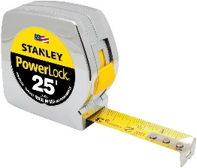
- Construction Tools:
Measuring Tape
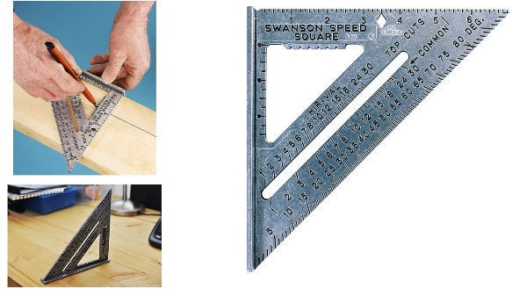
- (1) 20 ft Measuring Tape
- (1) Speed Square for measuring angles
Speed Square
- 24-inch I-beam Level
- (1-2) Wheelbarrows for moving grass clumps, soil & mulch
- (2-3) Sharp, Straight-edged Shovel & (2-3) Round-pointed Shovels
- (24-30) 1-gallon milk jugs (with tops cut off but handles remaining) for students to move excavated dirt, sand, soil, etc.
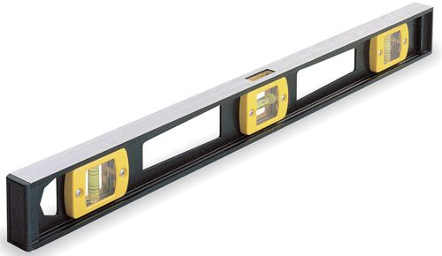
- (4-6) Hand-held Trowels (for stirring soil amendments together)
- Water hose for watering plants at the end of day
I-beam Level
- Twine (at least 160 ft)
- Garden Stakes or Flags

Project Plan for Butterfly-shaped Garden

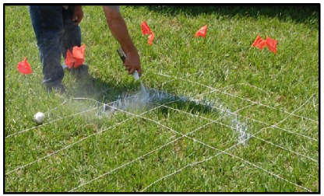
- Construction Instructions:
- Select the area for the butterfly garden, and lay out a 12’x13’ grid using a measuring tape, stakes, and twine. Make each square within the grid equal to one square foot. (12” x 12”).
- Be sure your grid lines are straight and spaced evenly. Use a standard ruler if necessary to confirm that each square is 12”x12”. Check this at two or three spots along the body to ensure that it is the same width at the top, middle, and bottom.
- Once the large grid is laid out on the ground, use a can of marking paint and graph 1 on page 5 to draw the outline of the butterfly over the grid lines (twine) and onto the ground. Note that 1 square on the graph represents one square on your grid. (Remember, you are creating a really big, exact copy of the butterfly drawing.)
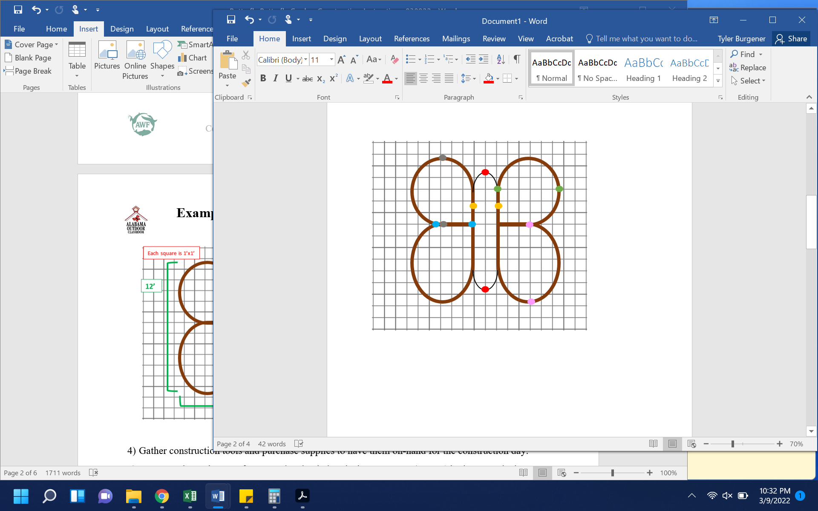
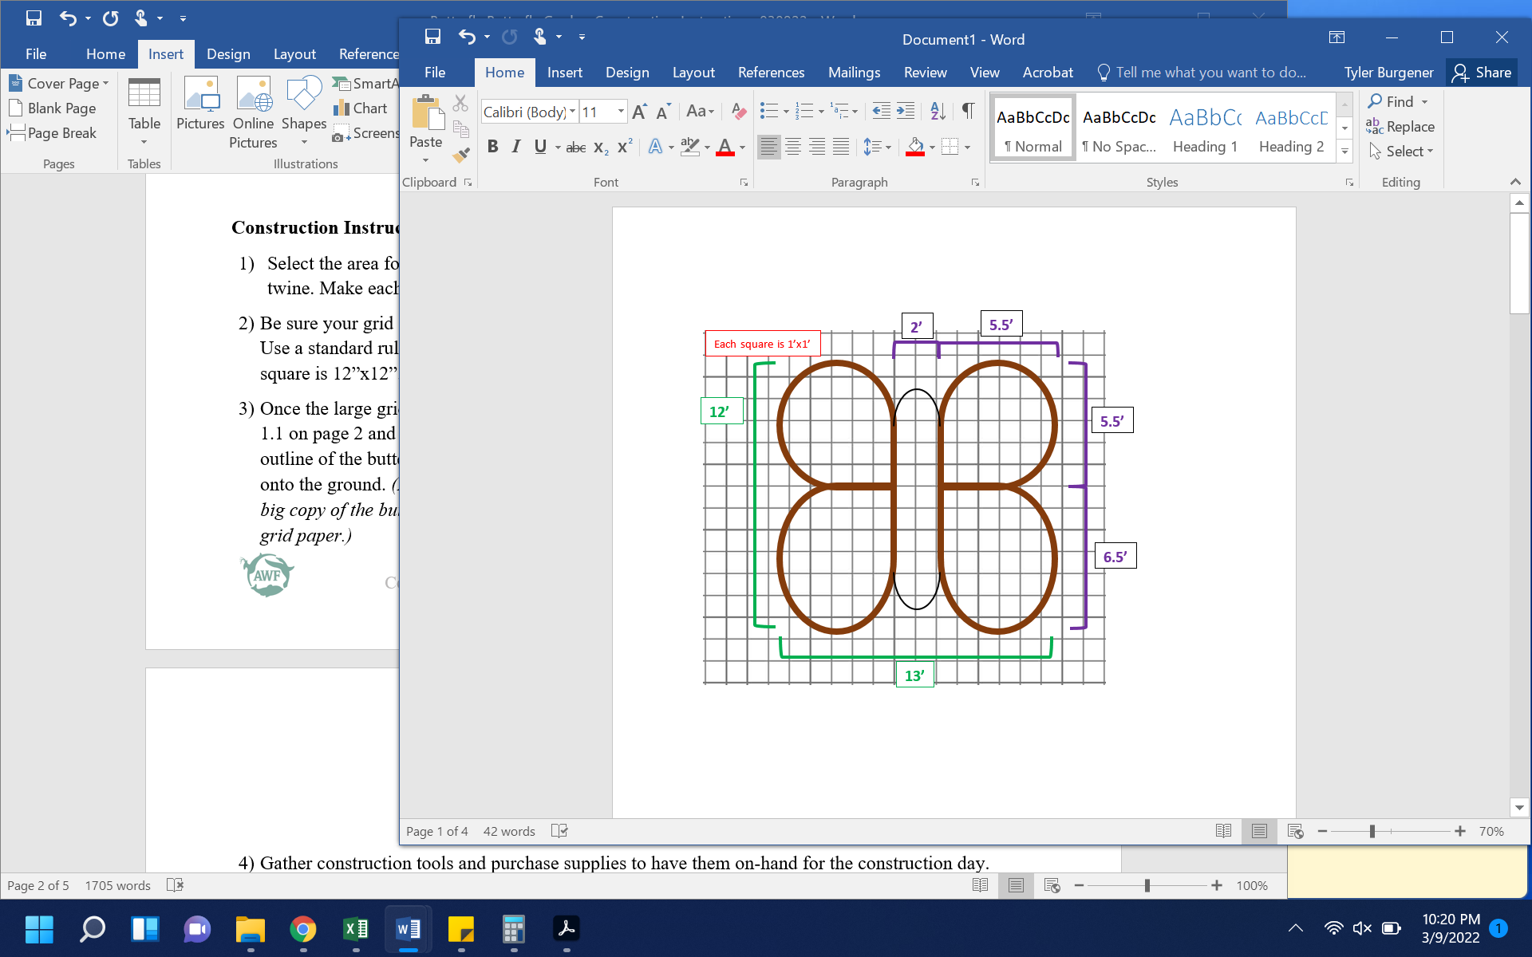
- After drawing the butterfly onto your grid, you need to verify that your measurements are correct using graph 2 on page 5. Confirm that the following measurements are correct.
Graph 1 – Measurements for full butterfly.
Graph 2 – Points for measurement confirmation.
  - Distance between the two red dots is 10’.
  - Distance between the green dots is 5.5’. Should be the same in the same spot on the other top wing.
  - Distance between the yellow dots is 2’.
  - Distance between the blue dots is 3’. Should be the same in the same spot where the other wings join.
  - Distance between the grey dots is 5.5’. Should be the same in the same spot on the other top wing.
  - Distance between the pink dots is 6.5’. Should be the same in the same spot on the other bottom wing.

Project Plan for Butterfly-shaped Garden

- Construction Instructions (continued):
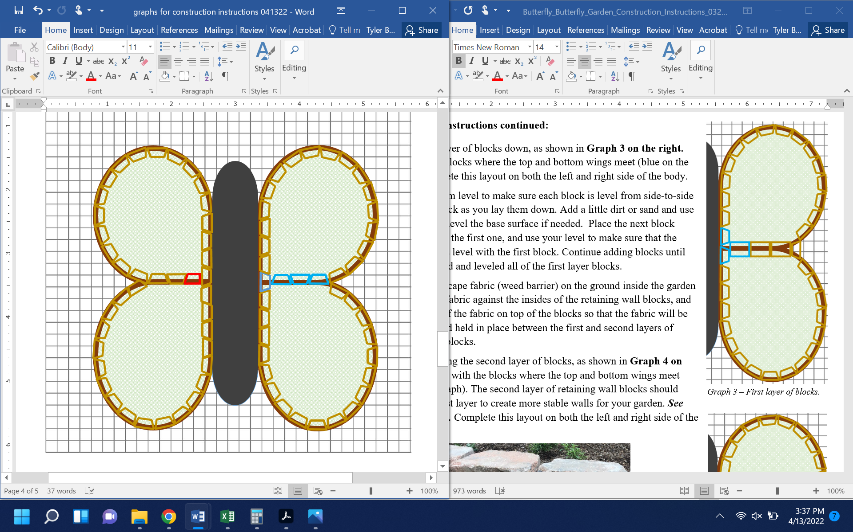
- Once all of your measurements are confirmed accurate, dig and remove the grass in a path that is 1 inch deep and 8 inches wide along the INSIDE of the spray-painted garden perimeter to create a base on which to place the retaining wall blocks. Use your shovel/trowel to create a flat surface for the base to keep the retaining wall blocks level. If the area within your painted butterfly is not level you will want to dig it out as well to level it out.
Graph 3 – First layer of blocks.
- Lay the first layer of blocks down, as shown in Graph 3 on the right. Start with the blocks where the top and bottom wings meet (blue on the graph). Complete this layout on both the left and right side of the body.
- Use your I-beam level to make sure each block is level from side-to-side and front-to-back as you lay them down. Add a little dirt or sand and use your trowel to level the base surface if needed. Place the next block directly next to the first one, and use your level to make sure that the second block is level with the first block. Continue adding blocks until you have placed and leveled all of the first layer blocks.
- Place the landscape fabric (weed barrier) on the ground inside the garden area, push the fabric against the insides of the retaining wall blocks, and lay the edges of the fabric on top of the blocks so that the fabric will be sandwiched and held in place between the first and second layers of retaining wall blocks.
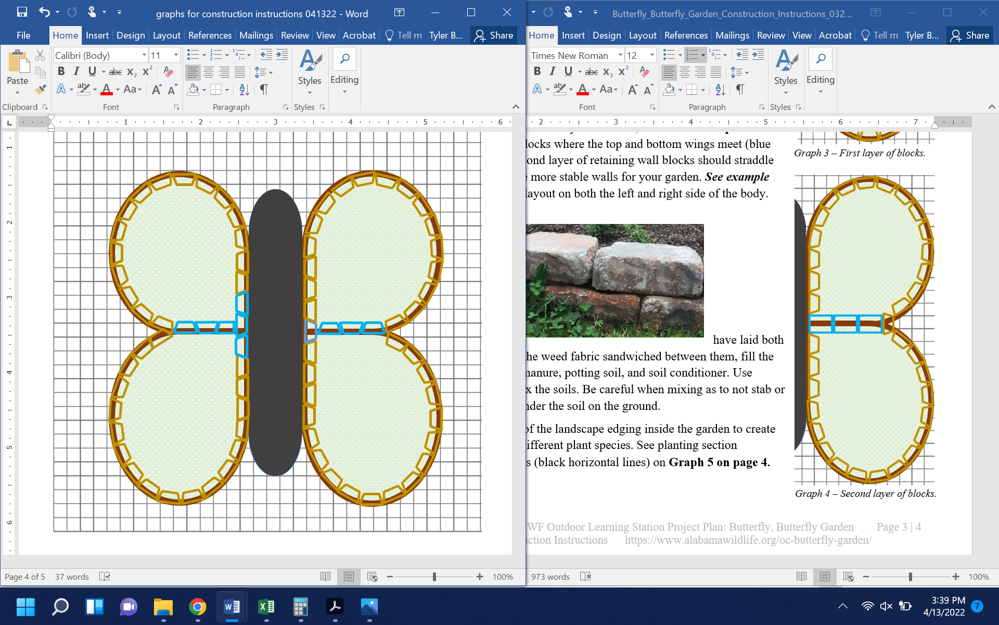
- Next, start laying the second layer of blocks, as shown in Graph 4 on the right. Start with the blocks where the top and bottom wings meet (blue on the graph). The second layer of retaining wall blocks should straddle the first layer to create more stable walls for your garden. See example below. Complete this layout on both the left and right side of the body.
Graph 4 – Second layer of blocks.
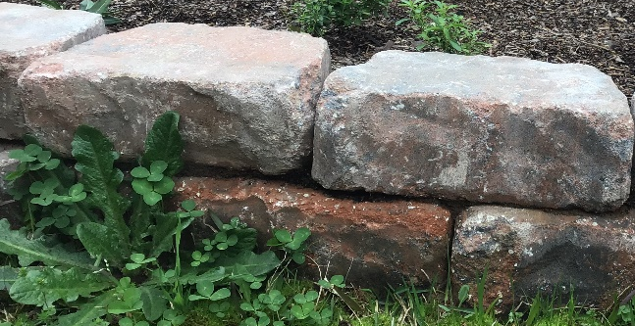

- Once you have laid both layers of blocks with the weed fabric sandwiched between them, fill the garden with top soil, manure, potting soil, and soil conditioner. Use trowels to turn and mix the soils. Be careful when mixing as to not stab or tear the weed fabric under the soil on the ground.

Project Plan for Butterfly-shaped Garden

- Construction Instructions (continued):
- Install dividers made of the landscape edging inside the garden to create planting sections for different plant species. See planting section examples with dividers (black horizontal lines) on Graph 5 below.
- Plant the flowers, grouping each of the different species of plants together within each section. See planting layout options (based on the number of species you have selected) in Graph 5 below.
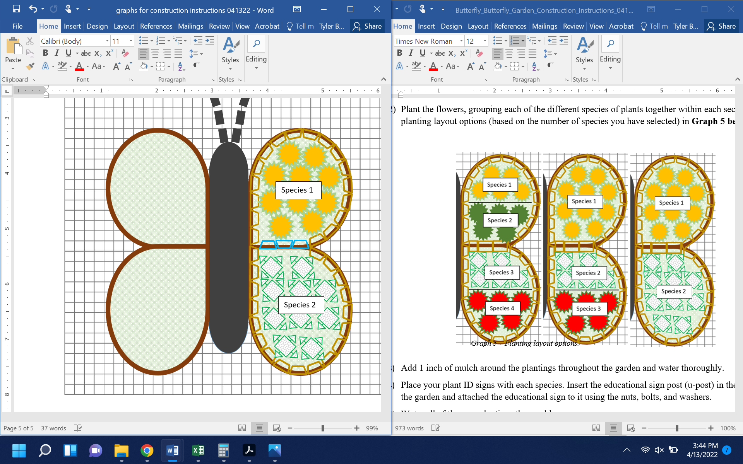
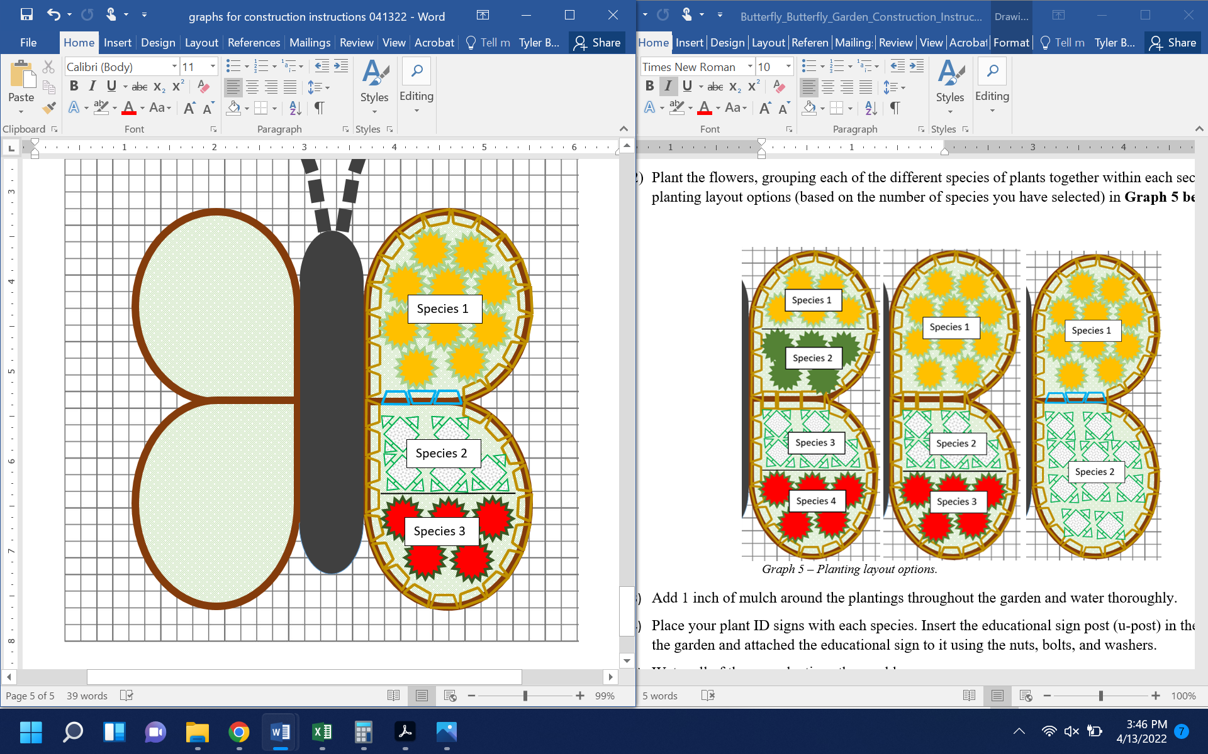
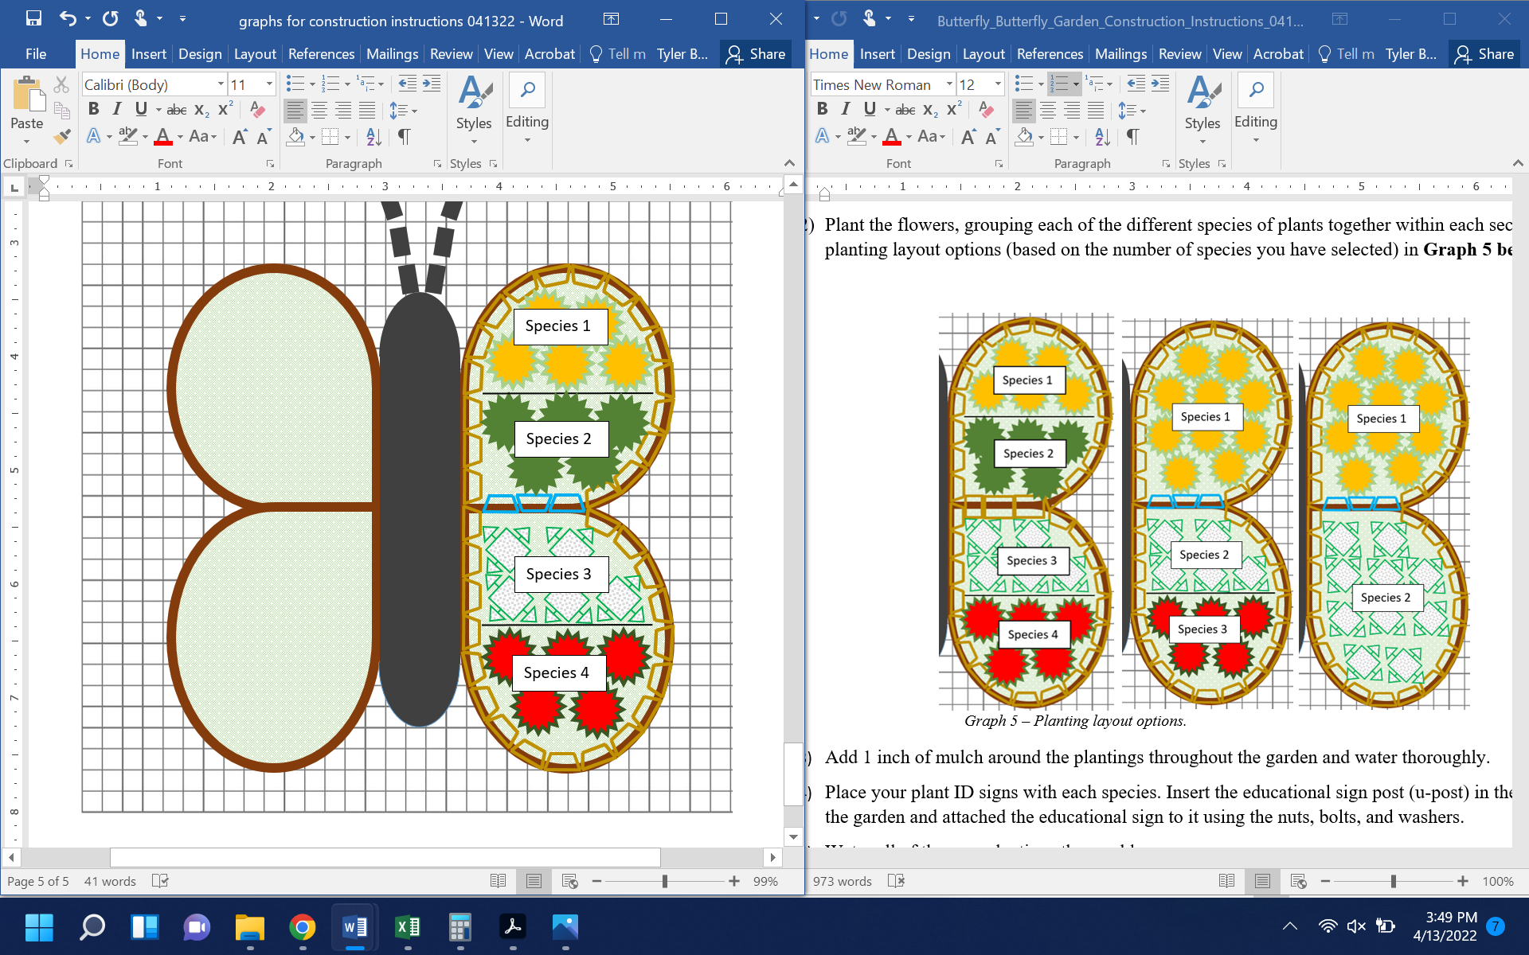
Graph 5 – Planting layout options.

- Add 1 inch of mulch around the plantings throughout the garden and water thoroughly.
- Attach Plant ID signs to stakes using adhesive. Sink the stakes a few inches into the ground in front of the appropriate plant species grouping, tree, or bush.
- Insert the educational sign post (u-post) in the ground near the garden and attached the educational sign to it using the nuts, bolts, and washers.
- Water all of the new plantings thoroughly.

