
Materials Budget for
Cardinal Directions Sign
Example Cardinal Directions Sign
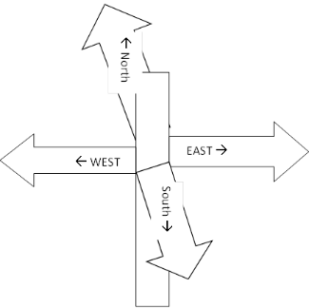
This wooden post has (4) planks attached pointing in four different directions (north, east, south & west) with “North ,” “South ,” “East ,” and “West ” etched onto the planks.
Optional Addition: Add (4) planks pointing in four different directions (north, east, south & west) with “Memphis (225 miles west) ”, “Washington D.C. (750 miles north) ”, “Montgomery (200 miles south) ” and “Atlantic Ocean (600 miles east) ”.
Letters on Sign need to be 4 inches tall to be seen from 40 ft away.
IF YOU CHOOSE A WOODEN SIGN
(1) 4” x 4”x 8’ Treated Post
(1 or 2) 2” x 6” x 12’ Pressure Treated Lumber
Cut (1) into (4) 3 ft planks for cardinal directions only OR Cut (2) into (8) 3 ft planks to include mileage to landmarks
(8-16) 1-in x 1-in x 2.75-in 18-Gauge G90 Galvanized Steel Angle (use two per plank)
(1) Box of (129) 2-in Wood To Wood Deck Screws (129)
(1) 50 lb bag of Fast Setting Concrete Mix
(1) Gallon of Exterior Wood Paint Primer
(1) Gallon Exterior/Outdoor Wood Polyurethane (sealant)
(1) Gallon Exterior Paint (pick a light color for base color)
(1) Quart Exterior Paint (pick a dark color for lettering)
(3) 3” Paint Brush (for painting base)
Small paint brushes (for painting lettering)
Estimated Total Cost: $240-255
IF YOU CHOOSE A METAL SIGN
(1) 4” x 4”x 8’ Treated Wood Post
6” H x 36”W .080 Aluminum Sign with Text on both sides
(4) for North , East , South & West OR (8) to include # of Miles N/E/S/W Landmark Name
(1) Box of (129) 2-in Wood To Wood Deck Screws (129)
(1) 50 lb bag of Fast Setting Concrete Mix
Estimated Total Cost: $265-505

