
Outdoor Learning Station Project Plan:
Materials Budget and Construction Instructions for
Cardinal Directions Sign

A cardinal directions sign includes a wooden post with (4) planks attached pointing in four different directions (north, east, south & west) with “North ,” “South ,” “East ,” and “West ” etched onto the planks. This is a helpful tool for students as they study weather patterns, the movement of the sun through the sky throughout the day and during different times of year, and the amount of sun and shade in the different areas of your Habitat Lab.
Optional Addition: Add (4) planks pointing in four different directions (north, east, south, or west). Then pick out four cities or landmarks that are in those same four different directions from your location, and etch the names of the locations along with the number of miles the locations can be found from your school. For example, if your school is in Huntsville, you could etch the following on the four planks: “Memphis (225 miles west) ”, “Washington D.C. (750 miles north) ”, “Montgomery (200 miles south) ” and “Atlantic Ocean (600 miles east) ”
- Location Suggestions for the Cardinal Directions Sign:
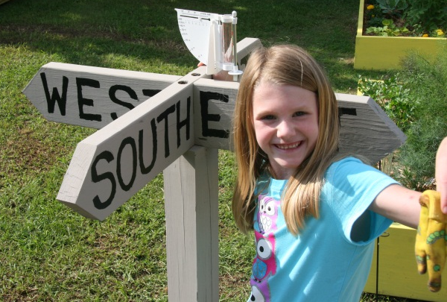
- Next to the Weather Station

- Example Cardinal Directions Signs:

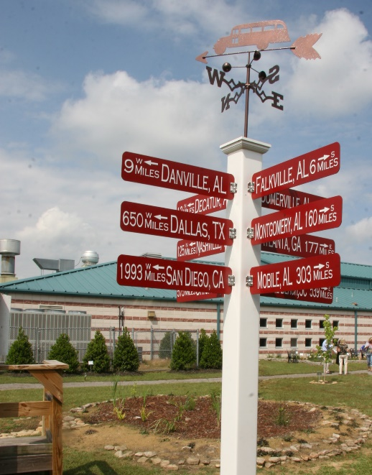
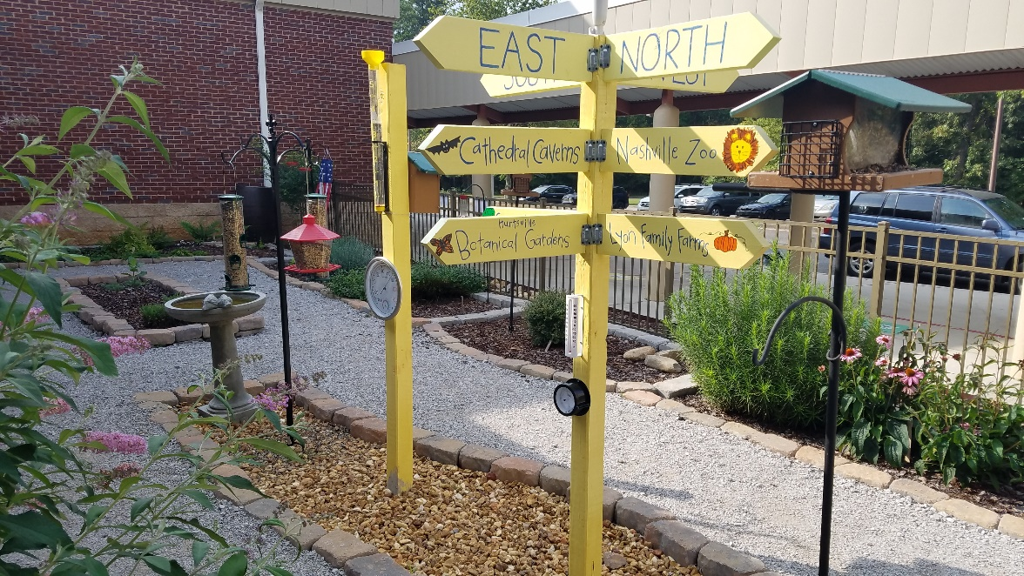
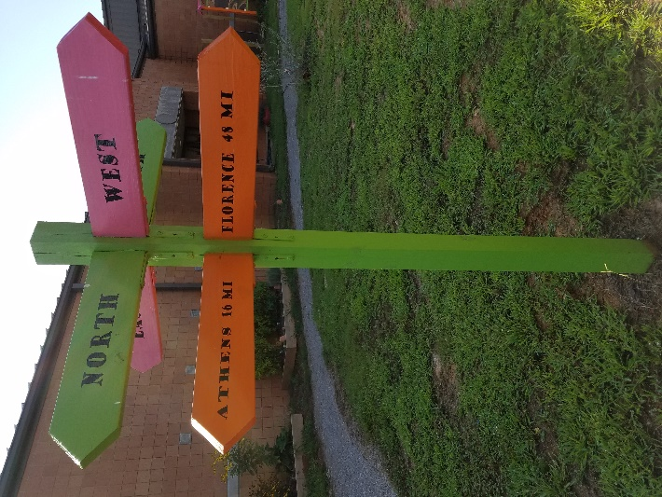

Project Plan for Cardinal Directions Sign

- Estimated Cost:
  - Cardinal Directions Sign w/ 4 wood planks: $240
  - Cardinal Directions Sign w/ 8 wood planks: $255
  - Cardinal Directions Sign w/ 4 metal planks: $265
  - Cardinal Directions Sign w/ 8 metal planks: $505
- Materials List with Estimated Budget:
*Listed prices are as of December 2024. They are subject to change.
Example Cardinal Directions Sign
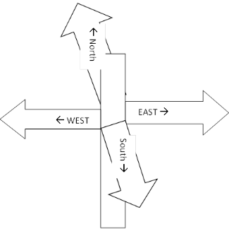
This wooden post has (4) planks attached pointing in four different directions (north, east, south & west) with “North ,” “South ,” “East ,” and “West ” etched onto the planks.
Optional Addition: Add (4) planks pointing in four different directions (north, east, south & west) with “Memphis (225 miles west) ”, “Washington D.C. (750 miles north) ”, “Montgomery (200 miles south) ” and “Atlantic Ocean (600 miles east) ”.
Letters on Sign need to be 4 inches tall to be seen from 40 ft away.
Station | Materials & Supplies | Estimated Cost | Example Source | Final Cost
IF YOU CHOOSE A WOODEN SIGN
Dir.Sign | (1) 4” x 4”x 8’ treated post @ ~$10.78 ea. | $10 | Lowe’s Item #552328
Dir.Sign | (1 or 2) Severe Weather 2” x 6” x 12’ #2 Prime Wood Pressure Treated Lumber @ ~$11.38 ea  Cut (1) into (4) 3 ft planks for cardinal directions only OR Cut (2) into (8) 3 ft planks to include mileage to landmarks | $10-20 total | Lowe’s Item #198476
Dir.Sign | (8-16) 1-in x 1-in x 2.75-in 18-Gauge G90 Galvanized Steel Angle (use two per plank) @ ~$0.72 ea | $10-15 | Lowe’s Item #1944324
Dir.Sign | (1) Box of (129) 2-in Wood To Wood Deck Screws (129) @ ~$9.98 ea | $10 | Lowe’s Item #7900
Dir.Sign | (1) 50 lb bag of Quikrete Fast Setting Concrete Mix  @~$6.71 ea | $5 | Lowe’s Item #10437
Dir.Sign | (1) Gallon of Exterior Wood Paint Primer | $20 | Need to ask Paint Store
Dir.Sign | (1) Gallon Exterior/Outdoor Wood Polyurethane (sealant) | $60 | Need to ask Paint Store
Dir.Sign | (1) Gallon Exterior Paint (pick a light color for base color) | $40 | Need to ask Paint Store
Dir.Sign | (1) Quart Exterior Paint (pick a dark color for lettering) | $25 | Need to ask Paint Store
Dir.Sign | (3) 3” Paint Brush (for painting base) @ ~$13.98 ea | $40 total | Lowe’s Item #1034365
Dir.Sign | Small paint brushes (for painting lettering) @ ~$4.98 ea | $5 | Lowe’s Item #105657
Estimated Total Cost: $225-250

Project Plan for Cardinal Directions Station

- Materials & Supplies with Estimated Budget (continued):
IF YOU CHOOSE A METAL SIGN
Dir.Sign | (1) 4” x 4”x 8’ treated post @ ~$10.78 ea. | $10 | Lowe’s Item #552328
Dir.Sign | 6” H x 36”W .080 Aluminum Sign with Text on both sides @ $60 ea  (4) for North , East , South & West OR  (8) to include # of Miles N/E/S/W Landmark Name | $240-$480 total | Sign Company via HLL Specialist
Dir.Sign | (1) Box of (129) 2-in Wood To Wood Deck Screws (129) @ ~$9.98 ea | $10 | Lowe’s Item #7900
Dir.Sign | (1) 50 lb bag of Quikrete Fast Setting Concrete Mix  @~$6.71 ea | $5 | Lowe’s Item #10437
Estimated Total Cost: $265-505
- Construction Tools:
- (1) Hammer (if you are using nails) or (1) Drill (if you are using screws) to attach planks to 4”x4”
- Shovel to dig hole for 4”x4”
- Bucket & Stick to mix Quikrete & water
- Level to make sure 4”x4” is straight (not leaning)
- Compass or Smart Phone to determine N, S, E & W
- Stencil for writing the words on the planks (optional)
- Paint brush(es) for painting sign
- Construction Instructions for Cardinal Directions Sign
- Purchase supplies and have them on-hand for the Habitat Lab Build Day.
- Dig hole 12-18 inches deep and 6 inches wide where you want to place the 4”x4” post for the sign.
- Cut the 4” x 4” post to the height you want (typically no more than 4-6 ft tall) allowing for 12-18 inches to be underground in the hole.
- Determine which direction is North, South, East & West in your Habitat Lab using a compass. (Some smart phone compasses require you to move the phone in a “figure 8” to help set the magnetic sensors). Then place the 4” x 4” post in the hole, making sure that the planks point to the appropriate direction (N, E, S & W). Also use a Level to make sure that the post is straight, not leaning. Note: If the post begins to lean, then support the 4” x 4” post with string and/or 2” x 4”’s until the Quikrete dries.

Project Plan for Cardinal Directions Station
- Construction Instructions (continued):
- Backfill the hole with dirt or concrete If concrete, mix a portion of the bag of Quikrete with water (per the directions on the bag) in a bucket, and then pour the Quikrete around the post until it is two inches above the surrounding ground so that rain water will not pool in the hole and cause the post to rot. You may need to use a stick to get rid of any bubbles in the Quikrete.
- Let pressure treated lumber dry out for a few weeks.
- Paint or stain the 4”x4” post along with all of the 2”x6”s.
- Paint “North”, “South”, “East” and “West” on four (4) of the 2”x6”s (using a color that will stand out from the color of the 2”x6”s). You may want to use stencils first to layout the words before painting them.
- Attach the (4) 2”x6”s to the top portion of the 4”x4” post using the brackets. These will be the planks pointing North, South, East & West.
- Optional: Paint the cities’ names or other locations’ names along with their mileage (discussed above) on the other four 2”x6’s and attach them to the 4”x4”.
- Insert the educational sign post (u-post) in the ground near the garden and attached the educational sign to it using the nuts, bolts, and washers.

