
Food Chain Assessment
Name: Date:

Research an animal that you would like to find in your habitat lab, and answer the questions below.
- Name of Animal that you would like to find in your habitat lab:
- What does this animal eat?
- What might eat this animal?
- Draw a food chain in the boxes below that includes these three organisms (plants/animals) from above. Be sure to include the sun and a decomposer as a part of the food chain.

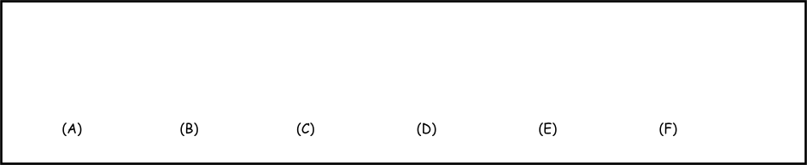

Identify the source of energy/organisms (1st blank) and the different trophic levels (2nd blank) of your food chain below.
- The (A) is the original source of energy in the above food chain.
- The (B) is a in the above food chain.
- The (C) is a in the above food chain.
- The (D) is a in the above food chain.
- The (E) is a in the above food chain.
- The (F) is a in the above food chain.

