
Find a Food Chain


Name:_________________________ Date: _______________
Alabama Wildlife Federation Habitat lab Field Journal Activity: Find a Food Chain, 5th Grade, page 1 of 1
Part 1: Answer the questions below.
1. What is a food chain?___________________________________________________________________________
_____________________________________________________________________________________________
2. Label the part(s) of a food chain in the diagram below using the following vocabulary words (some words will not be used):
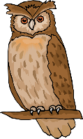
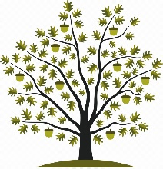
decomposer primary consumer producer secondary consumer sun tertiary consumer
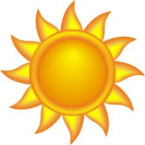
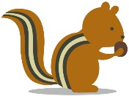
energy
energy
energy
a.
d.
c.
b.

a.____________________ b.____________________ c.____________________ d._____________________
3. How does a plant get energy from the sun?____________________________________________________________
_____________________________________________________________________________________________
4. How does an animal get its energy?_________________________________________________________________
_____________________________________________________________________________________________
Part 2: Explore the habitat lab and look for a link in a food chain such as a plant or animal. Use the Example Food Chain Components chart on page 3 along with field guides like the National Audubon’s Field Guide to the Southeastern States and/or the Alabama Wildlife Federation’s Dig into Plants and Wonders of Wildlife webpages to answer the following questions:
5. What did you find in the habitat lab that could be a link in a food chain?_______________________________
6. How does it get its energy to survive and reproduce?____________________________________________________
_____________________________________________________________________________________________
7. How does it provide energy for other living organisms?___________________________________________________
_____________________________________________________________________________________________
8. Draw a picture of your “food chain link” in the circle below where that plant or animal would be located in a food chain. Next try to guess what animal(s) or plant(s) the other links in the food chain might be, and then draw and label them using the vocabulary words in the box below. The arrows show the flow of energy through the food chain.
e.
d.
c.
b.
a.

a.________________ b.________________ c. ________________ d.________________ e.________________

f.________________
decomposer primary consumer producer secondary consumer sun tertiary consumer
f.

EXAMPLE FOOD WEB COMPONENTS
(A component is one part or element of the larger whole.)
Plants  (Producers) | Herbivores  (Primary Consumers) | Omnivores  (Secondary/Tertiary Consumers) | Carnivores  (Secondary/Tertiary Consumers) | Detritivores & Fungus  (Decomposers)
Grasses | Armyworms | Ants | Spiders | Mushrooms
Wildflowers | Caterpillars | Wasps | Fleas | Worms
Herbs | Butterflies | Lady Bugs | Ticks | Spiders
Shrubs | Bees | Crickets | Bats | Ants
Trees | Moths | Mosquitos | Snakes | Flies
Nuts | Grasshoppers | Songbirds | *Alligators | Beetles
Berries | Treehoppers | Squirrels & Chipmunks | *Some Fish | Millipedes
Acorns | Leafhoppers | Opossums | *Owls | Pill Bugs/Roly Polies
Pinecones | Katydids | Racoons | *Bobcats | Cockroaches
Seeds | Deer | Skunks | *Hawks | Snails
Fruits | Beavers | Frogs & Toads |  | Slugs
Aquatic plants | Rabbits | Salamanders
Algae | Some Fish | Turtles
 |  | Lizards
 |  | *Foxes (Red and Gray)
 |  | *Coyotes
 |  | *Black Bears |  | *Apex Predators

