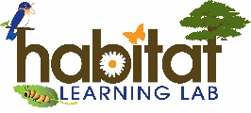
Living or Nonliving?
Habitat Lab Field Journal Activity Lesson Plans & Resources
Online Lesson Plans & Resources: https://alabamawildlife.org/field-investigation-living-or-nonliving/
Living Things Song: Reinforce the idea of living things by singing this song together to the tune of Freres Jacques. (Adapted from “Learner Classroom”)

Living Things Song
(Sing to the tune of Freres Jacques)
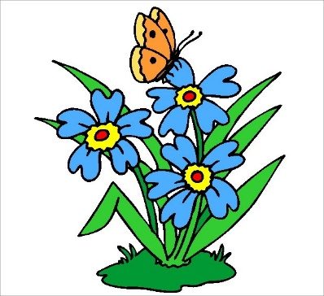
It is living!
It is living!
I know why!
I know why!
It eats and breathes and grows.
It eats and breathes and grows.
It’s alive!
It’s alive!

