
Living or Nonliving
Scavenger Hunt
Look at the picture and decide if the item in your Habitat Lab is living or nonliving. Color in the correct circle for each item.

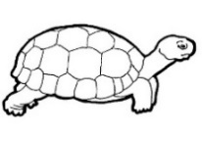 | turtle | - Living  - Nonliving
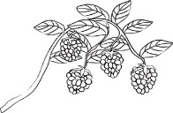 | berry bush | - Living  - Nonliving
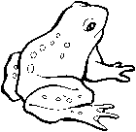 | frog | - Living  - Nonliving
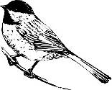 | bird | - Living  - Nonliving
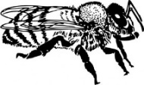 | bee | - Living  - Nonliving
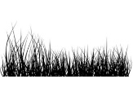 | grass | - Living  - Nonliving
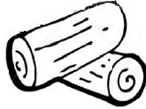 | log | - Living  - Nonliving
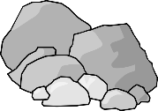 | rocks | - Living  - Nonliving
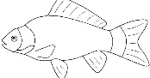 | fish | - Living  - Nonliving
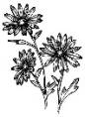 | flowers | - Living  - Nonliving

