
Outdoor Learning Station Project Plan:
Materials Budget and Construction Instructions for
Pollinator Garden (3-sided)
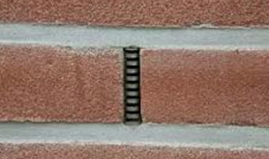
*A 3-sided garden is built against your school building so that the 4th side of the garden is the building’s brick wall. BEFORE you choose to build your garden against the building, you should look for “weep holes” in the brick (see pic on right). Do not cover your weep holes with garden soil as the soil will clog the holes. If the weep holes are less than 6 inches from the ground they would be covered by garden soil, and you need to build a 4-sided garden that is 2-3 inches out from the wall.
A Pollinator Garden should include flowering perennials that provide nectar and pollen throughout the growing season as well as water, shelter, and a place to raise young for a variety of pollinators.
The most critical component of a Pollinator Garden is native plants (plants that occur naturally in a specific region, ecosystem, or habitat without human introduction). They are easier to grow and are better adapted for our specific climate and soil than non-native plant species. Native pollinators have co-evolved with these native plants to most efficiently collect pollen and nectar, making their success more likely than if they were to pollinate non-native species. These plants are an important base in the food chain, as they draw in native pollinator species which are in turn food for native birds, mammals, reptiles, and amphibians. For these reasons, native plants increase the biodiversity of a Habitat Lab and should be used as much as possible in your Pollinator Garden.
- Habitat Requirements:
- Native flowering wildflowers, bushes and trees that produce nectar
- Puddling stations for pollinators that prefer to get their nutrition from excrement covered in sand
- Bushes and trees for cover from inclement weather and predators
- Dark colored stones where pollinators can warm their bodies
- Full sun for 6-8 hours per day for optimal plant growth
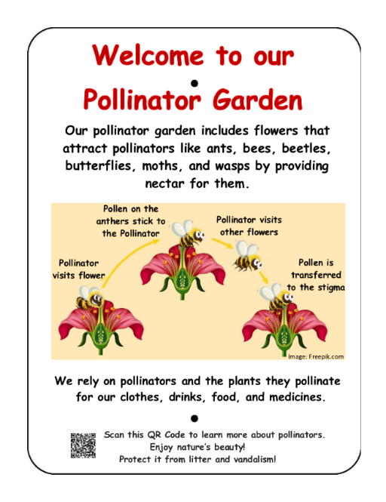
- Example Pollinator Garden Pictures & Educational Sign:
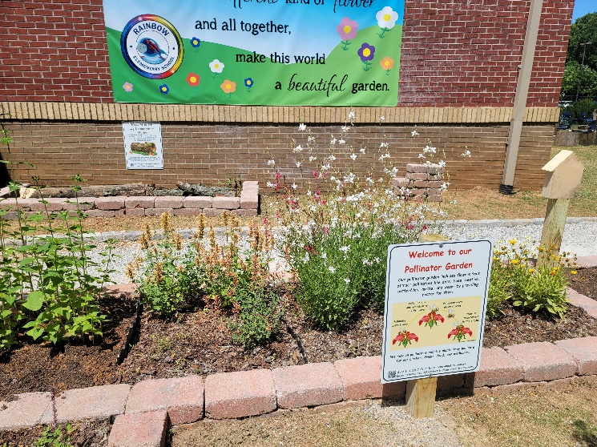
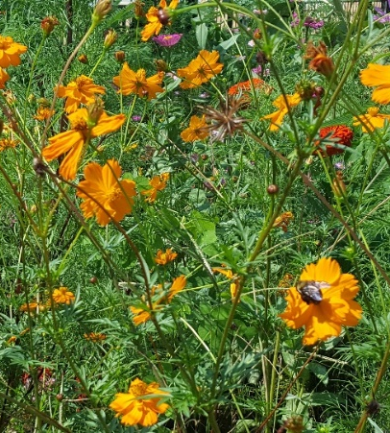

Project Plan for Pollinator Garden (3-sided)

- Materials List with Estimated Budget:
*Listed prices are as of December 2024. They are subject to change.
Example 3-sided Pollinator Garden
(Actual Size: 3 ft 8 in (W) x 13 ft 8 in (L) x 6 in (D) 3-sided raised bed garden against school building ~19 CF)
Station | Materials & Supplies | Estimated Cost | Example Source | Final Cost
Required Pollinator Garden Materials, Signage & Plants
3-sided Pollntr | (1) Can of Rust-Oleum Professional White Water-based Marking Paint (for laying out garden) @~$9.98 ea | $10 | Lowe’s Item #429750
3-sided Pollntr | (40) 4” x 12” Retaining Wall Blocks (to create three sides of raised bed against school building) @~$3.28 ea | $130 total | Lowe’s Item #477088
3-sided Pollntr | (1) 6’x50’ Sta-Green Professional Landscape Fabric (weed barrier) (16’ used for this garden) @~$33.98 ea | $35 | Lowe’s Item #510606
3-sided Pollntr | (4) 32-Quart (1CF) Bags of Evergreen Organic Potting Soil Mix (for garden) @~$6.38 ea | $25 total | Lowe’s Item #380608
3-sided Pollntr | (7) 1 CF/32 Qt Bags of Evergreen Organic Top Soil (for garden) @~$2.18 each | $15 total | Lowe’s Item #648834
3-sided Pollntr | (2) 1 CF Bags of Evergreen Organic Compost and Manure (for garden) @~$3.68 ea *Save handful for puddling stations if you are including them | $10 total | Lowe’s Item #380606
3-sided Pollntr | (3) 2 CF Bags of Evergreen Organic Drainage and Aeration Soil Conditioner (for garden) @~$4.58 ea | $15 total | Lowe’s Item #648829
3-sided Pollntr | (2) 2 CF Bags of Evergreen Natural Dark Brown Pine Bark Mulch (for garden) @~$3.48 ea **do NOT get black mulch, it gets hot & kills plants | $10 total | Lowe’s Item #92118
3-sided Pollntr | (1) Package of 40 6” Black Plastic Landscape Edging Pieces (18 to create (3) 3 ft dividers between the three plant species to make plant ID & weeding easier) @~$21.98 ea | $20 | Lowe’s Item# #379805
3-sided Pollntr | (16) Native Perennial Host Plants (4 different species, 4 plants of each) *See planting diagram on pg7. | $110 total | Nursery via HLL Specialist
3-sided Pollntr | (1) POLLIBEE Mason Bee House  @~$31.99 ea | $30 | https://a.co/d/djoEg1B
3-sided Pollntr | (1) 4” x 4” x 6’ Ground Contact Wood Pressure Treated Lumber (for educational Wooden Insect Hotel) @~$9.78 ea | $10 | Lowe’s Item #312530
3-sided Pollntr | (4) Plant ID Signs (one for each plant species) @~$6 ea | $25 total | Ask HLL Specialist
3-sided Pollntr | (4) Biomarkers to hold Plant ID signs (13” stake with a 2” x 4” plate) @ ~$3 ea (includes S&H) | $10 total | Via HLL Specialist or mcgbiomarkers.com/shop/


Project Plan for Pollinator Garden (3-sided)
- Materials List with Estimated Budget (continued):
3-sided Pollntr | (1) Gorilla Clear 3.75-fl oz Liquid Extreme Condition Waterproof, Quick Dry, Multipurpose Adhesive @~$9.28 ea (to attach Plant ID signs to stakes) | $10 | Lowe’s Item# 955829
3-sided Pollntr | (1) 6 ft. U-Post for Fence (for educational sign) @~$10.69 ea | $10 | Lowe’s Item#: 493054
3-sided Pollntr | Educational Sign | $75 | Ask HLL Specialist
3-sided Pollntr | (1) Hillman 1/4-in x 1-1/2 in Zinc-Plated Coarse Thread Hex Bolt (2-count) @~$0.88 ea | $5 total | Lowe’s Item #137634
3-sided Pollntr | (2) Hillman 1/4-in x 20 Zinc-Plated Steel Hex Nut @~$0.10 ea | $5 total | Lowe’s Item #63301
3-sided Pollntr | (2) Hillman 1/4-in Zinc-Plated Standard Flat Washer @~$0.15 ea | $5 total | Lowe’s Item #63306
Estimated Total Cost for Garden Materials (with signage & plants): $555

Additional *Optional* Pollinator Habitat Materials, Signage & Plants
Station | Materials & Supplies | Estimated Cost | Example Source | Final Cost
3-sided Pollntr | Native Trees for cover (plant in or near Habitat Lab) @~$75 ea | Depends on quantity | Nursery via HLL Specialist
3-sided Pollntr | Native Bushes for cover (plant in or near Habitat Lab) @~$30 ea | Depends on quantity | Nursery via HLL Specialist
3-sided Pollntr | 1 CF/32 Qt Bags of Evergreen Organic Top Soil (to mix with current soil and other amendments) @~$2.18 ea | 1 bag/ bush  2 bags/ tree | Lowe’s Item #648834
3-sided Pollntr | 1 CF Bags of Evergreen Organic Compost & Manure (to mix with current soil and other amendments) @~$3.68 ea | ¼ bag/ bush  ½ bag/ tree | Lowe’s Item #380606
3-sided Pollntr | (3) 2 CF Bags of Evergreen Organic Drainage and Aeration Soil Conditioner (to mix with current soil and other amendments) @~$4.58 ea | ¼ bag/ bush  ½ bag/ tree | Lowe’s Item #648829
3-sided Pollntr | Plant ID Signs (one for each plant species) @~$6 ea | Depends on # add’l plant species | Ask HLL Specialist
3-sided Pollntr | Biomarkers to hold Plant ID signs (13” stake with a 2” x 4” plate) @ ~$3 ea (includes S&H) | Depends on # add’l plant species | Via HLL Specialist or mcgbiomarkers.com/shop/
3-sided Bttrfly | (2) 12-18” wide Terracotta Clay Plant Saucer (to create puddling stations) @~$14.48 ea | $30 total | Lowe’s Item #94459

Project Plan for Pollinator Garden (3-sided)
- Materials List with Estimated Budget (continued):

3-sided Bttrfly | (1) .5 CF/50 Lb Bag of American Countryside All-purpose Sand (for puddling stations) @~$5.18 ea | $5 | Lowe’s Item #104898
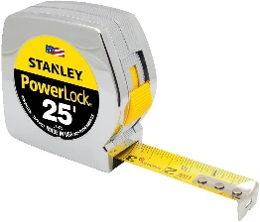
- Construction Tools:
Measuring Tape
- (1) 20 ft Measuring Tape
- (1) Speed Square for measuring angles
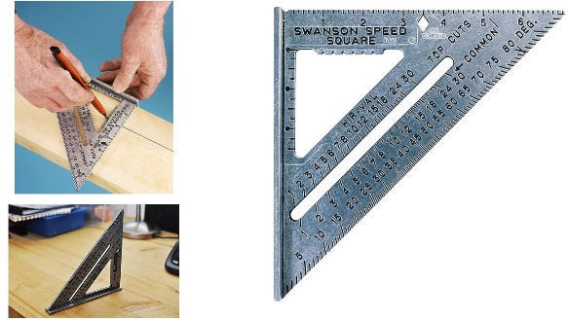
- (4-6) Shovels (2-3 for adults; 2-3 for children)
Speed Square
- (1-2) Wheelbarrows for moving grass clumps, soil & mulch
- (24-30) 1-gallon milk jugs (with tops cut off but handles remaining) for students to move dirt, sand, soil, etc.
- 24-inch I-beam Level
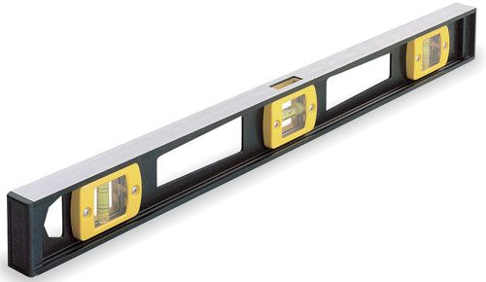
- (4-6) Hand-held Trowels (for stirring soil amendments together)
- Water hose for watering plants at the end of day
- Twine (40 ft long)
I-beam Level
- (4) Garden Stakes or Flags

- Construction Instructions for Pollinator Garden
- Gather construction tools and purchase supplies to have them on-hand for the construction day.
Stake #1
14 ft Twine
Speed Square
4 ft Twine
Steps 1-5 #1
Building Wall
- To create the perimeter of your garden, begin by placing a Stake #1 (or flag) in the ground where you want the back left corner to be located against the building.
- Place the speed square on the ground against the wall to measure the 90-degree angle needed for the inside of the back left corner of your garden.
- Cut the twine into two pieces that are 4 ft long and two pieces that are 14 ft long.
- Tie the end of a 4 ft piece of twine and at the end of a 14 ft piece of twine to Stake #1.

Project Plan for Pollinator Garden (3-sided)
- Construction Instructions (continued):
- Place the end of the measuring tape at Stake #1, and follow the edge of the building wall as you measure out 13 ft 8 in to create the first long-side of the garden. Place Stake #2 in the ground next to the wall to mark the second corner. Pull the 14 ft long piece of twine from Stake #2, and tie the end of it to Stake #2 to create a straight line.
Speed Square
13 ft 8 in of Twine
3 ft 8 in of Twine
Stake #3
Steps 6 & 7 #1
Stake #1
Stake #2
- Place the end of the measuring tape at Stake #1 again, and then follow the edge of the speed square as you measure out 3 ft 8 in from the wall. Place Stake #3 in the ground to create the first short-side of the garden. Make sure that the measuring tape stays straight and follows the outer edge of the speed square, so that the inside of the first corner forms a 90-degree angle. Pull the 4 ft long piece of twine from Stake #1 to Stake #3, and tie the end of it to Stake #3 to create a straight line.
Speed Square
Steps 8 - 10 #1
Stake #3
3 ft 8 in
3 ft 8 in of Twine
Stake #1
Stake #2
Stake #4
13 ft 8 in of Twine
- Next place the speed square on the ground against the wall by Stake #2 to determine the 90-degree angle needed for the inside of the back right corner of your garden.
- Place the end of the measuring tape at the second stake, and follow the opposite edge of the speed square as you measure out 3 ft 8 in. Place Stake #4 in the ground to mark the third corner. Make sure that the measuring tape stays straight, so that the second corner continues to form a 90-degree angle. Pull the 4 ft long piece of twine from Stake #2 to Stake #4, and tie the end of it to create a straight line.
- Next, tie one end of the remaining 14 ft piece of twine to Stake #4 and the other end Stake #3. This should create 90-degree angles in the third and fourth corners, and you can use your speed square to confirm this.
- Lastly spray paint lines along the ground following the OUTSIDE of the garden perimeter that was created by the twine. (See diagram at top of page 6)
Project Plan for Pollinator Garden (3-sided)
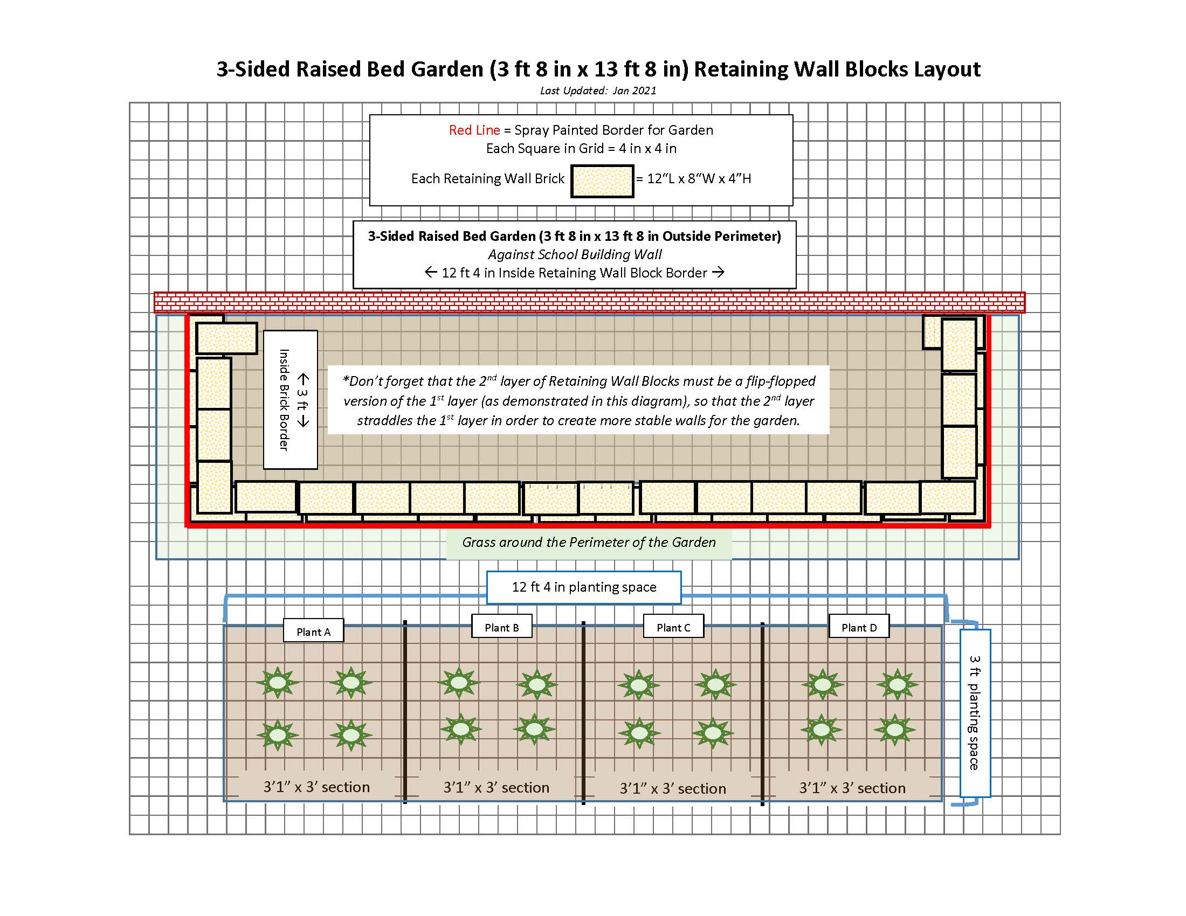
- Construction Instructions (continued):
Front of Garden
Back of Garden against Building Wall
Left Side
Right Side

- Dig and remove the grass in a path that is 1 inch deep and 8 inches wide along the INSIDE of the spray painted garden perimeter to create a base on which to place the reatining wall blocks. Use your shovel/ trowel to create a flast surface for the base to keep the retaining wall blocks level.
- Place the first retaining wall block in the back left corner with the 8-inch side of the block against the building and the 12-inch side creating the left side of the garden. Use your I-beam level to make sure the block is level from side-to-side and front-to-back. Add a little dirt or sand and use your trowel to level the base surface if needed. Place the next block directly next to the first one, and use your level to make sure that the second block is level with the first block. Continue adding blocks until you have placed and leveled three blocks (3 ft) in a row. You should have 8 inches of base surface remaining without a block.
- Place a retaining wall block at the end of your first side but place it perpendicular to the other blocks so that the 8-inch width of the new block fills in the final 8 inches of the first side of the garden. Use your I-beam level to make sure the new block is level and adjust it if needed. Continue adding blocks until you have placed and leveled thirteen blocks (13 ft) in a row to create the front of the garden. You should have 8 inches remaining in the front right side of your garden without a block.
- Place a block perpendicularly at the end of the second side of your garden, so that the 8-inch width of the new block fills in the final 8 inches of the second side. Use your I-beam level to make sure the new block is level and adjust it if needed. Place and level two more blocks, leaving the remaining 8 inches of the third side of the garden without a block.

Project Plan for Pollinator Garden (3-sided)
- Construction Instructions (continued):
- Lastly, place a block perpendicularly at the end of the third side of your garden with the 12-inch side against the wall, so that the 8-inch width of the new block fills in the final 8 inches of the third side. Use your I-beam level to make sure the new block is level and adjusted if needed. The first level of your garden is complete.
- Place the landscape fabric (weed barrier) on the grass inside the garden area, push the fabric against the insides of the retaining wall blocks and up against the building wall, and lay the edges of the fabric on top of the blocks so that the fabric is sandwiched and held in place between the first and second layers of retaining wall blocks. If your fabric is not wide enough to cover the insides of the block and have the edge of the fabric lay on top of the block, then you need to make your garden a little smaller (less wide).
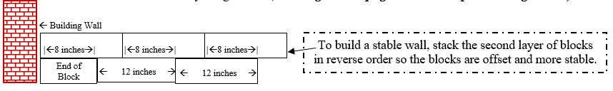
- Next, start laying the second layer of blocks from the back right corner that you just completed for the first layer of blocks, and then place the blocks in reverse order (counter-clockwise). Lay the 8-inch end of first block against the wall with the 12-inch side starting the right side of the second layer of blocks. Don’t forget—the second layer of retaining wall blocks should straddle the first layer to create more stable walls for your garden. (See diagram on page 6 and example drawing below.)
- Fill the bottom of the garden with top soil, add the compost and manure, and then add the potting soil and soil conditioner to retain moisture in the soil. Use trowels to turn and mix the soils.
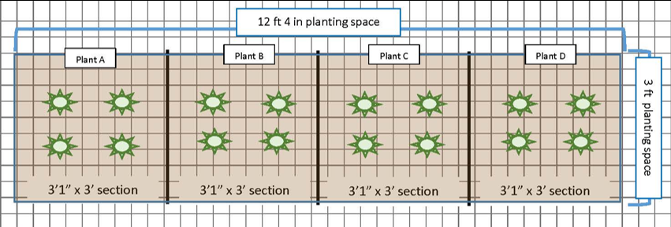
- Install 3 ft dividers of the landscape edging inside the garden to create (4) 3 ft 1 in x 3 ft planting sections——each section for a different plant species. (see the lines in the diagram below)

Project Plan for Pollinator Garden (3-sided)
- Construction Instructions (continued):
- Plant the flowers, grouping each of the different species of plants together within each square.
- Add 1 inch of mulch around the plantings throughout the garden.
- If you chose to purchase supplies, create puddle stations by filling terracotta pot lids or pie plates up to ½ inch with manure (for minerals), add ¼ inch of sand over the manure, and then soak the sandy soil with water.
- Dig holes twice the size of the pots for the trees and bushes if you are including an. Add a mix of top soil, compost and manure, soil conditioner, and current soil to each hole, plant each of the trees and bushes in the holes, and then add mulch around each plant. Try to plant the trees and bushes near the garden if possible.
- Attach Plant ID signs to stakes using adhesive. Sink the stakes a few inches into the ground in front of the appropriate plant species grouping, tree, or bush.
- Insert the educational sign post (u-post) in the ground near the garden and attach the educational sign to it using the nuts, bolts, and washers.
- Water all of the new plantings thoroughly.

