
Materials Budget for Pollinator Garden (4-sided)
Example Pollinator Garden (4-sided)
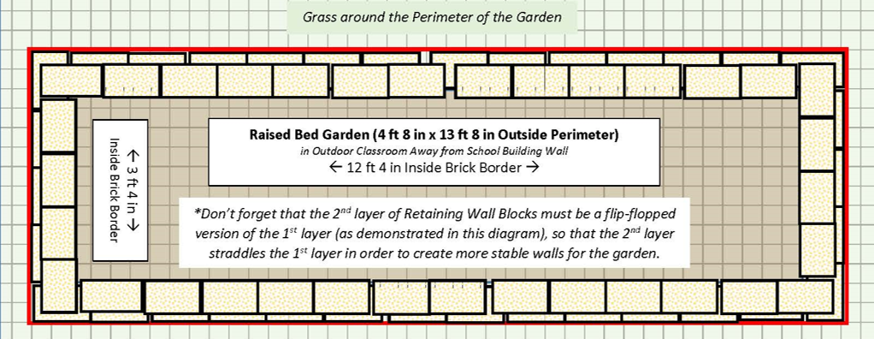
4 ft 8 in (W) x 13 ft 8 in (L) x 6” (D) 4-sided raised bed garden ~20 CF)
Required Pollinator Garden Materials, Signage & Plants
(1) Can of White Water-based Marking Paint (for laying out garden)
(70) 4” x 12” Retaining Wall Blocks (to create four sides of raised bed garden)
(1) 6’x50’ Professional Landscape Fabric (weed barrier) (16’ used for this garden)
(4) 32-Quart (1CF) Bags of Organic Potting Soil Mix (for garden)
(8) 1 CF/32 Qt Bags of Organic Top Soil (for garden)
(2) 1 CF Bags of Organic Compost and Manure (for garden)
(3) 2 CF Bags of Organic Drainage and Aeration Soil Conditioner (for garden)
(1) Black Steel Garden Trellis (for passionflower vines)
(1) Package of 40 6” Black Plastic Landscape Edging Pieces (18 to create (3) 3 ft dividers between the three plant species to make plant ID & weeding easier)
(2) 2 CF Bags of Natural Dark Brown Pine Bark Mulch (for garden) *do NOT get black mulch as it gets hot and kills plants*
(1) Bee/ Insect House
(1) 4” x 4” x 6’ Pressure Treated Lumber (for mounting insect house)
Educational Sign
(1) 6 ft. U-Post for Fence (for educational sign)
(2) 1/4-in x 1-1/2 in Zinc-Plated Coarse Thread Hex Bolt
(2) 1/4-in x 20 Zinc-Plated Steel Hex Nut
(2) 1/4-in Zinc-Plated Standard Flat Washer
(4) Plant ID Signs (one for each plant species)
(4) Biomarkers to hold Plant ID signs
(1) Bottle of Waterproof, Quick Dry, Multipurpose Adhesive (to attach Plant ID signs to stakes)
(20) Native Perennial Nectar Plants (4 species, 5 plants of each) *See planting diagram below.
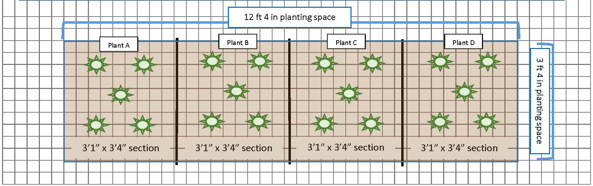
Estimated Total Cost for Garden Materials (with signage & plants): $690

Additional *Optional* Pollinator Habitat Materials, Signage & Plants
Native Trees for shelter/ cover such as Oaks, Dogwoods, or Tulip Poplars
Native Bushes for shelter/ cover such as Spicebushes or Wax Myrtles
1 CF/32 Qt Bag of Organic Top Soil - 1 bag per bush & 2 bags per tree to mix with current soil around roots of bush/tree
1 CF Bag of Organic Compost & Manure - 1/4 bag per bush & 1/2 bag per tree to mix with current soil around roots of bush/tree
2 CF Bags of Organic Drainage and Aeration Soil Conditioner - 1/4 bag per bush & 1/2 bag per tree to mix with current soil around roots of bush/tree
2 CF Bags of Natural Dark Brown Pine Bark Mulch (1 bag per bush, 2 bags per tree to place around base after planting) *do NOT get black mulch as it gets hot and kills plants*
Plant ID Signs (one for each plant species)
Biomarkers to hold Plant ID signs
(2) 12.2-in Terracotta Clay Plant Saucer (to create puddling stations)
(1) .5 CF/50 Lb Bag of All-purpose Sand (to create puddling stations)

