
Outdoor Learning Station Project Plan:
Materials Budget and Construction Instructions for
Sensory Garden (3-sided)
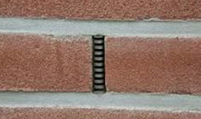
*A 3-sided garden is built against your school building so that the 4th side of the garden is the building’s brick wall. BEFORE you choose to build your garden against the building, you should look for “weep holes” in the brick (see pic on right). Do not cover your weep holes with garden soil as the soil will clog the holes. If the weep holes are less than 6 inches from the ground they would be covered by garden soil, and you need to build a 4-sided garden that is 2-3 inches out from the wall.

A Sensory Garden includes plants that help teach students how to use all five senses (sight, touch, taste, smell, touch) as they explore the Habitat Lab. Some plants have bright flowers or leaves to trigger a visual response, while other plants feel, taste, or smell unique. Wind chimes make a great, simple addition to the garden, but expanded sound gardens can be incorporated into the outdoor classroom as well. Each garden should incorporate elements that engage the students with all five of their senses.
- Habitat Requirements:
- Full sun for 6-8 hours per day for optimal plant growth
- Near the entrance of the Habitat Lab if possible.
- Example Sensory Garden Pictures & Educational Sign:

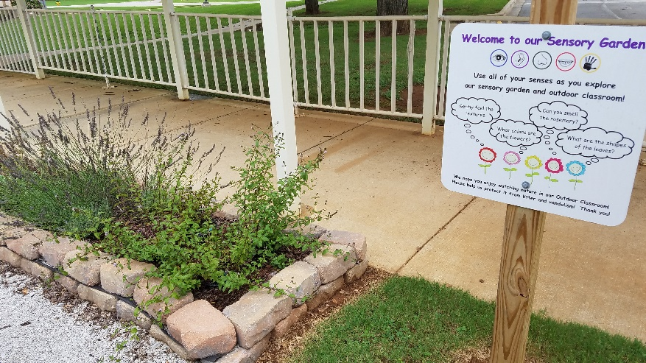

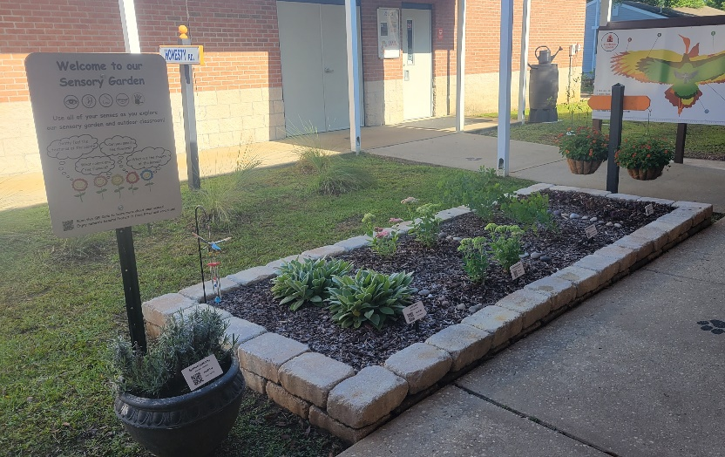
Project Plan for Sensory Garden (3-sided)

- Materials List with Estimated Budget:
*Listed prices are as of December 2024. They are subject to change.
Example 3-sided Sensory Garden
(Actual Size: 3 ft 8 in (W) x 13 ft 8 in (L) x 6 in (D) 3-sided raised bed garden against school building ~19 CF)
Station | Materials & Supplies | Estimated Cost | Example Source | Final Cost
Required Sensory Garden Materials, Signage & Plants
3-sided Sensory | (1) Can of Rust-Oleum Professional White Water-based Marking Paint (for laying out garden) @~$9.98 ea | $10 | Lowe’s Item #429750
3-sided Sensory | (40) 4” x 12” Retaining Wall Blocks (to create three sides of raised bed against school building) @~$3.28 ea | $130 total | Lowe’s Item #477088
3-sided Sensory | (1) 6’x50’ Sta-Green Professional Landscape Fabric (weed barrier) (16’ used for this garden) @~$33.98 ea | $35 | Lowe’s Item #510606
3-sided Sensory | (4) 32-Quart (1CF) Bags of Evergreen Organic Potting Soil Mix (for garden) @~$6.38 ea | $25 total | Lowe’s Item #380608
3-sided Sensory | (7) 1 CF/32 Qt Bags of Evergreen Organic Top Soil (for garden) @~$2.18 each | $15 total | Lowe’s Item #648834
3-sided Sensory | (2) 1 CF Bags of Evergreen Organic Compost and Manure (for garden) @~$3.68 ea | $10 total | Lowe’s Item #380606
3-sided Sensory | (2) 2 CF Bags of Evergreen Organic Drainage and Aeration Soil Conditioner (for garden) @~$4.58 ea | $15 total | Lowe’s Item #648829
3-sided Sensory | (2) 2 CF Bags of Evergreen Natural Dark Brown Pine Bark Mulch (for garden) @~$3.48 ea **do NOT get black mulch, it gets hot & kills plants | $5 total | Lowe’s Item #92118
3-sided Sensory | (1) Package of 40 6” Black Plastic Landscape Edging Pieces (18 to create (3) 3 ft dividers between the (4) plant species to make plant ID & weeding easier) @~$21.98 ea | $20 | Lowe’s Item# #379805
3-sided Sensory | (16) Sensory Plants (including (4) of each species – (1) species for touch, (1) species for sound, (2) species for sight) @~$7 ea *See planting diagram on pg7. | $115 total | Nursery via HLL Specialist
3-sided Sensory | (3) mint plants for taste (plant in hanging pot, not in-ground) @~$7 ea | $20 total | Nursery via HLL Specialist
3-sided Sensory | (3) annual plants (pick what is prettiest, smells best, etc.) (plant in hanging pot, not in garden) @~$7 ea | $20 total | Nursery via HLL Specialist
3-sided Sensory | (3) 63-in Steel-painted Metal Shepherd's Hook (for chimes, hanging annual basket, and hanging mint basket) @~$10.98 ea | $35 total | Lowe’s Item #150326


Project Plan for Sensory Garden (3-sided)

- Materials List with Estimated Budget (continued):
3-sided Sensory | (2) hanging planter (for annuals at wheelchair height) @~$9.98 ea | $20 total | Lowe's Item #4058131
3-sided Sensory | Large Aluminum Wind Chimes 37" @~$20.77 | $20 | https://a.co/d/694mWNt
3-sided Sensory | (5) Plant ID Signs (one for each plant species except annuals) @~$6 ea | $30 total | Ask HLL Specialist
3-sided Sensory | (5) Biomarkers to hold Plant ID signs (13” stake with a 2” x 4” plate) @ ~$3 ea (includes S&H) | $15 total | Via AWF Consultant or mcgbiomarkers.com/shop/
3-sided Sensory | (1) Gorilla Clear 3.75-fl oz Liquid Extreme Condition Waterproof, Quick Dry, Multipurpose Adhesive @~$9.28 ea (to attach Plant ID signs to stakes) | $10 | Lowe’s Item# 955829
3-sided Sensory | (1) 6 ft. U-Post for Fence (for educational sign) @~$10.69 ea | $10 | Lowe’s Item#: 493054
3-sided Sensory | Educational Sign (explains how senses are engaged) | $75 | Ask HLL Specialist
3-sided Sensory | (1) Hillman 1/4-in x 1-1/2 in Zinc-Plated Coarse Thread Hex Bolt (2-count) @~$0.88 ea | $5 total | Lowe’s Item #137634
3-sided Sensory | (2) Hillman 1/4-in x 20 Zinc-Plated Steel Hex Nut @~$0.10 ea | $5 total | Lowe’s Item #63301
3-sided Sensory | (2) Hillman 1/4-in Zinc-Plated Standard Flat Washer @~$0.15 ea | $5 total | Lowe’s Item #63306
Estimated Total Cost for Garden Materials (with signage & plants): $640

Additional *Optional* Sensory Garden Materials, Signage & Plants
Station | Materials & Supplies | Estimated Cost | Example Source | Final Cost
3-sided Sensory | Rosemary Bush (Excellent for scent. Best if planted in-ground near sensory garden, but some varieties will survive in pots.) @~$15 ea | $15 | Nursery via HLL Specialist
3-sided Sensory | Large Outdoor Planter (if you choose not to plant rosemary in-ground) @~$17.98 ea | $20 | Lowe’s Item #5447797
3-sided Sensory | (1) 32-Quart (1CF) Bags of Evergreen Organic Potting Soil Mix (for garden) @~$6.38 ea (mix with ¼ bag Compost & Manure and ¼ bag Soil Conditioner to use when planting Rosemary in-ground or in pot) | $5 | Lowe’s Item #380608
3-sided Sensory | (1)1 CF Bags of Evergreen Organic Compost & Manure (mix ¼ bag with 1 bag Top Soil and ¼ bag Soil Conditioner to use when planting Rosemary in-ground or in pot) @~$3.68 ea | $5 | Lowe’s Item #380606
Project Plan for Sensory Garden (3-sided)

- Materials List with Estimated Budget (continued):

3-sided Sensory | (1) 2 CF Bags of Evergreen Organic Drainage and Aeration Soil Conditioner (mix ¼ bag with 1 bag Top Soil and ¼ bag of Compost & Manure to use when planting Rosemary in-ground or in pot) @~$4.58 ea | $5 | Lowe’s Item #648829
3-sided Sensory | (1) 2 CF Bags of Evergreen Natural Dark Brown Pine Bark Mulch (place around base of rosemary after planting) @~$3.48 ea **do NOT get black mulch, it gets hot & kills plants | $5 | Lowe’s Item #92118
3-sided Sensory | Plant ID Signs (one for each plant species) @~$6 ea | $5 | Ask HLL Specialist
3-sided Sensory | Biomarkers to hold Plant ID signs (13” stake with a 2” x 4” plate) @ ~$3 ea (includes S&H) | $5 | Via HLL Specialist or mcgbiomarkers.com/shop/
3-sided Sensory | Additional Wind Chimes (select sets made from a variety of materials such as bamboo, glass, or shells so students can compare the sounds they make) | Varies based on item selected | Your Choice
3-sided Sensory | Additional 63-in Steel-painted Metal Shepherd's Hook (one for each set of chimse @~$10.98 ea | Varies based on # of chimes | Lowe’s Item #150326

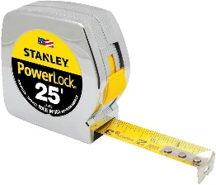
- Construction Tools:
Measuring Tape
- (1) 20 ft Measuring Tape
- (1) Speed Square for measuring angles
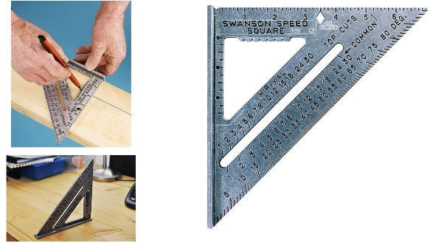
- (4-6) Shovels (2-3 for adults; 2-3 for children)
Speed Square
- (1-2) Wheelbarrows for moving grass clumps, soil & mulch
- (24-30) 1-gallon milk jugs (with tops cut off but handles remaining) for students to move dirt, sand, soil, etc.
- 24-inch I-beam Level
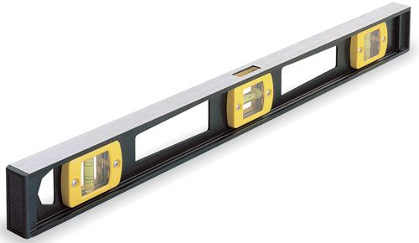
- (4-6) Hand-held Trowels (for stirring soil amendments together)
- Water hose for watering plants at the end of day
- Drill for attaching signs to posts
I-beam Level
- Twine (40 ft long)
- (4) Garden Stakes or Flags

Project Plan for Sensory Garden (3-sided)

- Construction Instructions for Sensory Garden
Stake #1
14 ft Twine
Speed Square
4 ft Twine
Steps 1-5 #1
Building Wall
- Gather construction tools and purchase supplies to have them on-hand for the construction day.
- To create the perimeter of your garden, begin by placing a Stake #1 (or flag) in the ground where you want the back-left corner to be located against the building.
- Place the speed square on the ground against the wall to measure the 90-degree angle needed for the inside of the back-left corner of your garden.
Speed Square
13 ft 8 in of Twine
3 ft 8 in of Twine
Stake #3
Steps 6 & 7 #1
Stake #1
Stake #2
- Cut the twine into two pieces that are 4 ft long and two pieces that are 14 ft long.
- Tie the end of a 4 ft piece of twine and at the end of a 14 ft piece of twine to Stake #1.
- Place the end of the measuring tape at Stake #1, and follow the edge of the building wall as you measure out 13 ft 8 in to create the first long-side of the garden. Place Stake #2 in the ground next to the wall to mark the second corner. Pull the 14 ft long piece of twine from Stake #2, and tie the end of it to Stake #2 to create a straight line.
Speed Square
Steps 8 - 10 #1
Stake #3
3 ft 8 in
3 ft 8 in of Twine
Stake #1
Stake #2
Stake #4
13 ft 8 in of Twine
- Place the end of the measuring tape at Stake #1 again, and then follow the edge of the speed square as you measure out 3 ft 8 in from the wall. Place Stake #3 in the ground to create the first short-side of the garden. Make sure that the measuring tape stays straight and follows the outer edge of the speed square, so that the inside of the first corner forms a 90-degree angle. Pull the 4 ft long piece of twine from Stake #1 to Stake #3, and tie the end of it to Stake #3 to create a straight line
- Next place the speed square on the ground against the wall by Stake #2 to determine the 90-degree angle needed for the inside of the back-right corner of your garden.

Project Plan for Sensory Garden (3-sided)

- Construction Instructions (continued):
- Place the end of the measuring tape at the second stake, and follow the opposite edge of the speed square as you measure out 3 ft 8 in. Place Stake #4 in the ground to mark the third corner. Make sure that the measuring tape stays straight, so that the second corner continues to form a 90-degree angle. Pull the 4 ft long piece of twine from Stake #2 to Stake #4, and tie the end of it to create a straight line.
- Next, tie one end of the remaining 14 ft piece of twine to Stake #4 and the other end Stake #3. This should create 90-degree angles in the third and fourth corners, and you can use your speed square to confirm this.
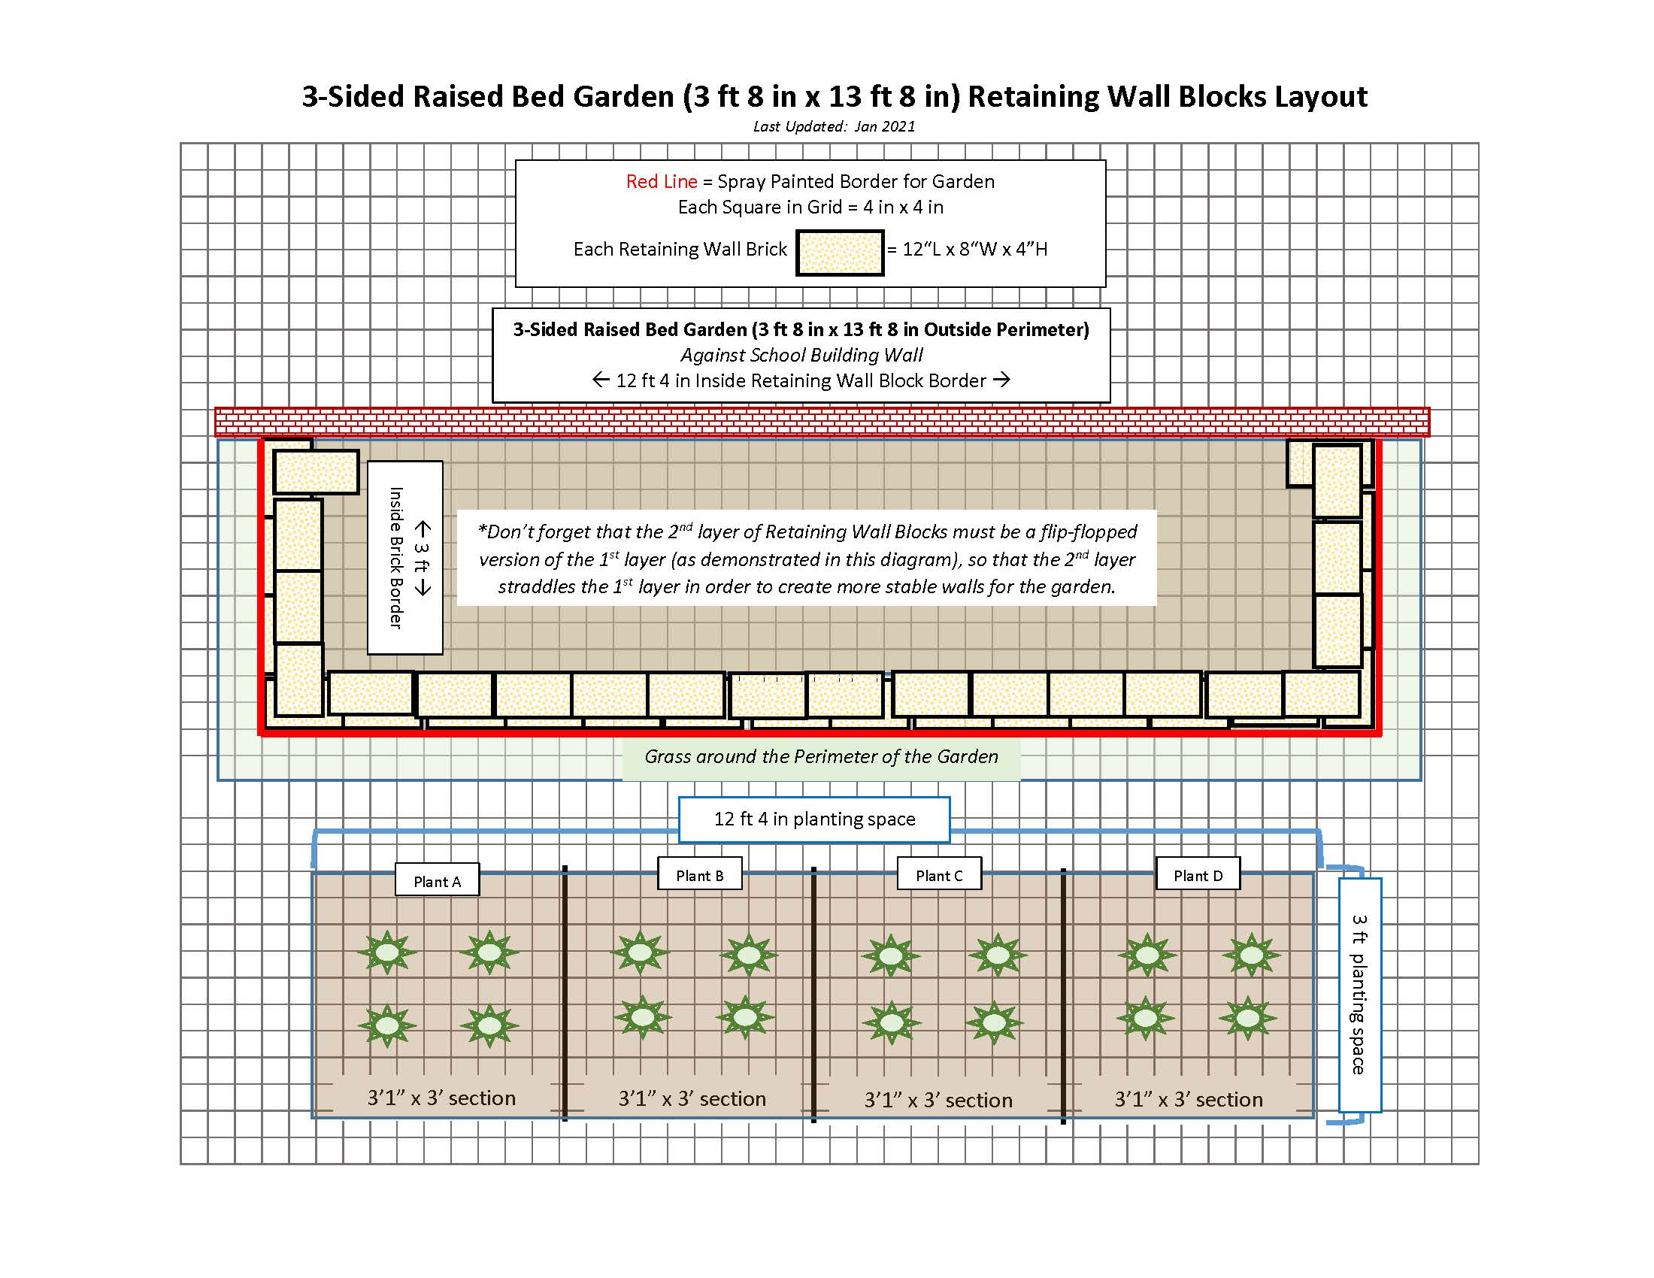
- Lastly spray paint lines along the ground following the OUTSIDE of the garden perimeter that was created by the twine. (See diagram below)
Front of Garden
Back of Garden against Building Wall
Left Side
Right Side

- Dig and remove the grass in a path that is 1 inch deep and 8 inches wide along the INSIDE of the spray-painted garden perimeter to create a base on which to place the retaining wall blocks. Use your shovel/trowel to create a flat surface for the base to keep the retaining wall blocks level.
- Place the first retaining wall block in the back-left corner with the 8-inch side of the block against the building and the 12-inch side creating the left side of the garden. Use your I-beam level to make sure the block is level from side-to-side and front-to-back. Add a little dirt or sand and use your trowel to level the base surface if needed. Place the next block directly next to the first one, and use your level to make sure that the second block is level with the first block. Continue adding blocks until you have placed and leveled three blocks (3 ft) in a row. You should have 8 inches of base surface remaining without a block.
Project Plan for Sensory Garden (3-sided)

- Construction Instructions (continued):
- Place a retaining wall block at the end of your first side but place it perpendicular to the other blocks so that the 8-inch width of the new block fills in the final 8 inches of the first side of the garden. Use your I-beam level to make sure the new block is level and adjust it if needed. Continue adding blocks until you have placed and leveled thirteen blocks (13 ft) in a row to create the front of the garden. You should have 8 inches remaining in the front right side of your garden without a block.
- Place a block perpendicularly at the end of the second side of your garden, so that the 8-inch width of the new block fills in the final 8 inches of the second side. Use your I-beam level to make sure the new block is level and adjust it if needed. Place and level two more blocks, leaving the remaining 8 inches of the third side of the garden without a block.
- Lastly, place a block perpendicularly at the end of the third side of your garden with the 12-inch side against the wall, so that the 8-inch width of the new block fills in the final 8 inches of the third side. Use your I-beam level to make sure the new block is level and adjust it if needed. The first level of your garden is completed.
- Place the landscape fabric (weed barrier) on the grass inside the garden area, push the fabric against the insides of the retaining wall blocks and up against the building wall, and lay the edges of the fabric on top of the blocks so that the fabric is sandwiched and held in place between the first and second layers of retaining wall blocks. If your fabric is not wide enough to cover the insides of the block and have the edge of the fabric lay on top of the block, then you need to make your garden a little smaller (less wide).
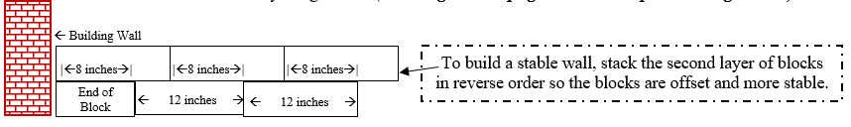
- Next, start laying the second layer of blocks from the back-right corner that you just completed for the first layer of blocks, and then place the blocks in reverse order (counter-clockwise). Lay the 8-inch end of first block against the wall with the 12-inch side starting the right side of the second layer of blocks. Don’t forget—the second layer of retaining wall blocks should straddle the first layer to create more stable walls for your garden. (See diagram on page 6 and example drawing below.)
- Fill the bottom of the garden with top soil, add the compost and manure, and then add the potting soil and soil conditioner to retain moisture in the soil. Use trowels to turn and mix the soils.
- Install 3 ft dividers of the landscape edging inside the garden to create (4) 3 ft 1 in x 3 ft sections – each section for a different plant species. (see the lines in the diagram at the top of page 8.)

Project Plan for Sensory Garden (3-sided)
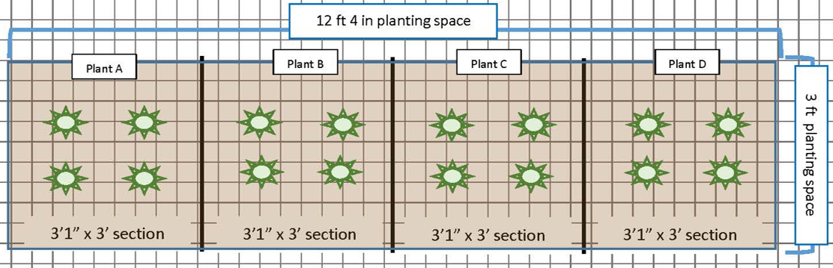
- Construction Instructions (continued):
- Plant the flowers, grouping each of the different species of plants together within each square. Plant the mint and annual in their hanging pots.
- Add 1 inch of mulch around the plantings throughout the garden and in the pots.
- Install the three shepherd’s hooks around the garden. Hang the chimes and hanging pots on them.
- If you chose to include rosemary and are planting it in the ground: dig a hole twice the size of the nursery pot and add a mix of potting mix, compost and manure, soil conditioner, and current soil to the hole; plant the bush in the hole; and add mulch around the base. If you chose to include rosemary and are planting it in a pot: fill the pot with the mix of potting mix, compost and manure, and soil conditioner; plant the bush, top with mulch.
- Attach Plant ID signs to stakes using adhesive. Sink the stakes a few inches into the ground in front of the appropriate plant species grouping or bush.
- Insert the educational sign post (u-post) in the ground near the garden and attached the educational sign to it using the nuts, bolts, and washers.
- Water all of the new plantings thoroughly.

