
Materials Budget for
Large Songbird Sanctuary (4-sided)
Example Songbird Garden (4-sided)
(Included in large sanctuary along with trees, bushes, bird bath, bird feeders, and bird houses.)
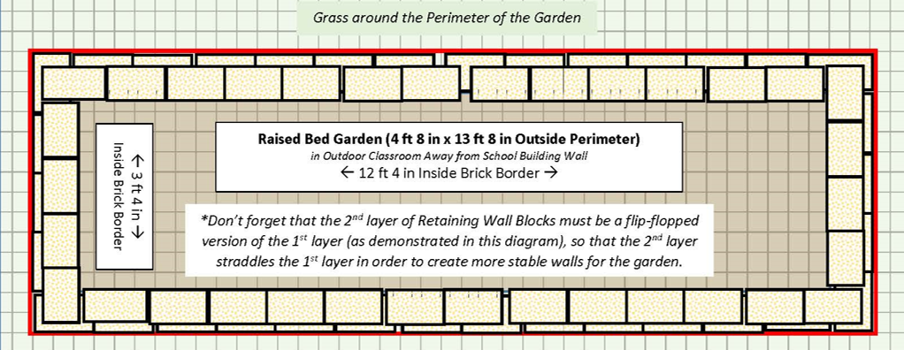
4 ft 8 in (W) x 13 ft 8 in (L) x 6” (D) 4-sided raised bed garden ~20 CF)
Required Large Songbird Sanctuary (4-sided) Materials, Signage & Plants
(1) Can of White Water-based Marking Paint (for laying out garden)
(70) 4” x 12” Retaining Wall Blocks (to create four sides of raised bed garden)
(1) 6’x50’ Professional Landscape Fabric (weed barrier) (16’ used for this garden)
(4) 32-Quart (1CF) Bags of Organic Potting Soil Mix (for garden)
(14) 1 CF/32 Qt Bags of Organic Top Soil (8 for garden, 6 for amended soil mix for bushes and trees)
(4) 1 CF Bags of Organic Compost and Manure (2 for garden, 2 for amended soil mix for bushes and trees)
(5) 2 CF Bags of Organic Drainage and Aeration Soil Conditioner (3 for garden, 2 for amended soil mix for bushes and trees)
(1) Package of 40 6” Black Plastic Landscape Edging Pieces (18 to create (3) 3 ft dividers between the three plant species to make plant ID & weeding easier)
(3) 2 CF Bags of Natural Dark Brown Pine Bark Mulch (for garden) *do NOT get black mulch as it gets hot and kills plants*
(2) 26-in H Natural Concrete Birdbaths (Pedestal & Bowl sometimes sold separately)
(2) Solar Bird Bath Fountain Pumps
(2) 76-inch Three-hook Shepherd’s Hooks (for bird feeding stations)
(2) 18-inch Wrap-around Squirrel Bafflers (to keep squirrels from climbing feeding station shepherd’s hook)
(2) 2-sided Suet Feeders
(2) Hopper Bird Feeders
(2) Hummingbird Feeders
(4) Suet Blocks (recurring purchase)
(1) 40lb Bags of Black Oil Sunflower Seeds (smaller bags available; recurring purchase)
(2) Wren Nesting Boxes
(2) Bluebird Boxes
(4) 4-in x 4-in x 6-ft Pressure Treated Lumber (to mount birdhouses)
(2) 50-lb Bags of Fast Setting Concrete Mix (for setting birdhouse posts)
(2) Squirrel Deflecting Bafflers for 4-in x 4-in Posts
(1) Box of 2-inch Wood-to-wood Screws (to attached bird boxes to posts)
Educational Sign (to explain songbird habitat)
(1) 6 ft. U-Post for Fence (for educational sign)
(2) 1/4-in x 1-1/2 in Zinc-Plated Coarse Thread Hex Bolt
(2) 1/4-in x 20 Zinc-Plated Steel Hex Nut
(2) 1/4-in Zinc-Plated Standard Flat Washer
(7) Plant ID Signs (one for each plant species)
(7) Biomarkers to hold Plant ID signs
(1) Bottle of Waterproof, Quick Dry, Multipurpose Adhesive (to attach Plant ID signs to stakes)
(20) Native Perennial Nectar Plants (4 species, 5 plants of each) *See planting diagram below.
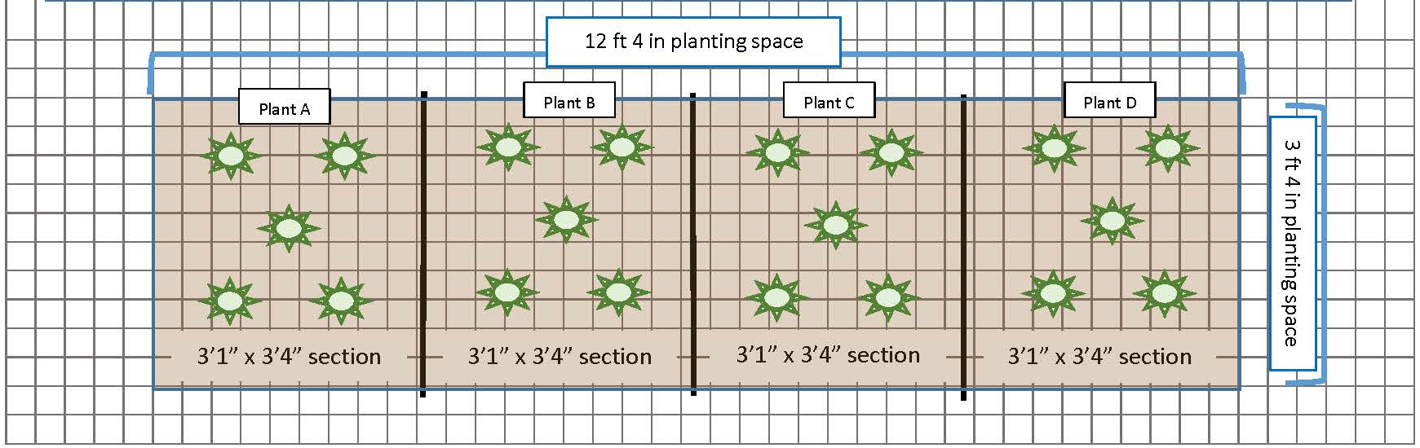
(1) Mature Tree
(2) Fruit-producing Bushes *need male & female of same species
(2) Evergreen Shrubs
Estimated Total Cost for Garden Materials (with signage & plants): $1,580

Additional *Optional* Large Songbird Sanctuary Materials, Signage & Plants
(1) Mature Tree
(2) Fruit-producing Bushes *need male & female of same species
(2) Evergreen Shrubs
1 CF/32 Qt Bag of Organic Top Soil - 1 bag per bush & 2 bags per tree to mix with current soil around roots of bush/tree
1 CF Bag of Organic Compost & Manure - 1/4 bag per bush & 1/2 bag per tree to mix with current soil around roots of bush/tree
2 CF Bags of Organic Drainage and Aeration Soil Conditioner - 1/4 bag per bush & 1/2 bag per tree to mix with current soil around roots of bush/tree
Plant ID Signs (one for each plant species)
Biomarkers to hold Plant ID signs
(2) Solar-powered Birdhouse Cameras
(1) Solar-powered Smart Feeder with Camera

