
Outdoor Learning Station Project Plan:
Materials Budget and Construction Instructions for
Simple Songbird Sanctuary
A simple Songbird Sanctuary is an area that provides a home or habitat (food, water, shelter & places to raise young) for songbirds. In your Habitat Lab, native trees and shrubs provide shelter and produce mast (nuts or fruit) that provide food for backyard birds. Bird baths and feeders can supplement their food and water sources. Artificial nesting boxes should be included for cavity-nesting birds such as bluebirds or wrens.
- Habitat Requirements:
- Low Traffic Flow (so that students are not continuously walking by the bird feeders and/or nesting boxes)
- Established “Cover” (if you have existing bushes or trees so the birds will feel safe from predators you will not need to purchase them for your Materials List below)
- Area Approved for Digging (areas where a tree(s) will be planted must not have any utility lines that could be damaged due to digging or from the root system(s) of the tree(s))
- Full sun for 6-8 hours per day for optimal plant growth

- Example Simple Songbird Sanctuary Pictures & Educational Sign:
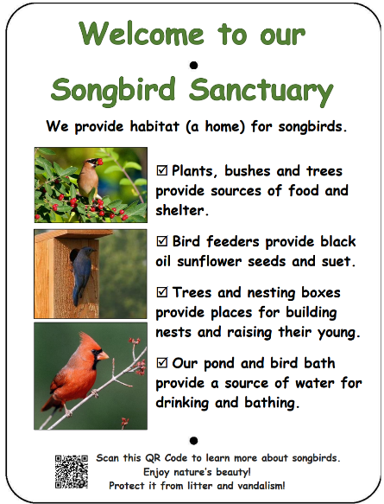
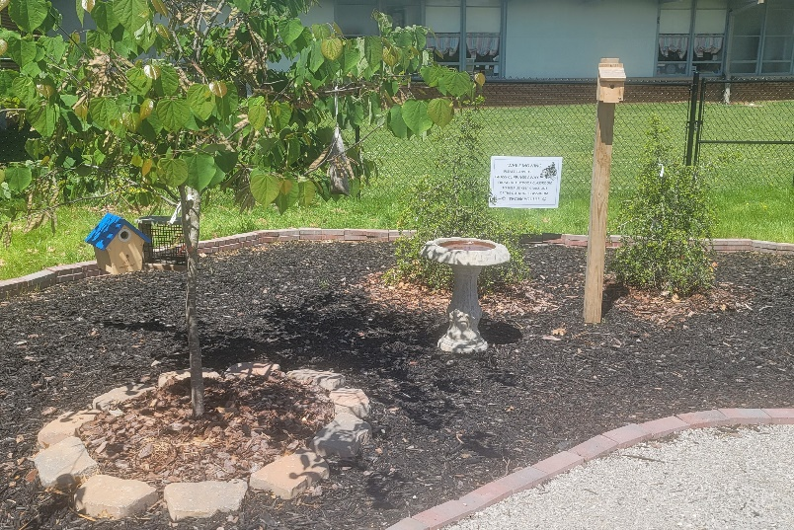

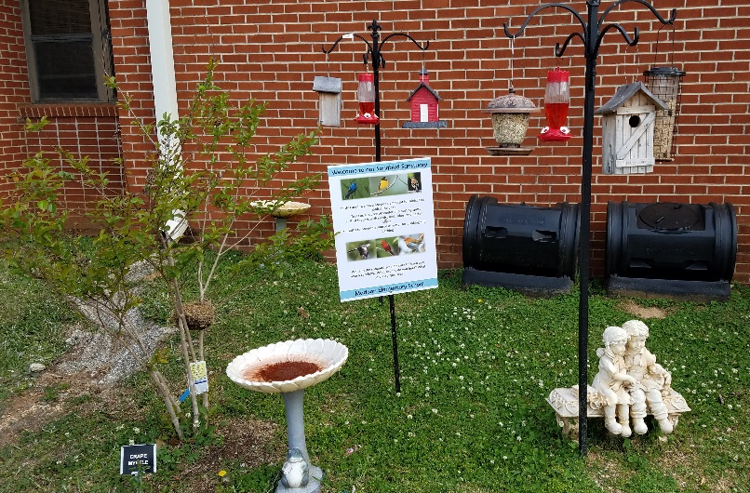
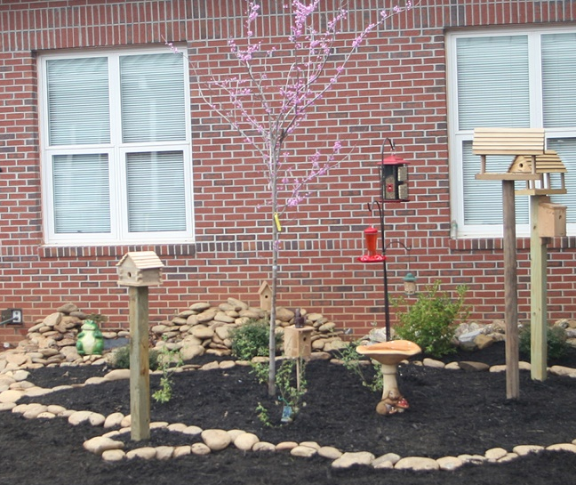
Project Plan for Simple Songbird Sanctuary

- Materials List with Estimated Budget:
*Listed prices are as of June 2025. They are subject to change.
Example Simple Songbird Sanctuary
Trees, bushes, bird bath, bird feeders, and bird houses
Station | Materials & Supplies | Estimated Cost | Example Source | Final Cost
Required Simple Songbird Sanctuary Materials, Signage & Plants
S-Sngbrd | (1) Can of Rust-Oleum Professional White Water-based Marking Paint (for marking plant placements) @~$9.98 ea | $10 | Lowe’s Item #429750
S-Sngbrd | (1) Mature Tree (see species list at www.alabamawildlife.org/habitat-lab-plant-suggestions/#songbird) @ ~$125 ea | $125 | Nursery via HLL Specialist
S-Sngbrd | (2) Fruit-producing Bushes *need male & female of same species (see species list at www.alabamawildlife.org/habitat-lab-plant-suggestions/#songbird) @ ~$30 ea | $60 total | Nursery via HLL Specialist
S-Sngbrd | (2) Evergreen Shrubs (see species list at www.alabamawildlife.org/habitat-lab-plant-suggestions/#songbird)) @ ~$30 ea | $60 total | Nursery via HLL Specialist
S-Sngbrd | (6) 1 CF/32 Qt Bags of Evergreen Organic Top Soil (to mix with current soil and other amendments - 1 bag/ bush, 2 bags/ tree) @~$2.18 each | $15 total | Lowe’s Item #648834
S-Sngbrd | (2) 1 CF Bags of Evergreen Organic Compost & Manure (to mix with current soil and other amendments - ¼ bag/ bush, ½ bag/ tree) @~$3.68 ea | $10 total | Lowe’s Item #380606
S-Sngbrd | (2) 2 CF Bags of Evergreen Organic Drainage and Aeration Soil Conditioner (to mix with current soil and other amendments - ¼ bag/ bush, ½ bag/ tree) @~$4.58 ea | $10 total | Lowe’s Item #648829
S-Sngbrd | (1) 26-in H Natural Concrete Birdbath Pedestal (must be sturdy) (bird bath pedestal and bowl sold separately) @ ~$19.98 ea | $20 | Lowe’s Item #10011
S-Sngbrd | (1) 4-in H Natural Concrete Birdbath Bowl  @ ~$19.98 ea | $20 | Lowe’s Item #10014
S-Sngbrd | (1) Mademax Solar Bird Bath Fountain Pump, Upgrade 1.4W Solar Fountain with 4 Nozzle, Free Standing Floating Solar Powered Water Fountain Pump @ ~$16.79 ea | $15 | https://a.co/d/d4lvX4y

Project Plan for Simple Songbird Sanctuary

- Materials List with Estimated Budget (continued):
S-Sngbrd | (1) Garden Accents 84-in Black Powder Coated Metal Scroll Shepherd's Hook @ ~$25.98 ea | $25 | Lowe’s Item #82066
S-Sngbrd | (1) 18 in. Wrap Around Squirrel Baffler (to keep squirrels from climbing feeder station pole) @ ~$24.99 ea | $25 | Home Depot Internet #203074700
S-Sngbrd | (1) HomeGrown Eastern Red Cedar Wood Seed/Suet Bird Feeder @ ~$13.98 ea | $15 | Lowe’s Item #791983
S-Sngbrd | (1) Style Selections Green Plastic Hopper Bird Feeder @ ~$18.68 ea | $20 | Lowe’s Item #1508755
S-Sngbrd | (1) Perky-Pet Favored Pinch-Waist Glass Hanging Squirrel-Resistant Nectar Hummingbird feeder - 16-oz @ ~$10.98 ea | $10 | Lowe’s Item #926625
S-Sngbrd | (2) National Audubon Society 11-oz Suet  (multiple varieties available) @ ~$1.98 ea | $5 total (recurring) | Lowe’s Item #926626
S-Sngbrd | (1) National Audubon Society 40-lb Black Oil Sunflower Bird Seed (smaller bags are available if needed based on storage abilities and use) @ ~$34.98 ea | $35 (recurring) | Lowe’s Item #926646
S-Sngbrd | (1) Woodlink 8-in H Tan Wood Wren Nesting Box Bird House @ ~$30.19 ea | $30 | Lowe’s Item #1287037
S-Sngbrd | (1) CARTMAN 0.5 Inch Thick Blue Bird Box House @ ~$12.34 ea | $10 | https://a.co/d/26i0YOM
S-Sngbrd | (2) Severe Weather 4-in x 4 in. x 6-ft #2 Ground Contact Wood Pressure Treated Lumber (1 each for birdhouses) @ ~$10.28 ea | $20 total | Lowe’s Item #312530
S-Sngbrd | (1) 50-lb bag Fast Setting Concrete Mix (for birdhouse posts) @ ~$6.91 ea | $5 | Lowe’s Item #10437
S-Sngbrd | (2) 18 in. Dia Black Powder Coat Squirrel Deflector For 4 x 4 Post (to keep predators from climbing posts) @ ~$29.10 ea | $60 total | Home Depot Internet #205188267
S-Sngbrd | (1) Box of Hillman 8 x 2-in Wood To Wood Deck Screws (attach boxes posts) *will not need all 50 for this project, hold onto extras for other OC projects  @ ~$7.98 ea | $10 | Lowe’s Item #755728
S-Sngbrd | (3) Plant ID Signs (one for each plant species) @~6 ea | $20 total | Ask HLL Specialist
S-Sngbrd | (3) Biomarkers to hold Plant ID signs (13” stake with a 2” x 4” plate) @ ~$3 ea (includes S&H) | $10 total | Via HLL Specialist or mcgbiomarkers.com/shop/
S-Sngbrd | (1) 6 ft. U-Post for Fence (for educational sign) @~$9.82 ea | $10 | Lowe’s Item #493054

Project Plan for Simple Songbird Sanctuary

- Materials List with Estimated Budget (continued):
S-Sngbrd | (1) Hillman 1/4-in x 1-1/2-in Zinc-Plated Coarse Thread Hex Bolt (2-Count) @~$.0.88 ea | $5 total | Lowe’s Item# 137634
S-Sngbrd | (2) Hillman 1/4-in x 20 Zinc-Plated Steel Hex Nut @~$0.10 ea | $5 total | Lowe’s Item# 63301
S-Sngbrd | (2) Hillman 1/4-in Zinc-plated Standard Flat Washer @~$0.15 ea | $5 total | Lowe’s Item# 63306
S-Sngbrd | Educational Sign (to explain Songbird Habitat) @~$75 ea | $75 | Ask HLL Specialist
S-Sngbrd | (1) Gorilla Clear 3.75-fl oz Liquid Extreme Condition Waterproof, Quick Dry, Multipurpose Adhesive @~$9.28 ea (to attach Plant ID signs to stakes) | $10 | Lowe’s Item# 955829
Estimated Total Cost for Garden Materials (with signage & plants): $745

Additional *Optional* Simple Songbird Sanctuary Materials, Signage & Plants
Station | Materials & Supplies | Estimated Cost | Example Source | Final Cost
S-Sngbrd | Mature Trees (see species list at www.alabamawildlife.org/habitat-lab-plant-suggestions/#songbird) @ ~$125 ea | Depends on Quantity | Nursery via HLL Specialist
S-Sngbrd | Fruit-producing Bushes *need male & female of same species (see species list at www.alabamawildlife.org/habitat-lab-plant-suggestions/#songbird) @ ~$30 ea | Depends on Quantity | Nursery via HLL Specialist
S-Sngbrd | Evergreen Shrubs (see species list at www.alabamawildlife.org/habitat-lab-plant-suggestions/#songbird) @ ~$30 ea | Depends on Quantity | HLL Specialist
S-Sngbrd | 1 CF/32 Qt Bags of Evergreen Organic Top Soil (to mix with current soil and other amendments) @~$2.18 each | 1 bag/ bush  2 bags/ tree | Lowe’s Item #648834
S-Sngbrd | 1 CF Bags of Evergreen Organic Compost & Manure (to mix with current soil and other amendments) @~$3.68 ea | ¼ bag/ bush  ½ bag/ tree | Lowe’s Item #380606
S-Sngbrd | 2 CF Bags of Evergreen Organic Drainage and Aeration Soil Conditioner (to mix with current soil and other amendments) @~$4.58 ea | ¼ bag/ bush  ½ bag/ tree | Lowe’s Item #648829

Project Plan for Simple Songbird Sanctuary

- Materials List with Estimated Budget (continued):

S-Sngbrd | Plant ID Signs (one for each plant species) @~6 ea | Depends on Quantity | Ask HLL Specialist
S-Sngbrd | (3) Biomarkers to hold Plant ID signs (13” stake with a 2” x 4” plate) @ ~$3 ea (includes S&H) | Depends on Quantity | Via AWF Consultant or mcgbiomarkers.com/shop/

- Construction Tools:
- (8) Shovels (4 for adults & 4 for children)
- Pick ax for removing large rocks if necessary
- (1-2) Wheelbarrows for moving grass clumps and soil
- (24-30) 1-gallon milk jugs (with tops cut off but handles remaining) for students to move excavated dirt, sand, soil, etc.
- (4-6) Hand-held trowels (for stirring soil amendments together)
- Water hose for watering plants at end of day

- Construction Instructions for Simple Songbird Sanctuary
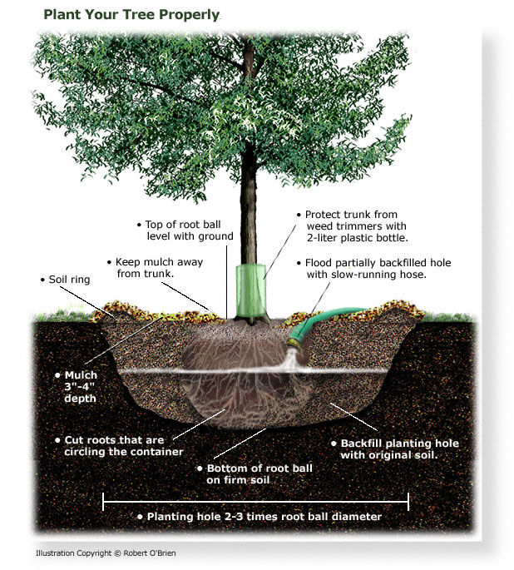
- Gather construction tools and purchase supplies to have them on-hand for the construction day.
- Decide where you want to plant your tree(s), bushes, &/or other plants, and place the plants in those locations. Spray-paint a circle twice the diameter of each plant’s pot.
- Plant the tree(s). See Alabama Cooperative Extension Publication ANR-1405 for tree planting instructions. (https://ssl.acesag.auburn.
edu/pubs/docs/A/ANR-1405/ANR-1405-archive.pdf )
- Dig a hole 2-3 times the width of the root ball of the tree and three inches deeper than the height of the root ball.
- Mix the soil that has been excavated with the top soil, compost/ manure, and soil conditioner to create an enriched and aerated soil for the tree to grow in.

Project Plan for Simple Songbird Sanctuary

- Construction Instructions (continued):
- Loosen the soil at the bottom & sides of the hole, then add 3 inches of the enriched soil into the bottom of the hole.
- Remove the tree from the pot and loosen the roots by hand. If the roots wrap around the root ball, try to loosen them or cut them so that they can spread outward. If the tree is in a burlap ball, place the tree in the hole and then carefully cut the burlap bag and let it fall into the hole. The burlap will biodegrade with time.
- Place the tree in the hole, making certain that the trunk of the tree is straight and not leaning to one side. The top of the root ball should be even with the ground or slightly higher by no more than an inch.
- Fill the hole around the root ball with the enriched soil, and then thoroughly soak it with a hose for 5-10 minutes.
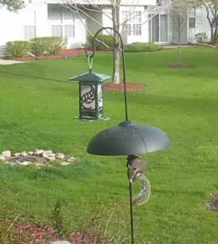
- Plant the fruit-bearing & evergreen shrubs following the same steps as those for planting the tree (above).
- Choose a spot for your bird feeder station(s) that is at least six feet from the closest tree or limb to help keep squirrels from jumping on the bird feeders. If possible, pick a location in front of a hall window where students can watch the birds. Install the bird feeder station(s) with shepherd hooks and a baffle half way up the pole.
- Fill the bird feeders with seed, suet, meal worms, fruit, etc., and then attach each bird feeder to a shepherd’s hook.
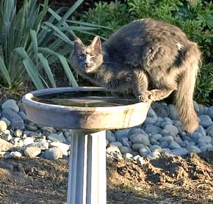
- Install the bird bath and add water to the basin. Install the solar fountain. Select bird bath location at least 6 feet from trees and bushes
so that predators cannot ambush the birds in the bird bath.
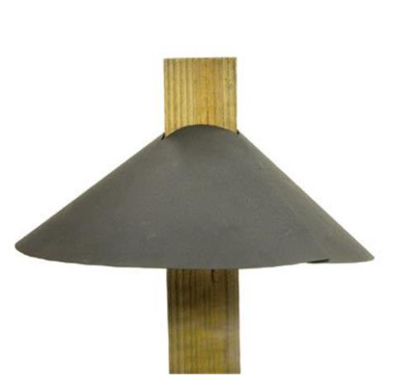
- Choose locations for bird houses (or nesting boxes) that are as far apart as possible while still remaining in the outdoor classroom area. If you are installing multiple bluebird boxes, refer to this site for information on placement. www.nestwatch.org/learn/all-about-bird
houses/birds/eastern-bluebird/.
- Attach bird houses to top of 4” x 4”’s. Install baffles. Dig 1-ft-deep hole to install 4” x 4”’s one foot in the ground to stabilize the bird houses (or nesting boxes). Use concrete around the base of the 4”x4” in the hole if needed; if not, then pack dirt back in hole around the base of the 4” x 4”.
- Water all of the new plantings thoroughly.

