
Outdoor Learning Station Project Plan:
Materials Budget and Construction Tips for
Weather Station
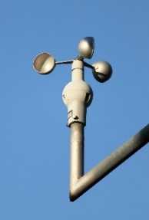
The weather station in your Habitat Lab includes various weather instruments that you can use to measure, record and track weather conditions over time.
- Thermometer measures the air temperature.
- Anemometer (pictured right) measures wind speed.
- Hygrometer measures humidity, or the amount of water vapor in the air.
- Rain gauge measures the amount of rain that has fallen over a specific time period.
- Barometer measures air pressure in the atmosphere, also called barometric pressure.
- Wind sock is a cone-shaped tube of fabric, which resembles a giant sock, attached to pole that rotates. It helps us determine wind direction and relative wind speed.
- Cardinal directions sign, for which we have a separate project plan, includes directional signs pointing North, South, East, and West attached to a 4”x4” post. Use the cardinal directions sign in your Habitat Lab along with your wind sock to determine the direction the wind is blowing.
- Example Weather Stations & Educational Sign:
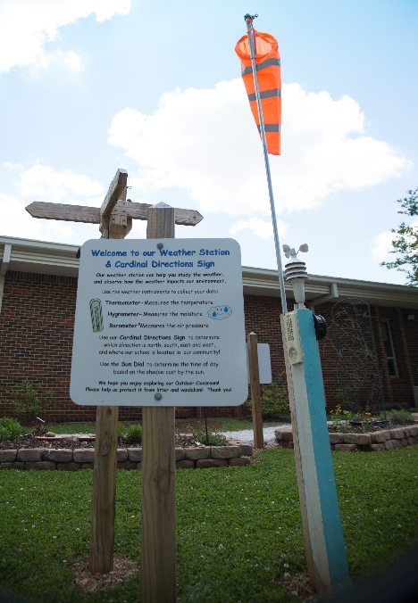
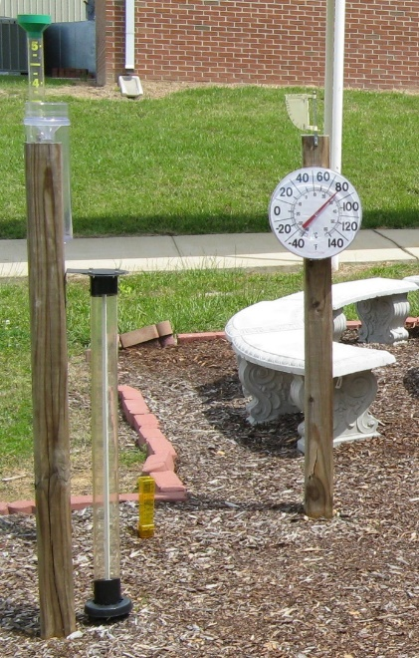

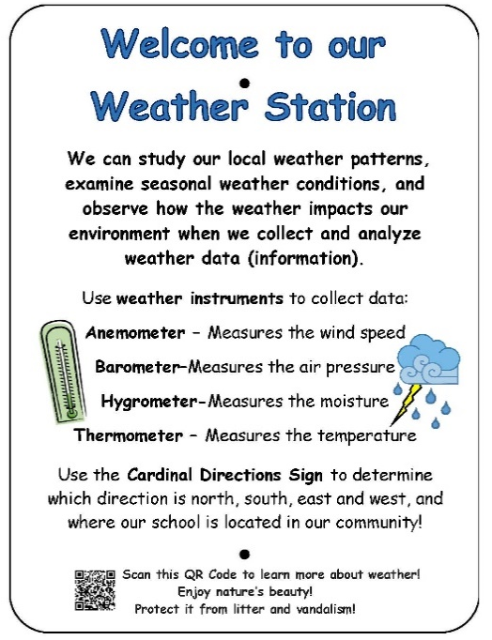

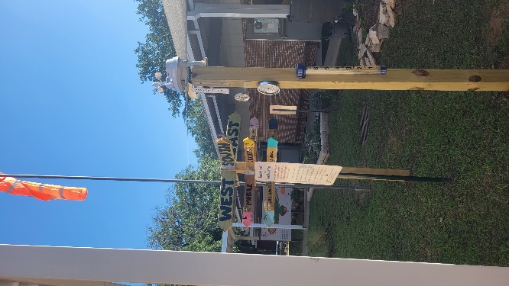


Project Plan for Weather Station

Example Analog Weather Station
A weather station should include an analog thermometer (for air temperature) and analog rain gauge (for rainfall) so that the students can practice reading a thermometer and reading the measurements in a rain gauge, a weather sock and cardinal directions sign so that students can determine the direction of the wind, and an anemometer (for wind speed), a hygrometer (for humidity), and barometer (for air pressure). A project plan for a cardinal directions sign can be found on the AWF website.
Station | Materials & Supplies | Estimated Cost | Example Source | Final Cost
Weather | Large (5”) Rain Gauge (this one is easy to read, and it is easy to empty and then put back after the students have recorded their measurements) @~$10.13 + S&H ea | $15 | https://www.grainger.com/product/3KXZ5
Weather | Large Analog Thermometer (easy to read and should be easy to mount on your weather station post) @~$3.98 ea | $5 | Lowe’s Item# 396644
Weather | Outdoor Analog Hygrometer (to measure humidity – this one is a combo with a thermometer, but we suggest you still include a traditional analog thermometer so that students can learn how to read it.) @~$9.78 ea | $10 | Lowe’s Item# 2737940
Weather | Outdoor Analog Barometer (this instrument can be used to help predict weather events hours in advance because it measures the air pressure) @~$31.28 ea | $35 | https://a.co/d/7GYUeea
Weather | Anemometer (measures wind speed. This one is included in a solar powered digital weather station.) @~$114.19 ea | $115 | https://a.co/d/4UpVCy6
Weather | Waterproof Connection Box 11 x 4 x 3 inches (to store and protect anemometer receiver) @~$15.29 ea | $15 | https://a.co/d/aJwTSym
Weather | Wind Sock @~$12.39 ea | $10 | https://a.co/d/5zbU2vn
Weather | (1) Severe Weather 4-in x 8-ft #2 Ground Contact Wood Pressure Treated Lumber (to attach instruments to) @~$10.68 ea | $10 | Lowe’s Item# 552328
Weather | (1) Box of (50) 3.5” #10 exterior deck screws (to attach the weather instruments; not all will be used on the weather station so save remaining for Cardinal Directions sign) @ ~$9.98 ea | $10 | Lowe’s Item# 9479
Weather | (1) 50 lb bags of Quikrete Fast Setting Concrete Mix @~$6.91 ea | $5 | Lowe’s Item# 10437
Weather | (1) 6 ft. U-Post for Fence (for educational sign) @~$10.69 ea | $10 | Lowe’s Item #493054
Weather | Educational Sign (to explain weather station) @~$75 ea | $75 | Ask HLL Specialist
Weather | (1) Hillman 1/4-in x 1-1/2-in Zinc-Plated Coarse Thread Hex Bolt (2-Count) @~$.0.88 ea | $5 total | Lowe’s Item# 137634
Weather | (2) Hillman 1/4-in x 20 Zinc-Plated Steel Hex Nut @~$0.10 ea | $5 total | Lowe’s Item# 63301
Weather | (2) Hillman 1/4-in Zinc-plated Standard Flat Washer @~$0.15 ea | $5 total | Lowe’s Item# 63306
Total Estimated Cost: $335
- Materials & Supplies with Estimated Budget:
*Listed prices are as of December 2024. They are subject to change.

Project Plan for Weather Station

- Construction Tips

- Purchase supplies and have them on-hand for the Habitat Lab Build Day.
- Select a spot for your weather station next to the Cardinal Directions Sign in the middle/ open area of your Habitat Lab. Do not put it next to a tree or building that might block the wind or shade the thermometer.
- Dig hole 12-18 inches deep and 6 inches wide where you want to place the 4”x4” post for the sign.
- Cut the 4” x 4” post to the height you want (typically no more than 4-6 ft tall) allowing for 12-18 inches to be underground in the hole.
- Place the post in the hole and set it with concrete.
- Let pressure treated lumber dry out for a few weeks.
- Paint or stain the post if you desire.
- Attach the instruments to the post. Use the tips below to help you place the instruments properly.
  - Be sure to attach your rain gauge low enough for your students to read and empty it.
  - Your anemometer will need to be mounted atop the post so it can catch the wind unobstructed. Your Wind sock should be mounted atop the post or near the top of the post in a manner that allows it to fly above the anemometer.
- Insert the educational sign post (u-post) in the ground near the garden and attached the educational sign to it using the nuts, bolts, and washers.

