
Materials Budget for Large Rain Garden

This materials budget is based on an 11’ x 18’ x 1’ rain garden in a clay-heavy site. The size and depth of your rain garden as well as the materials needed for amending the soil should be determined based on your site’s drainage area and natural soil composition. Follow the instructions for a custom rain garden in our Project Plan or in one of AL Cooperative Extension System’s (ACES) publications on their site (www.aces.edu).
Example Large Rain Garden
11 ft (W) x 8 ft (L) x 1 ft (D) rain garden 198CF (~50 CF pooling space, 50CF mulch, 99CF amended soil)
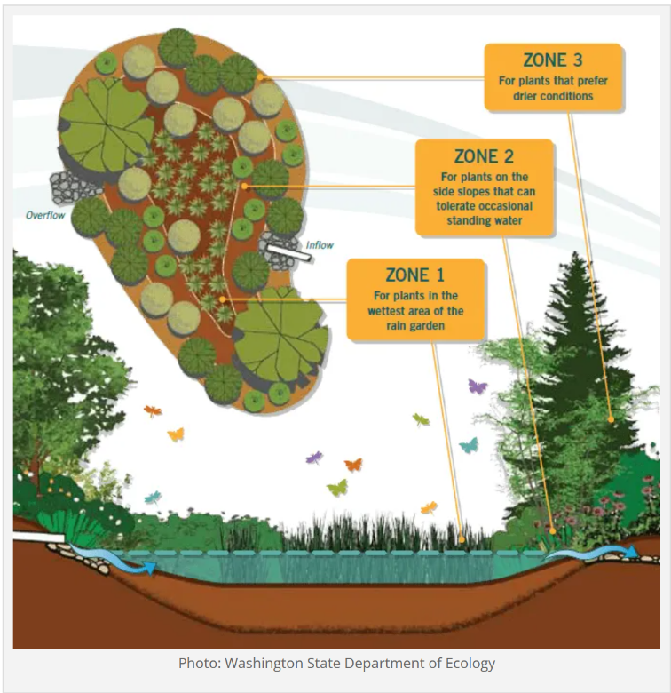
Required Large Rain Garden Materials, Signage & Plants
(1) Can of Rust-Oleum Professional White Water-based Marking Paint (for laying out garden)
(2) One Ton Pallet of Large Landscape Rock for border
(20) 1 CF/32 Qt Bags of Evergreen Organic Top Soil *If you have high quality topsoil at the site, decrease your amount of these bags.
(20) 1 CF Bags of Evergreen Organic Compost and Manure
(118) .5 CF/50 Lb Bags of American Countryside All-purpose Sand
(25) 2CF Bags of Natural Brown Hardwood Bark Mulch
(67) Rain Garden Plants (15 plants of 1 species in ponding zone; 17 plants of 1 species for transition zone; 35 plants of 1 species for edge zone)
(1) Educational Sign (about the function of wetlands and rain gardens)
(1) 6 ft. U-Post for Fence (for educational sign)
(2) 1/4-in x 1-1/2 in Zinc-Plated Coarse Thread Hex Bolt
(2) 1/4-in x 20 Zinc-Plated Steel Hex Nut
(2) 1/4-in Zinc-Plated Standard Flat Washer
(3) Plant ID Signs (one for each plant species)
(3) Biomarkers to hold Plant ID signs
(1) Bottle of Waterproof, Quick Dry, Multipurpose Adhesive (to attach Plant ID signs to stakes)
Estimated Total Cost for Garden Materials (with signage & plants): $2,140
Additional *Optional* Large Rain Garden Materials, Signage & Plants
(1) 3/8-in x 25-ft-Element Kink Free Rubber Black Soaker Hose
(1) 50-gallon RTS Home Accents Flat Back Brown Rain Barrel *if you do not have a spigot near the bog, you will need a rain barrel to help slow flow of rain water and store water for future watering
(1) RTS Home Accents Black Rain Barrel Stand (*optional – helps elevate spigot to increase water flow out of barrel and allow for room for buckets to catch water coming out of barrel)
(1) EarthMinded FlexiFit Universal Diverter System *needed if you are connecting rain barrel to downspout* (to divert downspout water into rain barrel or to the hose that links to the buried soaker hose)
(1) 5/8-in x 6-ft FLEXON Light-Duty Vinyl Green Hose (to connect soaker hose to rain barrel)

