
Outdoor Learning Station Project Plan:
Materials Budget and Construction Instructions for
Medium Rain Garden

A Rain Garden is essentially a miniature watershed. At the low point of a dry creek bed or spillway, capturing runoff from hard surfaces (roof, driveway, concrete, asphalt, etc.), a rain garden slows flow and allows rain water to be absorbed into the soil close to where the rain falls and helps to recharge groundwater instead of allowing the runoff to flow downhill to become a destructive force elsewhere. Often, stormwater overwhelms municipal sewer drains, picking up pollutants as it flows, and reaching streams and creeks where it causes more havoc such as erosion problems, sediment pollution, and nutrient pollution (nitrogen from fertilizers and from sewage). These things ultimately cause perils to our drinking water and to wildlife inhabiting the waterways.
Use this environmental concept to mitigate water issues in the schoolyard and create a wildlife habitat at the same time. The species planted should be native to your area and specific to local riparian zones (area directly next to a stream including the area where water can overflow). These native plants will act as natural water filters and hold water and soil in place. The plants will also provide habitat and food sources to wildlife.

- Location Suggestions
- Area near a downspout and/or spigot (so that you can divert rain water into the habitat and/or fill the pond and bog with water during low rain levels)
- Flat, horizontal area along or at the bottom of a sloped spillway (to slow flow of runoff during rain)
- Area approved for digging (must not have any utility lines in the area) and at least 10 feet away from the school’s foundation
- Avoid areas where water stands for more than 24 hours (test by digging a 12" deep hole and fill it with water - if it drains in under 24 hours, your soil is good)
- Full sun or full shade (be sure to choose the appropriate plants based on your sunlight conditions)

- Determining Size and Depth
This project plan is for 8’ x 11’ x 1’, but you should determine the size and depth of your rain garden using these helpful tips below.
- The garden should be 10–35% the size of the area draining into it. Soil type will determine the percentage.
  - Clay soil infiltration rate is <0.25 in/hr, so garden should be 25-35% of the drainage area.
  - Sandy soil infiltration rate is ~0.5 in/hr, so garden should be 15-25% of the drainage area.
  - Loamy soil infiltration rate is >1.0 in/hr, so garden should be 10-20% of the drainage area.
- Your soil type will determine the depth and amendments for your rain garden.
  - For clay soil (poor drainage, compacts easily):
    - A deeper bog is appropriate (8-12”). Amend soil to 50-60% coarse sand, 20-30% compost, and 10-20% topsoil. If topsoil layer of ground is compacted or too clay-heavy, use store-bought topsoil instead.

Project Plan for Small Rain Garden
- Determining Size and Depth (continued):
  - For sandy soil (fast-draining, low in nutrients):
    - Bog should be around 6-8” deep. Amend soil to 10% topsoil or clayey loam, 30% compost, and 60% existing sandy soil. If topsoil layer of ground is compacted or too clay-heavy, use store-bought topsoil instead.
  - For loamy soil (ideal, well-balanced):
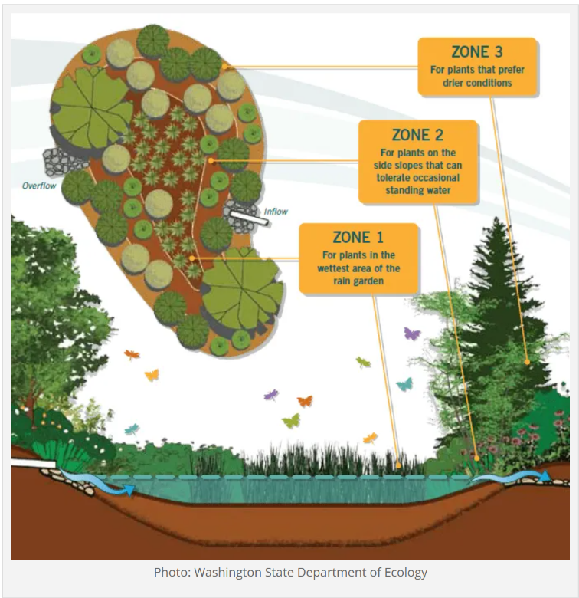
    - Bog should be around 6-12” deep. Amend soil to 10% sand, 30% compost, and 60% existing loam soil.
- Depth across the garden will vary based on zones. The garden should have three different zones. Use this ratio as a guide, but know that your landscape and soil type will ultimately determine how your zones are laid out.
  - The ponding zone should be about 30-40% of the total garden area. It should be in the center and be the deepest. This will collect most of the water after heavy rain.
  - The transition zone should be 30-40% of the total garden area. It surrounds the ponding zone.
  - The upland or edge zone should be about 20-30% of the total garden area. It is the outer rim or highest side of the garden.

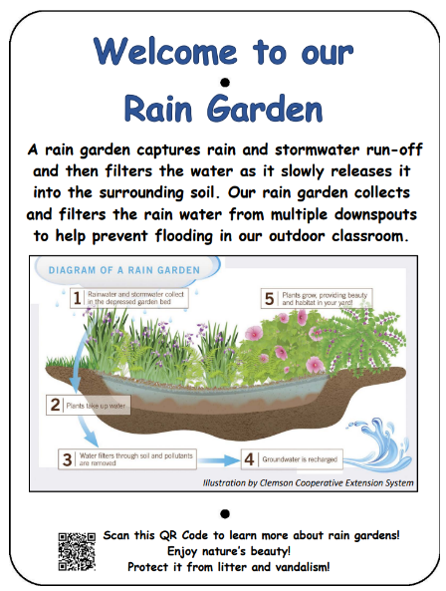
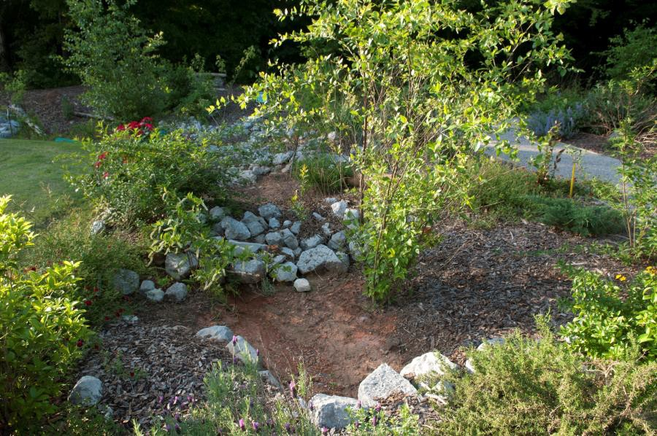

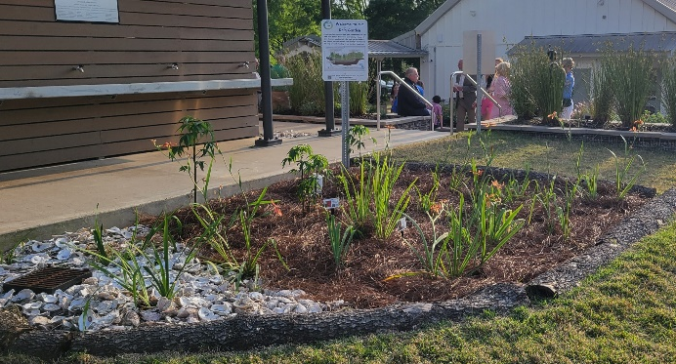

Project Plan for Medium Rain Garden
Example Medium Rain Garden
8-ft x 11-ft x 1-ft 88CF
top 3” will be left empty, then 3” mulch (22CF), then 6” of amended soil (44CF)
This example is based on a clay-heavy site.
Station | Materials & Supplies | Estimated Cost | Example Source | Final Cost
Required Medium Rain Garden Materials, Signage & Plants
Md. Rain Garden | (1) Can of Rust-Oleum Professional White Water-based Marking Paint (for laying out garden) @~$9.98 ea | $10 | Lowe’s Item #429750
Md. Rain Garden | (1) One Ton Pallet of Large Landscape Rock for border | $350 | Local Landscape Materials Company
Md. Rain Garden | (9) 1 CF/32 Qt Bags of Evergreen Organic Top Soil @~$2.18 each *If you have high quality topsoil at the site, decrease your amount of these bags. | $20 total | Lowe’s Item #648834
Md. Rain Garden | (9) 1 CF Bags of Evergreen Organic Compost and Manure @~$3.68 ea | $35 total | Lowe’s Item #380606
Md. Rain Garden | (52) .5 CF/50 Lb Bags of American Countryside All-purpose Sand @ ~$5.18 ea (or bulk order of 26CF or 1 CY) | $270 total | Lowe’s Item# 104898
Md. Rain Garden | (11) 2CF Bags of Natural Brown Hardwood Bark Mulch @~$3.98 ea | $45 total | Lowe’s Item #648830
Md. Rain Garden | (34) Rain Garden Plants (4 plants of 1 species in ponding zone; 10 plants of 1 species for transition zone; 20 plants of 1 species for edge zone) @ ~$7 ea | $240 total | Nursery via HLL Specialist
Md. Rain Garden | Educational Sign (about purpose of rain garden) | $75 | Ask HLL Specialist
Md. Rain Garden | (1) 6 ft. U-Post for Fence (for educational sign) @~$10.69 ea | $10 | Lowe’s Item #493054
Md. Rain Garden | (1) Hillman 1/4-in x 1-1/2-in Zinc-Plated Coarse Thread Hex Bolt (2-Count) @~$0.88 ea | $5 total | Lowe’s Item #137634
Md. Rain Garden | (2) Hillman 1/4-in x 20 Zinc-Plated Steel Hex Nut @~$0.10 ea | $5 total | Lowe’s Item #63301
Md. Rain Garden | (2) Hillman 1/4-in Zinc-plated Standard Flat Washer @~$0.15 ea | $5 total | Lowe’s Item #63306
Md. Rain Garden | (3) Plant ID Signs @ ~$6 ea | $20 total | Ask HLL Specialist
Md. Rain Garden | (3) Biomarkers to hold Plant ID signs (13” stake with a 2” x 4” plate) @ ~$3 ea (includes S&H) | $10 total | Via HLL Specialist or mcgbiomarkers.com/shop/
Md. Rain Garden | (1) Gorilla Clear 3.75-fl oz Liquid Extreme Condition Waterproof, Quick Dry, Multipurpose Adhesive @~$9.28 ea (to attach Plant ID signs to stakes) | $10 | Lowe’s Item# 955829
Estimated Total Cost for Materials (with signage & plants): $1,100
- Materials List with Estimated Budget:
*Listed prices are as of June 2025. They are subject to change.
Project Plan for Medium Rain Garden
- Materials List with Estimated Budget (continued):
Additional *Optional* Medium Rain Garden Materials, Signage & Plants
Md. Rain Garden | (1) 3/8-in x 25-ft-Element Kink Free Rubber Black Soaker Hose @ ~$15.98 ea | $15 | Lowe’s Item #2626704
Md. Rain Garden | (1) 50-gallon RTS Home Accents Flat Back Brown Rain Barrel @ ~$209.00 ea *if you do not have a spigot near the bog, you will need a rain barrel to help slow flow of rain water and store water for future watering | $210 | Lowe’s Item #4057929
Md. Rain Garden | (1) RTS Home Accents Black Rain Barrel Stand @ ~$72.98 ea (*optional – helps elevate spigot to increase water flow out of barrel and allow for room for buckets to catch water coming out of barrel) | $75 | Lowe’s Item #4057926
Md. Rain Garden | (1) EarthMinded FlexiFit Universal Diverter System @ ~$35.95 ea *needed if you are connecting rain barrel to downspout* (to divert downspout water into rain barrel or to the hose that links to the buried soaker hose) | $35 | https://www.therainbarreldepot.com/earthminded-universal-diverter-system/
Md. Rain Garden | (1) 5/8-in x 6-ft FLEXON Light-Duty Vinyl Green Hose (to connect soaker hose to rain barrel) @ ~$11.98 ea | $10 | Lowe’s Item #812743

- Construction Tools
- (8) Shovels (4 for adults & 4 for children)
- (1) Pick ax for removal of large stones if necessary
- (2-4) Wheelbarrows
- (4-6) buckets or 1-gallon milk jugs (with tops cut off but handles remaining) for students to move dirt, peat moss, sand, etc. if they are in piles rather than bags
- Water hose for watering plants at the end of day
- Construction Instructions for Rain Garden
- Gather construction tools and purchase supplies to have them on-hand for the construction day.
- Measure out an 8 ft x 11 ft rectangle and mark its boundaries with landscaping spray paint; then draw desired shape of rain garden that fits within the rectangle using the landscaping spray paint. Rain gardens are typically teardrop- or kidney-shaped.
- Dig out the rain garden. Remember that the deepest part should be in the center, surrounded by a gradual slope. The top 5-8” inches of excavated soil are considered “topsoil” and should be saved to mix with amendments before refilling the depression. Excavated soil (beyond 8” deep) can be used to create a berm on the downhill side of the rain garden where the overflow will exit the rain garden. A berm is really only necessary on a sloped landscape, not a flat one. Make the berm as tall as the uphill side of the rain garden. Include a notch or low spot on the berm to direct the overflow away from structures.
Project Plan for Medium Rain Garden

- Construction Instructions (continued):
- Connect a sloping channel for incoming water. Run water through the spillway with a hose to make sure the grade of the channel is right and that rain will reach the retention area.
- Premix your top soils and amendments in a wheelbarrow or on the ground on top of a tarp.
- Fill the depression with your mixture of native soil, top soil, compost, sand, and soil conditioner. Reserve some of the ingredients to make a soil mixture to add to holes when planting. Reserve some of the mixture to add to holes when planting.
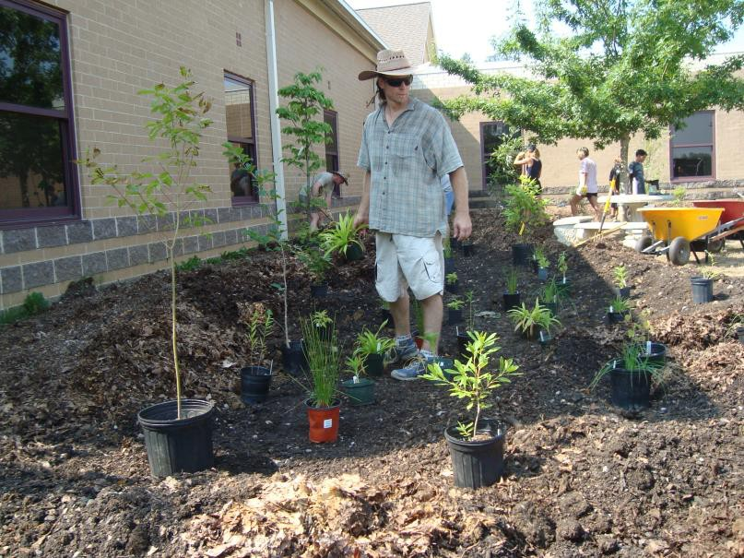
- Use rocks and logs to decorate your rain garden. Strategically place stones or gravel at the entry point to slow down the flow of water and reduce erosion.
- Plant your plants by zone. Plant species that prefer drier conditions higher on the berm or edge, plant species that are more adaptable on the slope, and plant species that prefer wetter conditions in farther into the depression in the ponding zone. Add soil mixture to each hole to improve soil for each planting. Top with the thin layer of native soil (excavated soil from hole) and compact soil around each plant.
- Top the garden with a 3” layer of mulch and water new plantings thoroughly.
- Attach Plant ID signs to stakes using adhesive. Sink the stakes a few inches into the ground in front of the appropriate plant species grouping, tree, or bush.
- Insert the educational sign post (u-post) in the ground near the garden and attached the educational sign to it using the nuts, bolts, and washers.
- Optional: Install Rain Barrel on downspout near the Rain Garden, and attach a soaker hose to the rain barrel to funnel rain water into the garden.

