
Materials Budget for Sensory Garden (4-sided)
Example Sensory Garden (4-sided)
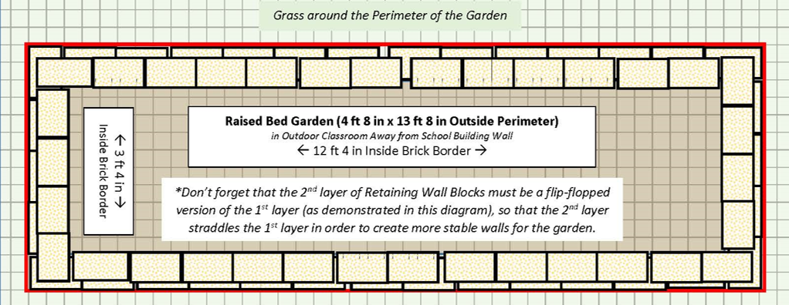
4 ft 8 in (W) x 13 ft 8 in (L) x 6” (D) 4-sided raised bed garden ~20 CF)
Required Sensory Garden Materials, Signage & Plants
(1) Can of White Water-based Marking Paint (for laying out garden)
(70) 4” x 12” Retaining Wall Blocks (to create four sides of raised bed garden)
(1) 6’x50’ Professional Landscape Fabric (weed barrier) (16’ used for this garden)
(5) 32-Quart (1CF) Bags of Organic Potting Soil Mix (1 for hanging pots, 4 for garden)
(8) 1 CF/32 Qt Bags of Organic Top Soil (for garden)
(2) 1 CF Bags of Organic Compost and Manure (for garden)
(3) 2 CF Bags of Organic Drainage and Aeration Soil Conditioner (for garden)
(1) Package of 40 6” Black Plastic Landscape Edging Pieces (18 to create (3) 3 ft dividers between the (3) plant species to make plant ID & weeding easier)
(2) 2 CF Bags of Natural Dark Brown Pine Bark Mulch (for garden) *do NOT get black mulch as it gets hot and kills plants*
(1) Set of 34-36” wind chimes
(3) 64” Metal Shepherd’s Hook (1 for wind chimes, 2 for hanging pots)
(2) Hanging Pots (1 for annuals & 1 for mint - at wheelchair height)
Educational Sign (explain how the senses are engaged)
(1) 6 ft. U-Post for Fence (for educational sign)
(2) 1/4-in x 1-1/2 in Zinc-Plated Coarse Thread Hex Bolt
(2) 1/4-in x 20 Zinc-Plated Steel Hex Nut
(2) 1/4-in Zinc-Plated Standard Flat Washer
(5) Plant ID Signs (one for each plant species except annuals)
(5) Biomarkers to hold Plant ID signs
(1) Bottle of Waterproof, Quick Dry, Multipurpose Adhesive (to attach Plant ID signs to stakes)
Sensory Plants (including (5) of each species – (1) species for touch, (1) species for sound, (2) species for sight) *See planting diagram below.
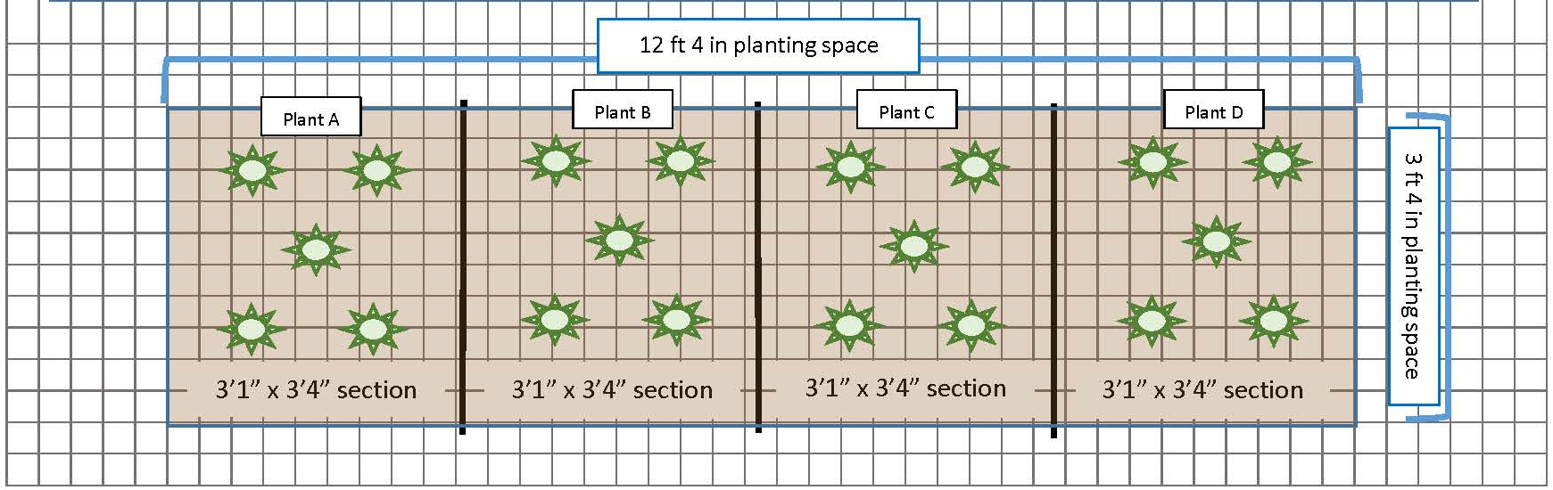
(3) mint plants for taste (plant in hanging pot, not in garden)
(3) annual plants (pick what is prettiest, smells best, etc.) (plant in hanging pot, not in garden)
Estimated Total Cost for Garden Materials (with signage & plants): $770

Additional *Optional* Sensory Garden Materials, Signage & Plants
Rosemary Bush (Excellent for scent. Best if planted in-ground near sensory garden, but some varieties will survive in pots.)
Large pot for Rosemary Bush (if you choose not to plant it in-ground)
(1) 32-Quart (1CF) Bag of Evergreen Organic Potting Soil Mix (mix with ¼ bag Compost & Manure and ¼ bag Soil Conditioner to use when planting Rosemary in-ground or in pot)
(1) 1 CF Bag of Organic Compost & Manure (mix ¼ bag with 1 bag Top Soil and ¼ bag Soil Conditioner to use when planting Rosemary in-ground or in pot)
(1) 2 CF Bags of Organic Drainage and Aeration Soil Conditioner (mix ¼ bag with 1 bag Top Soil and ¼ bag of Compost & Manure to use when planting Rosemary in-ground or in pot)
(1) 2 CF Bags of Natural Dark Brown Pine Bark Mulch (place around base of Rosemary after planting) *do NOT get black mulch as it gets hot and kills plants*
Plant ID Signs (one for each plant species)
Biomarkers to hold Plant ID sign
Additional Wind Chimes (select sets made from a variety of materials such as bamboo, glass, or shells to compare their sounds)
Additional 64” Shepherd’s Hook (one for each set of chimes)

