
Materials Budget for Veggie Garden (3-sided)

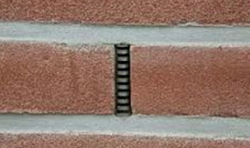
*A 3-sided garden is built against your school building so that the 4th side of the garden is the building’s brick wall. BEFORE you choose to build your garden against the building, you should look for “weep holes” in the brick (see pic on right). Do not cover your weep holes with garden soil as the soil will clog the holes. If the weep holes are less than 6 inches from the ground they would be covered by garden soil, and you need to build a 4-sided garden that is 2-3 inches out from the wall.
Example Veggie Garden (3-sided)
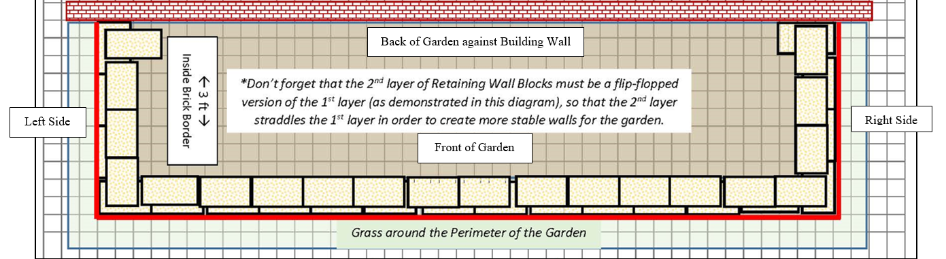
(3 ft 8 in (W) x 13 ft 8 in (L) x 6 in (D) 3-sided raised bed garden against building ~19 CF)
Sidewalk or Crushed Limestone Path
(1) Can of White Water-based Marking Paint (for laying out garden)
(40) 4” x 12” Retaining Wall Blocks (to create three sides of raised bed against school building)
(1) 6’x50’ Professional Landscape Fabric (weed barrier) (16’ used for this garden)
(4) 32-Quart (1CF) Bags of Organic Potting Soil Mix (for garden)
(7) 1 CF/32 Qt Bags of Organic Top Soil (for garden)
(2) 1 CF Bags of Organic Compost and Manure (for garden)
(3) 2 CF Bags of Organic Drainage and Aeration Soil Conditioner (for garden)
(1) Package of 40 6” Black Plastic Landscape Edging Pieces (to divide species to make plant ID & weeding easier)
(1) 2 CF Bags of Natural Dark Brown Pine Bark Mulch (for garden) *do NOT get black mulch as it gets hot and kills plants*
Seeds or potted plants – your preferred selection of vegetables and companion plants
(1) Educational Sign
(1) 6 ft. U-Post for Fence (for educational sign)
(2) 1/4-in x 1-1/2 in Zinc-Plated Coarse Thread Hex Bolt
(2) 1/4-in x 20 Zinc-Plated Steel Hex Nut
(2) 1/4-in Zinc-Plated Standard Flat Washer
Estimated Total Cost for Garden Materials (with signage & plants): $380-460

