
Materials Budget for Large Frog & Toad Habitat
Example Large Frog and Toad Habitat (8 ft x 11 ft)
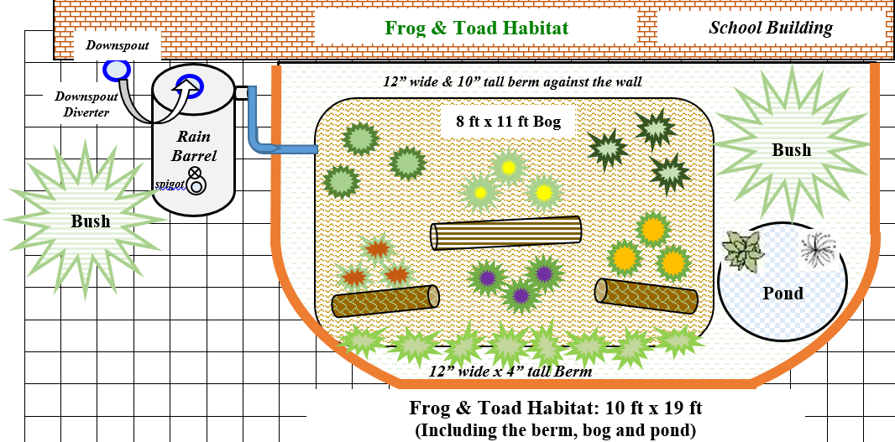
Required Habitat Materials, Signage & Plants
(1) Can of White Water-based Marking Paint (for laying out bog and pond)
(50) 11-in L x 4-in H x 6-in D Retaining Wall Blocks (trapezoid-shaped to create border around berm and 2 steps in pond) …OR… (1) ton stackable, flat natural stone
(1) 13-ft x 10-ft (600-Gallon) Black PVC Pond Liner (~8 mil thick)
(1) 3/8-in x 25-ft Kink Free Rubber Black Soaker Hose
(1) 3 CF Bag of Sphagnum Peat Moss Organic Moisture Control (1 bag expands to 6 CF)
(48) .5 CF/50 Lb Bags of All-purpose Sand
(11) 32-Quart (1CF) Bags of Organic Potting Soil Mix
(21) 1 CF/32 Qt Bags of Organic Top Soil
(2) 1 CF Bags of Organic Compost and Manure
(12) 2 CF Bag of Organic Drainage and Aeration Soil Conditioner
(2) Bales of Pine Straw (to spread around bog after planting)
(20) Wildflowers (4 species, 3 plants each – in bog; 1 species, 8 plants – for groundcover around pond/ bog)
(6) Ferns (2 species, 3 plants each – inside bog)
(1) Aquatic Plant (in pond)
(1) Native Wet-soil-tolerant Bush (to plant between pond and school wall)
(1) 3.91-ft diameter x 12” deep (64 gal) High Density Polyethylene Pre-formed Pond
…OR…
(1) 2.16 ft diameter (9 gal) High Density Polyethylene Pre-formed Pond
(2) .5 CF Bag of 1” 0.5-cu ft River Rock Gravel
(1) 5/8-in x 6-ft Hose (to connect spigot or rain barrel to soaker hose)
(1) Educational Sign (for the life cycle of frogs)
(1) 6 ft. U-Post for Fence (for educational sign)
(2) 1/4-in x 1-1/2-in Zinc-Plated Coarse Thread Hex Bolt
(2) 1/4-in x 20 Zinc-Plated Steel Hex Nut
(2) 1/4-in Zinc-plated Standard Flat Washer
(9) Plant ID Signs (one for each plant species)
(9) Biomarkers to hold Plant ID signs
(1) Bottle of Waterproof, Quick Dry, Multipurpose Adhesive (to attach Plant ID signs to stakes)
Estimated Total Cost for Habitat Bog and Pond Materials (with signage & plants): $1,385-1,445

Additional *Optional* Habitat Materials, Signage & Plants
(1) Pond Spitter Decoration and Pond Aerator
(1) Low Water Shut-off 80-GPH Submersible Fountain Pump *needed if you buy pond aerator*
(1) Clear Vinyl Tubing (tubing diameter will depend on pump and aerator selected x 10 ft) (to connect pump to spitter) *needed if you buy pond aerator and pump*
(1) 50-gallon Flat Back Rain Barrel *if you do not have a spigot near the bog, you will need a rain barrel to help slow flow of rain water and store water for future watering
(1) Rain Barrel Stand *optional – helps elevate spigot to increase water flow out of barrel and allow for room for buckets to catch water coming out of barrel
(1) EarthMinded FlexiFit Universal Diverter System *needed if you are connecting rain barrel to downspout* (to divert downspout water into rain barrel or to the hose that links to the buried soaker hose)
Bush(es) to plant nearby/ in front of downspout if it’s open-ended
1 CF/32 Qt Bags of Evergreen Organic Top Soil (to mix with current soil and other amendments if you get bushes – 1 bag per bush)
1 CF Bags of Evergreen Organic Compost & Manure (to mix with current soil and other amendments – ¼ bag per bush)
2 CF Bags of Evergreen Organic Drainage and Aeration Soil Conditioner (to mix with current soil and other amendments – ¼ bag per bush)
Plant ID Signs (one for each plant species)
Biomarkers to hold Plant ID signs
Outdoor Waterproof Solar Lights (to place around the habitat to attract bugs)

