
Outdoor Learning Station Project Plan:
Materials Budget and Construction Instructions for
Large Frog & Toad Habitat
A Frog and Toad Habitat should provide food sources, water, shelter, and places for frogs and toads to lay their eggs which will become tadpoles. To meet their habitat needs, this learning station will consist of two features built together as one habitat:
- Frog Pond – A frog pond should have shallow water where frogs and toads can lay their eggs. In a Habitat Lab, the frog pond can be a pre-formed plastic pond that is approximately 3 to 4 feet in diameter and 10 to12 inches deep with 8 to 10 inches of water and one or two pots of native marginal aquatic plants.
- Bog Garden – A bog is a type of wetland in a low-lying area where water collects, often times depositing dead, decaying plant matter. Flora and fauna that thrive in a bog area prefer a moist environment, but do not require standing water (like a pond, marsh or swamp) unless the bog area recently experienced heavy rains and has not yet drained. An example bog garden can be created in your Habitat Lab by digging a hole in the ground that is 11 ft long, 8 ft wide, and 12 inches deep, placing a 10 ft x 13 ft pond liner in the hole, and filling it with layers of peat moss, sand, and compost.
- Location Requirements:
- Area near a Downspout and/or Spigot (so that you can divert rain water into the habitat and/or fill the pond and bog with water during low rain levels)
- Flat Area (so the soil in the bottom of the bog will not flow out of the pond in a heavy rain)
- Area Approved for Digging (must not have any utility lines under the area)
- Full to Part Shade (be sure to choose the appropriate plants based on your sunlight conditions)
- Example Frog & Toad Habitat Pictures & Educational Sign:
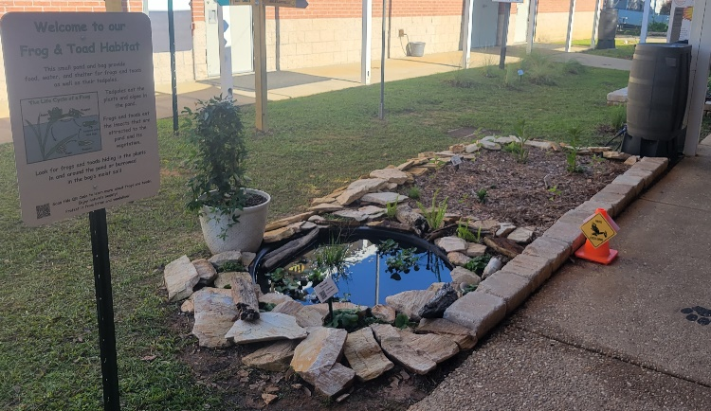
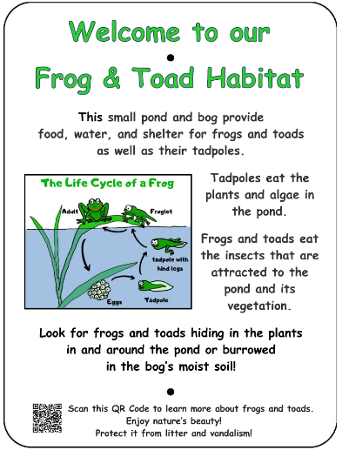

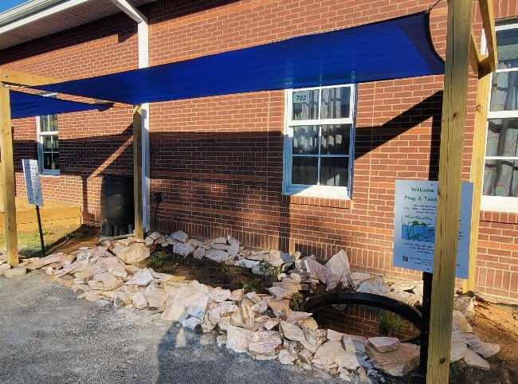

Project Plan for Large Frog and Toad Habitat

- Materials List with Estimated Budget:
*Listed prices are as of December 2024. They are subject to change.

Example Large Frog and Toad Habitat Materials Budget
(8 ft x 11 ft bog with 3’-4’ diameter pond and plants)
Station | Materials & Supplies | Estimated Cost |  | Source of Materials |  | Final Cost
Required Habitat Materials, Signage & Plants
Lg Frog | (1) Can of Rust-Oleum Professional White Water-based Marking Paint @ ~$9.98 ea |  | $10 |  | Lowe’s Item #429750
Lg Frog | (50) 11-in L x 4-in H x 6-in D Flagstone Concrete Retaining Wall Blocks (trapezoid-shaped to create 32’ border around berm and 2 steps in pond) @ ~$2.98 ea  …OR…  1 ton stackable, flat natural stone @~$350 |  | $150-350 total |  | Lowe’s Item #477095  …OR…  Local Landscape Materials Company
Lg Frog | (1) Smartpond 13-ft x 10-ft (600-Gallon) Black PVC Pond Liner (~8 mil thick) @ ~$83.48 ea |  | $85 |  | Lowe’s Item #62415
Lg Frog | (1) 3/8-in x 25-ft-Element Kink Free Rubber Black Soaker Hose @ ~$15.98 ea |  | $15 |  | Lowe’s Item #2626704
Lg Frog | (1) 3 CF Bag of Fafard Sphagnum Peat Moss Organic Moisture Control (1 bag expands to 6 CF) @ ~$21.98 ea |  | $20 |  | Lowe’s Item #674760
Lg Frog | (48) .5 CF/50 Lb Bags of American Countryside All-purpose Sand @ ~$5.18 ea |  | $250 total |  | Lowe’s Item# 104898
Lg Frog | (11) 32-Quart (1CF) Bags of Evergreen Organic Potting Soil Mix @~$6.38 ea |  | $70 total |  | Lowe’s Item #380608
Lg Frog | (21) 1 CF/32 Qt Bags of Evergreen Organic Top Soil @ ~$2.18 ea (save handful to mix with current soil and other amendments to plant bush) |  | $45 total |  | Lowe’s Item #648834
Lg Frog | (2) 1 CF Bags of Evergreen Organic Compost and Manure @~$3.68 ea (save handful to mix with current soil and other amendments to plant bush) |  | $5 total |  | Lowe’s Item #380606
Lg Frog | (12) 2 CF Bag of Evergreen Organic Drainage and Aeration Soil Conditioner @ ~$4.58 ea (save handful to mix with current soil and other amendments to plant bush) |  | $55 total |  | Lowe’s Item #648829
Lg Frog | (2) bales of pine straw (to spread around bog after planting @ ~$4.57 ea |  | $10 total |  | Lowe’s Item # 128653
Lg Frog | (20) Wildflowers (4 species, 3 plants each – in bog; 1 species, 8 plants – for groundcover around pond/ bog) @~$7 ea |  | $140 total |  | Nursery via HLL Specialist
Lg Frog | (6) Ferns (2 species, 3 plants each – inside bog) @~$10 ea |  | $60 total |  | Nursery via HLL Specialist

Project Plan for Large Frog and Toad Habitat
- Materials List with Estimated Budget (continued):

Lg Frog | (1) Aquatic Plant (in pond) | $15 | Nursery via HLL Specialist
Lg Frog | (1) Native Wet-soil-tolerant Bush (to plant between school building and pond) | $30 | Nursery via HLL Specialist
Lg Frog | (1) 3.91-ft diameter x 12” deep (64 gal) MacCourt Black High Density Polyethylene Pre-formed Pond @ ~$280.08  …OR…  (1) 2.16 ft diameter (9 gal) MacCourt Black High Density Polyethylene Pre-formed Pond @ ~$17.98 ea | $280  …OR…  $20 | Lowe’s Item #447801  …OR…  Lowe’s Item #1176703
Lg Frog | (2) .5 CF Bag of 1” American Countryside 0.5-cu ft River Rock Gravel @ ~$5.18 ea | $10 | Lowe’s Item #2623
Lg Frog | (1) 5/8-in x 6-ft FLEXON Light-Duty Vinyl Green Hose @ ~$11.98 ea | $10 | Lowe’s Item #812743
Lg Frog | Educational Sign about Life Cycle of a Frog | $75 | Ask AWF Consultant
Lg Frog | (1) 6 ft. U-Post for Fence (for educational sign) @~$10.69 ea | $10 | Lowe’s Item #493054
Lg Frog | (1) Hillman 1/4-in x 1-1/2-in Zinc-Plated Coarse Thread Hex Bolt (2-Count) @~$0.88 ea | $5 total | Lowe’s Item #137634
Lg Frog | (2) Hillman 1/4-in x 20 Zinc-Plated Steel Hex Nut @~$0.10 ea | $5 total | Lowe’s Item #63301
Lg Frog | (2) Hillman 1/4-in Zinc-plated Standard Flat Washer @~$0.15 ea | $5 total | Lowe’s Item #63306
Lg Frog | (9) Plant ID Signs @ ~$6 ea | $55 | Ask HLL Specialist
Lg Frog | (9) Biomarkers to hold Plant ID signs (13” stake with a 2” x 4” plate) @ ~$3 ea (includes S&H) | $30 | Via HLL Specialist or mcgbiomarkers.com/shop/
Lg Frog | (1) Gorilla Clear 3.75-fl oz Liquid Extreme Condition Waterproof, Quick Dry, Multipurpose Adhesive @~$9.28 ea (to attach Plant ID signs to stakes | $10 | Lowe’s Item# 955829
Estimated Total Cost for Habitat Materials (with signage & plants): $1,385-1,445
Additional *Optional* Habitat Materials, Signage & Plants
Lg Frog | (1) TetraPond Pond Spitter Decoration and Pond Aerator @~$29 ea | $30 | https://a.co/d/hLnGi2p
Lg Frog | (1) Smartpond® Low Water Shut-off 80-GPH Submersible Fountain Pump @ ~$25.98 ea *Needed if you buy pond aerator* | $25 | Lowe’s Item #2566875
Lg Frog | (1) EZ-FLO 3/8-in ID x 20-ft PVC Clear Vinyl Tubing (to connect pump to spitter) @~$12.68 ea *Needed if you buy pond aerator and pump* | $15 | Lowe’s Item #814318
Lg Frog | (1) 50-gallon RTS Home Accents Flat Back Brown Rain Barrel @ ~$209.00 ea *if you do not have a spigot near the bog, you will need a rain barrel to help slow flow of rain water and store water for future watering | $210 | Lowe’s Item #4057929

Project Plan for Large Frog and Toad Habitat
Lg Frog | (1) RTS Home Accents Black Rain Barrel Stand @ ~$72.98 ea (*optional – helps elevate spigot to increase water flow out of barrel and allow for room for buckets to catch water coming out of barrel) | $75 | Lowe’s Item #4057926
Lg Frog | (1) EarthMinded FlexiFit Universal Diverter System @ ~$35.95 ea *needed if you are connecting rain barrel to downspout* (to divert downspout water into rain barrel or to the hose that links to the buried soaker hose) | $35 | https://www.therainbarreldepot.com/earthminded-universal-diverter-system/
Lg Frog | Native wet-soil tolerant Bush(es) to plant nearby/ in front of downspout if it’s open-ended @~$30 ea | Depends on quantity | Nursery via HLL Specialist
Lg Frog | 1 CF/32 Qt Bags of Evergreen Organic Top Soil (to mix with current soil and other amendments if you get bushes – 1 bag per bush) @~$2.18 ea | 1 bag/ bush | Lowe’s Item #648834
Lg Frog | 1 CF Bags of Evergreen Organic Compost & Manure (to mix with current soil and other amendments – ¼ bag per bush) @~$3.68 ea | ¼ bag/ bush | Lowe’s Item #380606
Lg Frog | 2 CF Bags of Evergreen Organic Drainage and Aeration Soil Conditioner (to mix with current soil and other amendments – ¼ bag per bush) @~$4.58 ea | ¼ bag/ bush | Lowe’s Item #648829
Lg Frog | Plant ID Signs (one for each plant species)@ ~$6 ea | Depends on # add’l plant species | Ask HLL Specialist
Lg Frog | Biomarkers to hold Plant ID signs @ ~$3 ea (includes S&H) | Depends on # add’l plant species | Via HLL Specialist or mcgbiomarkers.com/shop/
Lg Frog | Solar Lights Outdoor Waterproof, 6 Pack @$22.79 ea | $25 | https://a.co/d/1tev0j3
- Materials List with Estimated Budget (continued):
- Construction Tools:
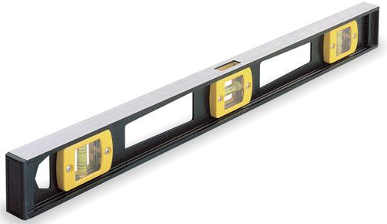
- (4) Spade Shovels for digging
- (1) pick ax for removal of large stones if necessary
- (2) Wheelbarrows for moving dirt, sand & mulch
- (4-6) 1-gallon milk jugs (with tops cut off but handles remaining)
for students to move dirt, peat moss, sand, etc. if they are in
piles rather than bags
I-beam Level
- (1) 24 or 48-inch Box Beam or I-beam Level
- Scissors or box cutter
- Water hose for filling bog and pond and for watering plants at the end of day
- Construction Instructions for Large Frog and Toad Habitat
- Procure tools, materials & supplies, and have them on-hand for the Habitat Lab Build Day.

Project Plan for Large Frog and Toad Habitat
- Construction Instructions (continued):
- Choose a location where some of the water from a nearby downspout OR a water spigot can be diverted into the bog. Measure along the wall 1 foot from the spigot (or 3 feet from the downspout to allow room for a 50-gallon rain barrel that is 2 ft in diameter) and 1 foot out from the wall (for berm between frog bog and school building), and spray paint an to mark the spot (See diagram below). This will be the corner of your bog closest to the water source (spigot or downspout).
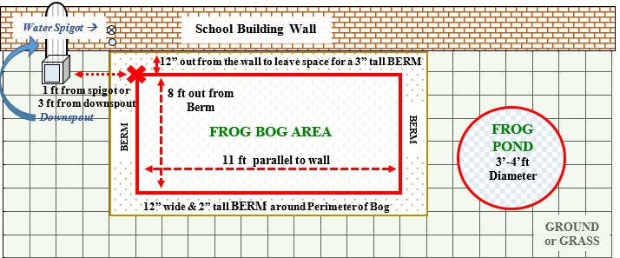
- Then spray paint the perimeter for your Frog Bog Area on the ground – 8 ft out from the back berm and 11 ft long parallel to the wall. See diagram below.

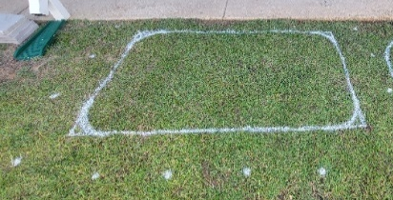
- Next measure out 12” from the perimeter of the bog to create a 12” wide Berm around the WHOLE border of the bog. You can spray paint this perimeter with dashes so you know where to build your berm. See the BERM around the Bog Area in the diagram above and the spray paint example photo on right.
- Then place the pre-formed pond that will be the Frog Pond to the side of the bog, about one foot away from the edge of the dashed berm line, and spray paint the perimeter of the pre-formed pond on the ground so that you will know where to dig. Position it towards the front end of the bog (away from school wall). See Frog Pond in diagram above.
- Dig out 4” inches of the dirt and grass inside of the spray-painted Frog Bog Area and MOVE the excavated soil & grass to the pre-determined dumping zone. **Make sure none of the grass is remaining in the frog habitat area.**
- Dig out another 8” of dirt from the Frog Bog Area and use the excavated soil to create a 12” wide, 2” tall flat berm around the whole perimeter of the Frog Bog Area. If you have more excavated dirt then is needed to build the berm, move it to the pre-determined dumping zone. If the frog & toad habitat is against a school building wall, use the dirt to make the 12” wide flat berm 3” tall (rather than 2”) behind the bog (along the wall of the building) to prevent water from accumulating at the back of the bog and leaking into the school building. Your hole for the bog will be 14” deep total 12” dug into the ground plus 2” of berm built around the perimeter. See example photo at top of page 6.

Project Plan for Large Frog and Toad Habitat
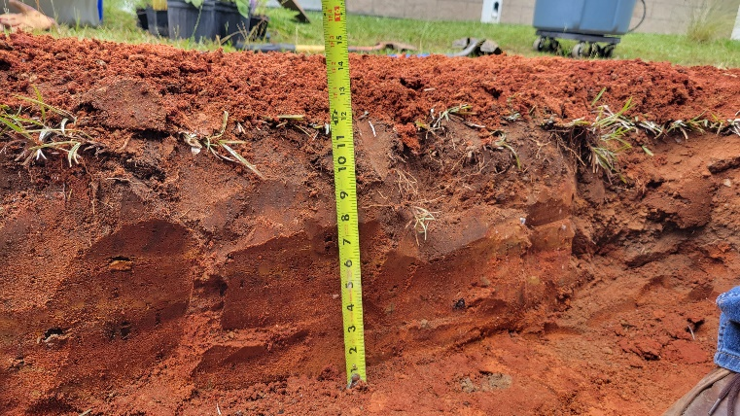
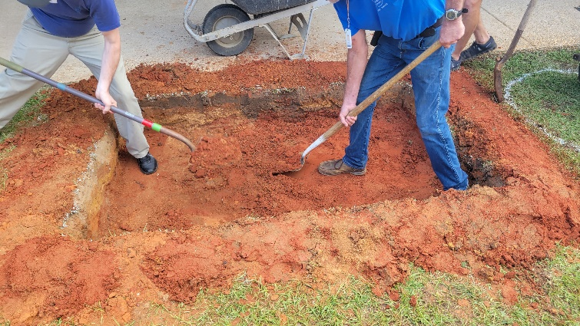
- Construction Instructions (continued):

- Place the 10 ft x 13 ft pond liner inside the bog area and mold it to the bottom and sides of the hole you dug. Place the remaining pond liner on top of the flat berm, and then cut away any excess pond liner. See example photo below.
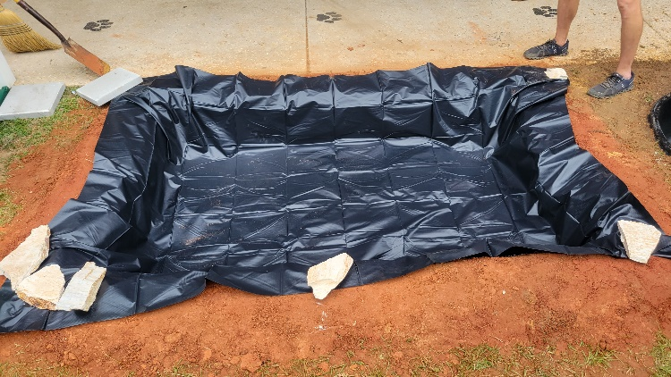
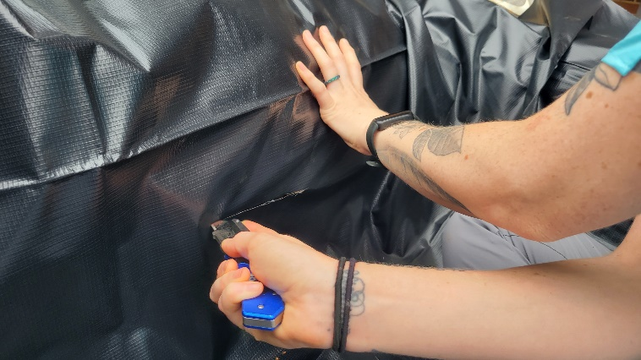
- Cut 6-inch long horizontal slits in the left, front and right sides of the pond liner about 6 inches up from the bottom of the bog. This will allow water to seep into the ground after heavy rains and it will prohibit the top level of the bog from washing away. See example photo below.

- Place a soaker hose in the bottom of the bog with the nozzle (open-end ) sticking up out of the back corner of the bog that is closest to the spigot or rain barrel so that you can fill the bog with water if you have no rain for 5-7 days. Put rocks or bricks on top of the soaker hose if needed to hold it down until you have enough soil & sand on it to hold it in place. See diagram and example photo at the top of page 7. *Note: If you enter the bog to accomplish this, remove your shoes as to not carry any grass seeds into the bog.


Project Plan for Large Frog and Toad Habitat
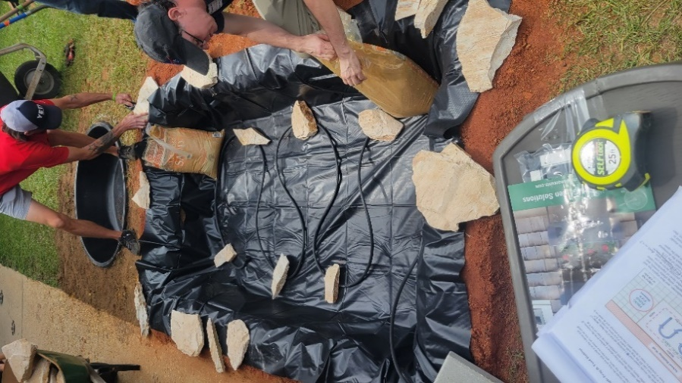
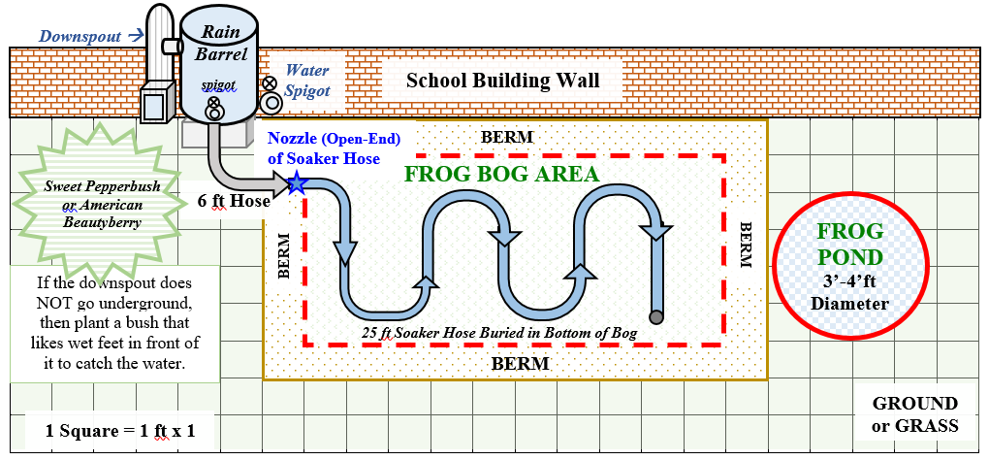
- Construction Instructions (continued):
- Add 1” layers of each of the following substrate components, in this order: sand (13 bags), peat moss (~1/4 bag), soil conditioner (6 bags), and organic top soil (8 bags). Remove the rocks holding down the soaker hose once your substrate is thick enough to hold down the soaker hose. Stir these layers together thoroughly using plastic trowels or your hands, and be sure not to pull on or move the soaker hose as you do so. Then add another layer of sand (13 bags), peat moss (~1/4 bag), soil conditioner (6 bags), and organic top soil (8 bags). Top this with a layer of cow manure and compost (2 bags). Stir these 5 layers to incorporate them with one another as well as the mixed substrate already in the bog. Lastly, add the last three inches of peat moss (1/4 bag) covered by organic top soil (5 bags) and then sand (13 bags).
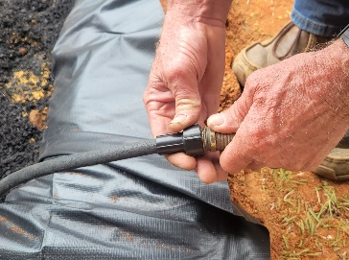
- Attach a water hose to the nozzle (open-end) of the 25 ft soaker hose that is sticking out in the back corner of the bog. See example photo on right. Turn on the spigot to fill up the bog with water. The water level should thoroughly soak the soil but you should not have standing water. Once the soil is soggy, students (3-4 at a time) can take off their socks and shoes and stomp around in the bog to help mix the soil, peat moss, and sand. If the students are unable to mix the ingredients with their feet, then use trowels again to help mix all of the ingredients. Your goal is to have ALL of the peat moss be saturated with water.
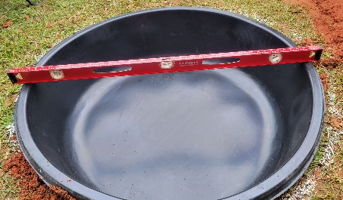
- Dig the area you spray painted for the pre-formed pond. The hole the depth of the pre-formed pond, occasionally placing the pond inside of the hole to test the depth. The lip of the pond should sit flush on the ground. Dig more if the pond is still sticking up out of the ground too far. Once you have the correct depth, use a level to make sure that the top of the pond is level with the ground from front to back and side to side. See example photo on right. Use sand (up to 1 bag) to level the ground under the pond if needed.

Project Plan for Large Frog and Toad Habitat
- Construction Instructions (continued):
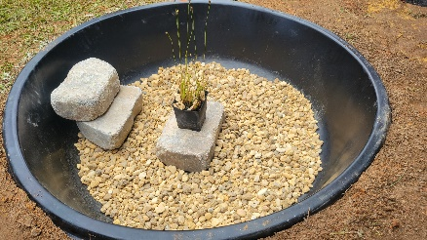
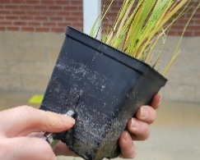
- Place your aquatic plants in the pond. Keep them in their plastic pots. If you have more than one plant of each species, you can combine them into one large pot per species. If there are no holes in the pots, poke 3-6 small 2-inch holes in the side of each pot to allow the plants to suck up and filter the water in the pond. See example photo on right. Then, pour some of the gravel in each pot around the base of each plant’s stem to help weigh down the plants so they don’t float when you fill up the pond.
- Pour the rest of the bag of gravel around the bottom of the pond. Then stack two retaining wall blocks along the edge of the pond to help frogs enter and leave the pond. See example photo on right. You may need to use a stone to make your plant taller. It is okay for the pot to be submerged, but most of the plant’s stems/ leaves need to be out of the water.
- Use a hose to fill the pre-formed pond 10” deep.
- Place a single layer of retaining wall blocks or natural, flat stones on top of the berm to hold the liner in place, all the way around the bog. Add an additional ring of blocks around your pond if you’d like to. See example photo below.

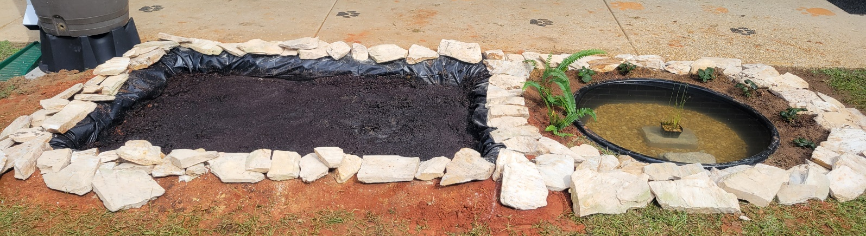
- Plant around-the-pond and/or berm plants. Plant bush between bog and school wall. If your downspout is open (doesn’t run underground), plant a bush in front of the downspout as well. Spread pine straw around base of plants. Do not use mulch, as it can be difficult for frogs and toads to burrow in. See diagram on page 9.
- After the bog settles, add potting soil (11 bags) & sand (9 bags plus any remainder from leveling pond) to fill it even with the ground around it. *Fill to ground level, not the height of the berm.
- Plant bog plants after the bog’s soil has settled and feels somewhat firm. This may take a day or two. See diagram on page 9. Spread pine straw in bog around plants. Do not use mulch, as it can be difficult for frogs and toads to burrow in.
- Add small logs into bog if desired.
- Attach Plant ID signs to stakes using adhesive. Sink the stakes a few inches into the ground in front of the appropriate plant species grouping or bush.

Project Plan for Large Frog and Toad Habitat
- Construction Instructions (continued):
- Insert the educational sign post (u-post) in the ground near the garden and attached the educational sign to it using the nuts, bolts, and washers.
- If you chose to get a pond aerator and pump, install them in the pond.
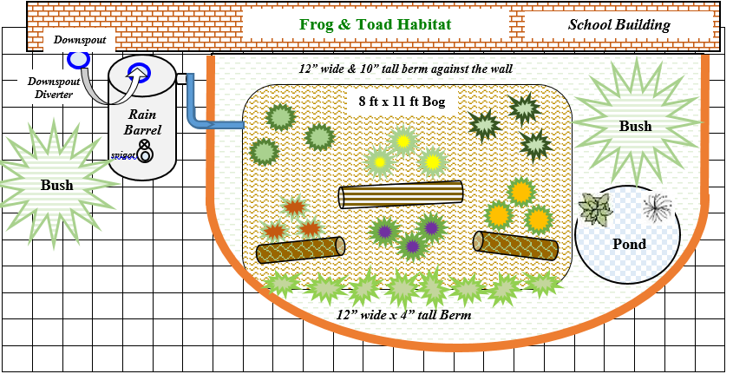
- If you chose to get solar pathway lights, install them around the habitat.

WALL

