
Seasonal Weather Observations
Name: | ______________________________________________________  -------------------------------------------------------  ______________________________________________________

Go outside and observe the weather. Then use your weather observations to help you determine which season it is.
What is the weather like?
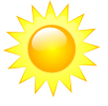  - Sunny | 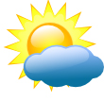  - Partly Cloudy |   - Cloudy
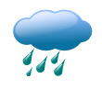  - Raining | 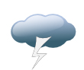  - Thunder/ Lightning | 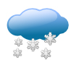  - Snow
******************************************************************
What is the temperature? | Hot? | Cold?
******************************************************************
Time of Day: | ______________________________________________________  -------------------------------------------------------  ______________________________________________________

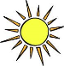  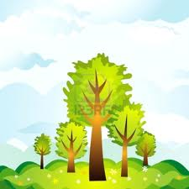  - Morning |   - Noon | - Afternoon | - Night  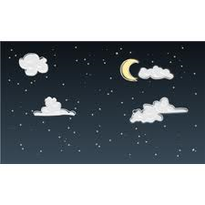
****************************************************************** Are the leaves…
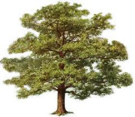  - On the trees and bushes? | 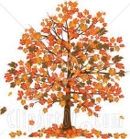  - Falling off the trees and bushes? | 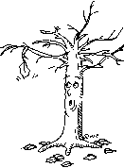  - On the ground?
******************************************************************
******************************************************************
Month of the Year: | ______________________________________________________  -------------------------------------------------------  ______________________________________________________

August September October November December
January February March April May June
******************************************************************
Which season do you think it is?
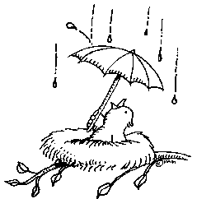  Spring | 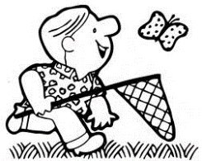  Summer | 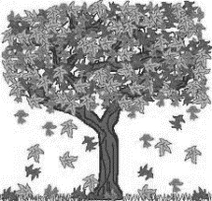  Fall | 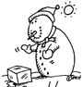  Winter
******************************************************************
Draw a picture of today’s seasonal weather:

