QR Codes for Upper Grades Ecosystem Investigation Webpages
Learning Station/ Topic | URL | QR Code
Habitats
Bat House | https://www.alabamawildlife.org/learn-about-bats-upper/ | 
Bee Habitat | https://www.alabamawildlife.org/learn-about-bees-upper/ | 
Box Turtle Habitat | https://www.alabamawildlife.org/learn-about-box-turtles-and-their-habitat-upper/ | 
Butterfly Garden | https://www.alabamawildlife.org/learn-about-butterflies-and-their-habitat-upper/ | 
Decomposition Stations | https://www.alabamawildlife.org/learn-about-decomposers-and-their-habitat-upper/ | 
Frog and Toad Habitat | https://www.alabamawildlife.org/learn-about-frogs-and-toads-and-their-habitat-upper/ | 
Pollinator Garden | https://www.alabamawildlife.org/learn-about-pollinators-and-their-habitat-upper/ | 
Songbird Garden | https://www.alabamawildlife.org/learn-about-songbirds-and-their-habitat-upper/ | 
Other Learning Stations
Sunflower Garden/ Fibonacci | https://www.alabamawildlife.org/learn-about-fibonacci-sequence/ | 
Pond | https://www.alabamawildlife.org/learn-about-ponds-upper/ | 
Rain Garden | https://www.alabamawildlife.org/learn-about-rain-gardens-upper/ | 
Sensory Garden | https://www.alabamawildlife.org/learn-about-senses-upper/ | 
Weather Station | https://www.alabamawildlife.org/learn-about-weather-upper/ | 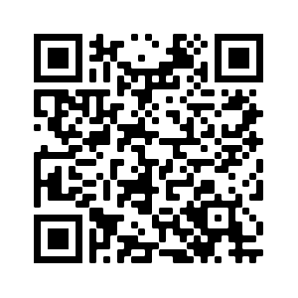
Woodland Wildflower Garden | https://www.alabamawildlife.org/learn-about-woodland-wildflowers-upper/ | 
Topics
AL’s Biodiversity | https://www.alabamawildlife.org/learn-about-alabamas-biodiversity-upper/ | 
AL’s Ecoregions | https://www.alabamawildlife.org/learn-about-alabamas-ecoregions-upper/ | 
AL’s Waterways | https://www.alabamawildlife.org/learn-about-alabamas-waterways-upper/ | 
Native Plants | https://www.alabamawildlife.org/why-plant-native/ | 
Plant Anatomy | https://www.alabamawildlife.org/learn-about-plant-anatomy-upper/ | 

