
Welcome to our
Box Turtle Habitat

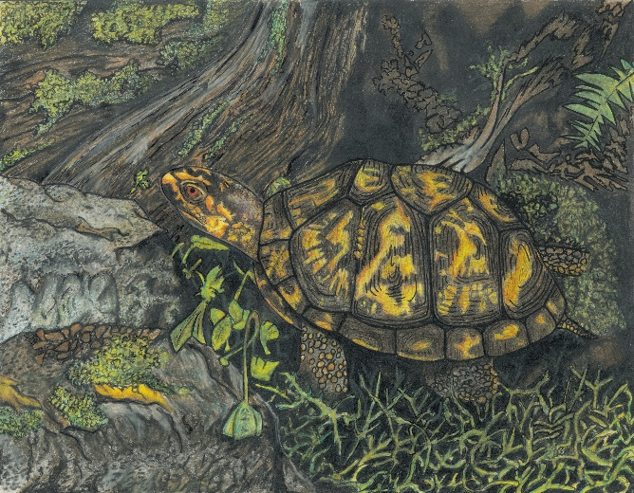
Eastern box turtles are the only native terrestrial turtle species in north Alabama. They have one of the best adaptations in the wildlife community! They can pull their heads, legs and tails into their shells for protection from predators. Also, the colors on their shells act as camouflage as they crawl along the forest floor looking for snails, bugs and plants to eat. Our habitat provides plants for shelter, water to drink and cool off in, sand where they can lay their eggs, and food that we give them.
This species is listed as “protected” in Alabama. Our school has a permit from the Alabama Department of Conservation and Natural Resources to keep two box turtles for educational purposes.


Scan this QR Code to learn more about box turtles.
Enjoy nature’s beauty!
Protect it from litter and vandalism!

