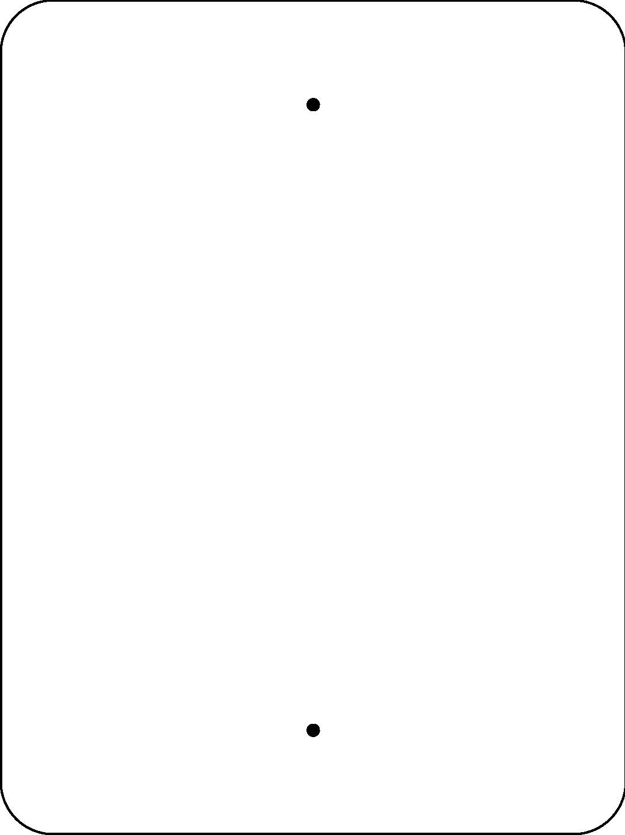
Welcome to our
Compost Station
Decomposition is the process of turning dead
material into nutrients that plants use as food.
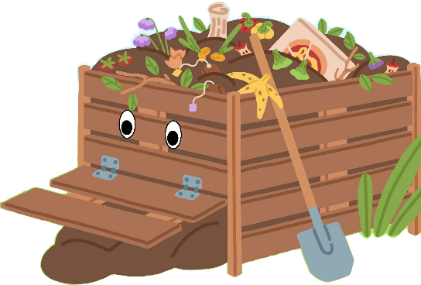
It’s nature’s way of recycling!
In our compost pile, bacteria
(decomposers) use oxygen and heat
to breakdown organic materials.
- Plastic
- Meat
- Oil
- Fat
- Diseased plants
- Perennial weeds
- Weeds with seed heads

- Cardboard
- Paper
- Sticks
- Leaves
- Grass clippings
- Dead flowers
- Vegetable & fruit waste

What you can add to the bin:
Do NOT add to the bin:

Finished compost is dark, spongy, and full of nutrients.
We spread our compost into our gardens to fertilize the plants, help break-up the soil so that it can retain water, and help the plants grow faster and bigger!

Scan this QR Code to learn more about decomposition.
Enjoy nature’s beauty!
Protect it from litter & vandalism!

