
Welcome to our
Gourd Garden
Humans began growing gourds 25,000 years ago.
Fossilized gourds used by Native Americans were found in 11,000-year-old mastodon dung!
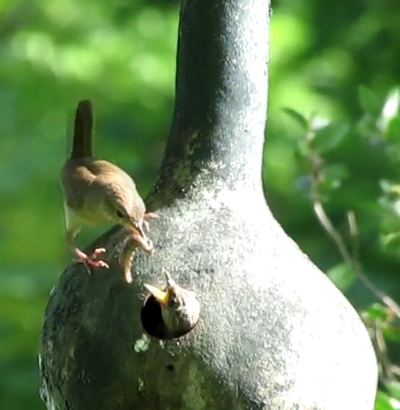
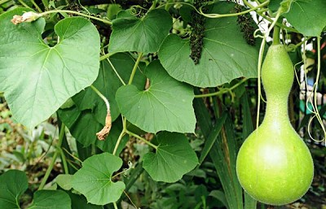
Gourds have many uses:
Bowls, Cups & Utensils
Storage Containers
Food & Medicine
Musical Instruments
Birdhouses & Feeders
And More!


Scan this QR Code to learn more about gourds.
Enjoy nature’s beauty!
Protect it from litter and vandalism!

