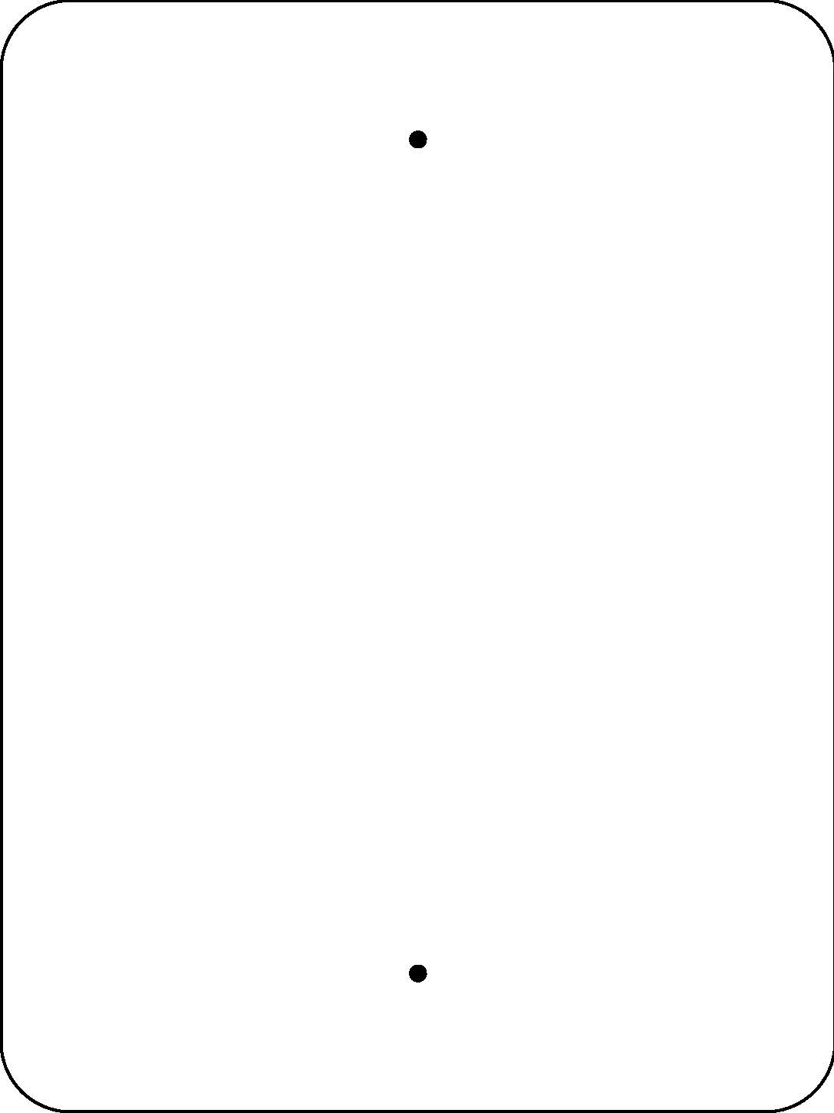
Welcome to our
Log Decomposition Station
Decomposition is nature’s way of recycling. It is the process of turning dead material (like fallen logs and leaves) into nutrients that plants can use as food.
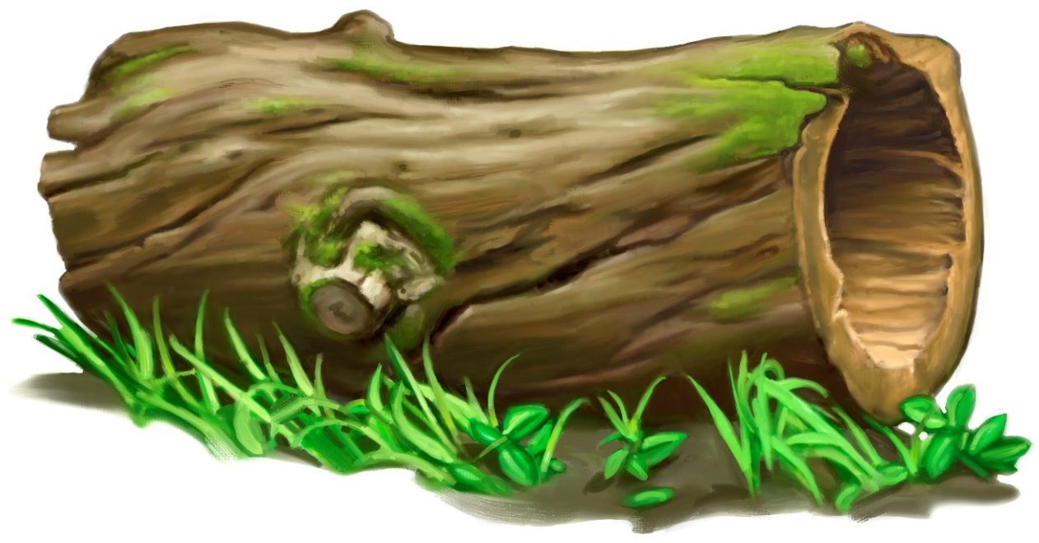


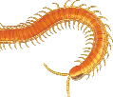
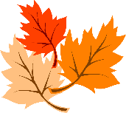
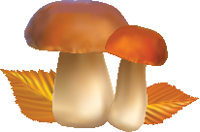

Decomposers like fungus (mold & mushrooms) and invertebrates (beetles, snails & millipedes) eat and break down the log, turning it back into soil.


Scan this QR Code to learn more about decomposition.
Enjoy nature’s beauty!
Protect it from litter and vandalism!

