
Welcome to our
Rain Garden

A rain garden captures rain and stormwater run-off and then filters the water as it slowly releases it into the surrounding soil. Our rain garden collects and filters the rain water from multiple downspouts to help prevent flooding in our outdoor classroom.
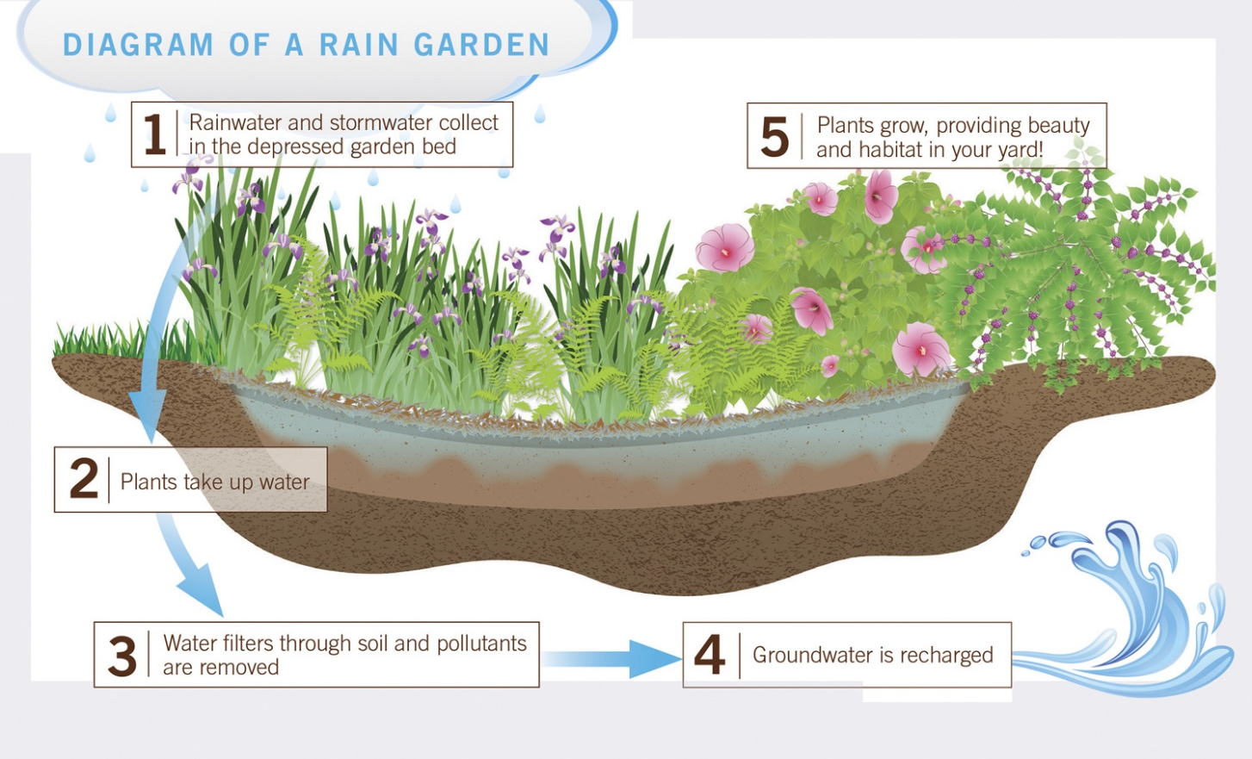
Illustration by Clemson Cooperative Extension System


Scan this QR Code to learn more about rain gardens!
Enjoy nature’s beauty!
Protect it from litter and vandalism!

