
Welcome to our Sensory Garden







Use all of your senses as you explore
our sensory garden and outdoor classroom!
Gently feel the textures of the plants.
Can you smell the flowers?

What colors are the flowers?
What are the shapes of the leaves?

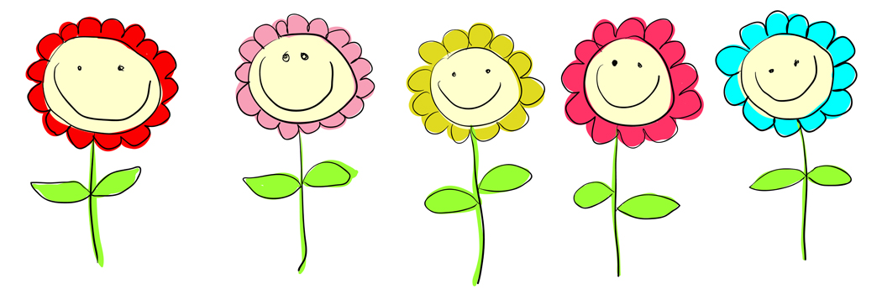


Scan this QR Code to learn more about your senses!
Enjoy nature’s beauty! Protect it from litter and vandalism!

