
Welcome to our
Veggie Garden

We like to grow vegetables that we can eat
and that will make us healthy. Some of the
vegetables grow aboveground on a stem or vine
(like a tomato), but others grow underground (like a potato).
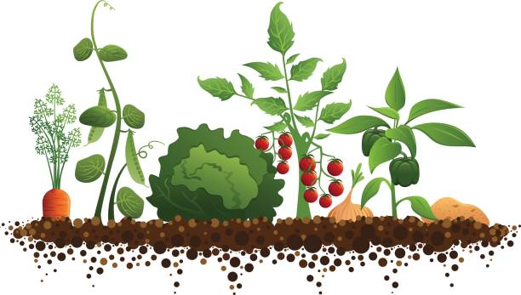


Scan this QR Code to learn more about veggie gardens.
Enjoy nature’s beauty!
Protect it from litter and vandalism!

