
Welcome to our
Woodland Wildflower Garden

Most flowers thrive in sunny areas, but our native woodland wildflowers need the shade of a forest. The woodland provides nutrient-rich soils from the decay of last falls’ leaves, and the tree canopy helps keep the soil moist for these unique and rare wildflowers.

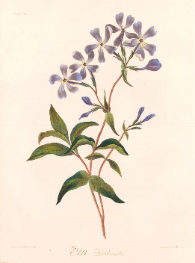
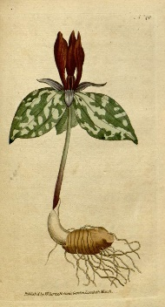
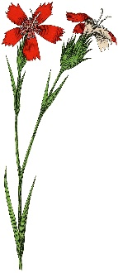
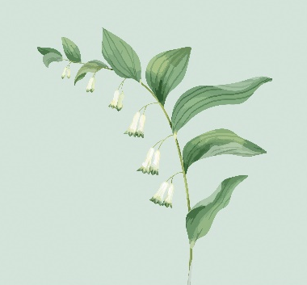
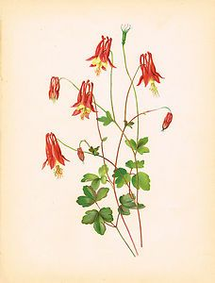

Wild Columbine Solomon’s Seal Fire Pink Trillium Wild Blue Phlox

Keep a look out for these beautiful flowers in the spring before they disappear again until the following year.


Scan this QR Code to learn more about our wildflowers.
Enjoy nature’s beauty!
Protect it from litter and vandalism!

