
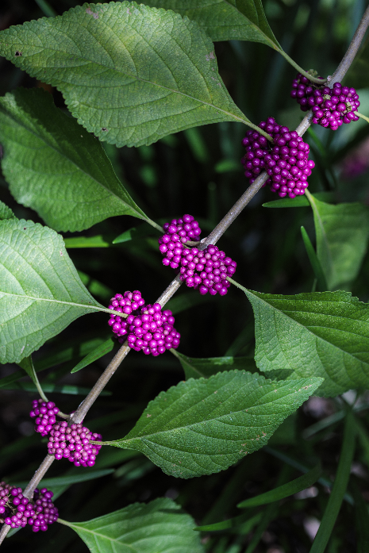

American Beautyberry
Callicarpa americana
Food for Birds

Native to Alabama

