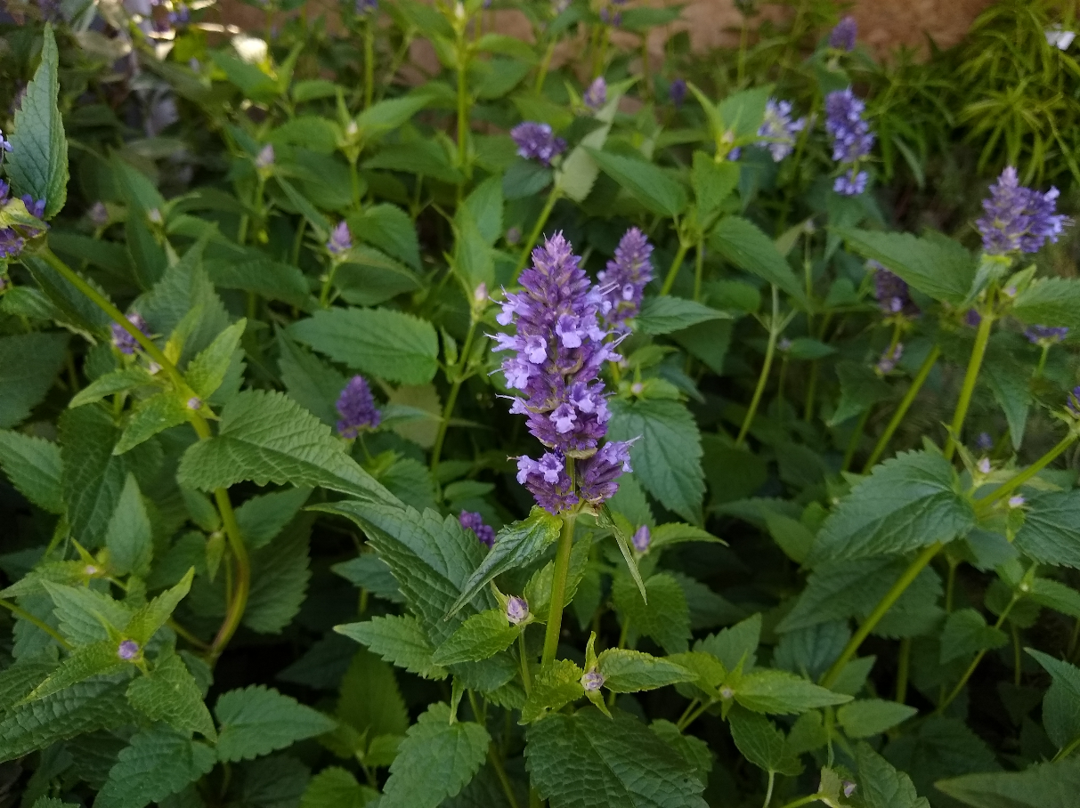

Anise Hyssop
Agastache foeniculum
Food for Birds
Native to Alabama

