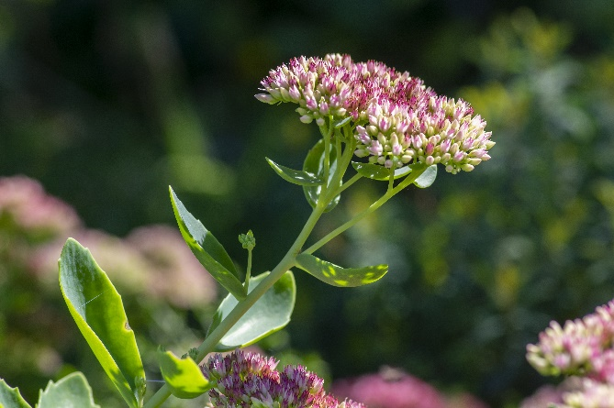


Autumn Joy
Sedum
Hylotelephium spectabile
Touch My Leaves
Non-
native

