
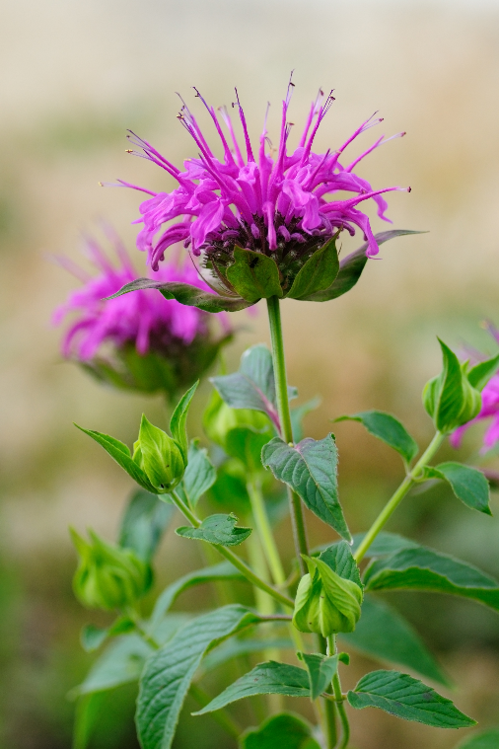
Bee Balm
Monarda fistulosa
Nectar Plant

Native to Alabama

