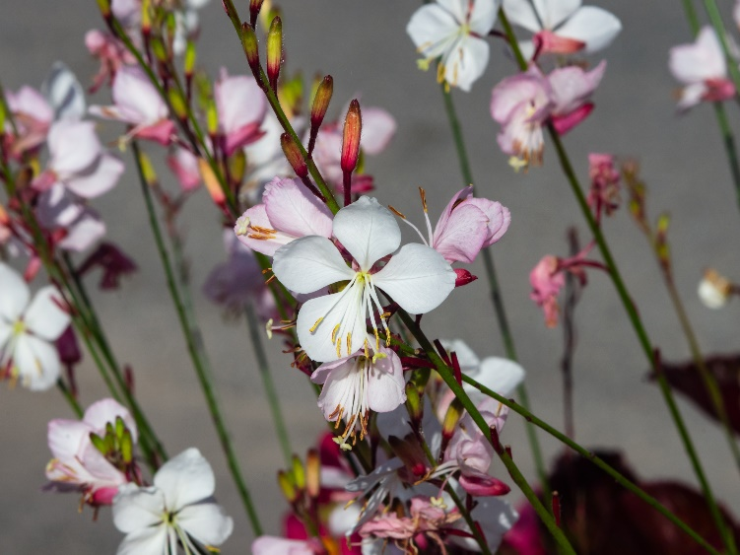


Beeblossom
Oenothera lindheimeri
Nectar Plant

Non-native

