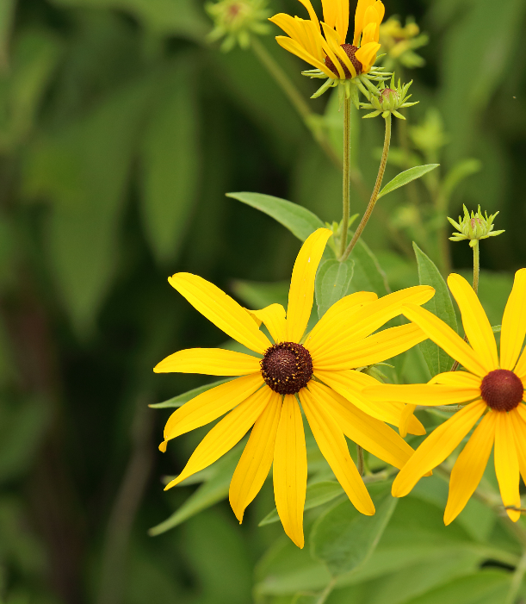


Black-eyed Susan
Rudbeckia hirta
Seeds & Nectar Plant

Native to Alabama

