
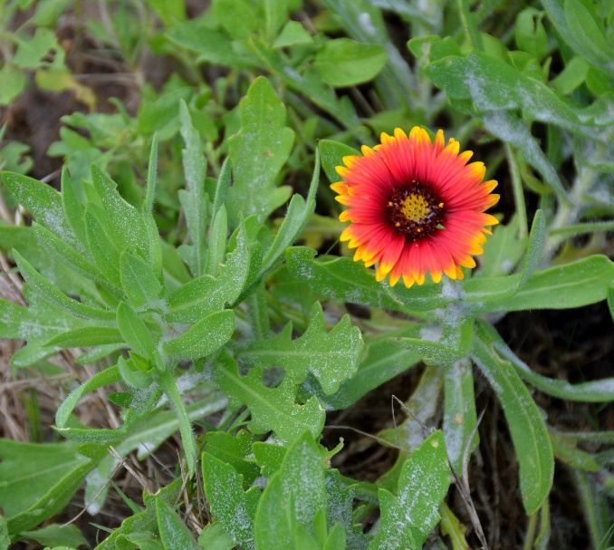

Blanket Flower
Gaillardia pulchella
Seeds &
Nectar Plant

Native to Alabama

